Supporting Information
for
Sex differences in dispersal syndrome are modulated by environment and evolution
Authors: Abhishek Mishra†, Sudipta Tung†, P.M. Shreenidhi¹, Mohammed Aamir Sadiq², VR Shree Sruti, Partha Pratim Chakraborty and Sutirth Dey*
Affiliation: Population Biology Laboratory, Biology Division, Indian Institute of Science Education and Research-Pune, Dr. Homi Bhabha Road, Pune, Maharashtra, India, 411 008
†Equal contribution

*Corresponding author:
Sutirth Dey
Associate Professor, Biology Division
Indian Institute of Science Education and Research, Pune
Dr. Homi Bhabha Road, Pune, Maharashtra, India 411 008
Tel: +91-20-25908054
Email: s.dey@iiserpune.ac.in
Appendix S1: Detailed materials and methods
Text S1.1 Fly populations and their ancestry
We used individuals from a large (breeding size of ~2400 individuals) laboratory population of Drosophila melanogaster, named DB₄, for investigating the ecological dispersal syndrome in Experiments 1 and 2 (for details, see Text S1.4 and S1.5, respectively). The DB populations in turn trace their ancestry back to the IV lines, which were wild-caught at South Amherst, MA, USA in 1970 [1]. Ever since, these flies have been maintained in the laboratory at large population sizes to ameliorate inbreeding-like effects. For examining the evolutionary dispersal syndrome, we used eight D. melanogaster populations derived from DB populations, four of which (VB₁₋₄) have been subjected to selection for higher dispersal (see the selection procedure in Text S1.3) over 70 generations, with the other four populations (VBC₁₋₄) serving as the corresponding control populations (Fig. S1).
Text S1.2 Maintenance regime of experimental populations
The larvae and adults of all the populations (i.e. DB₄, VBs and VBCs) were maintained at 25°C, constant light conditions and 80–90% humidity. During regular maintenance, the flies are made to oviposit on petri-plates containing standard banana-jaggery medium for 12-16 hours. After oviposition, we cut 40 small strips of the medium, each containing ~60-70 eggs that are sampled randomly, and introduce them individually into 35-mL plastic vials that had ~6 mL of the same banana-jaggery medium. This ensures that the larvae are raised under low-to-moderate level of crowding, to avoid any confounding effect of density-dependent selection [2]. In these vials, the adults start emerging by the 8th–9th day after egg collection. For the DB₄ population, on the 12th day, the adults are transferred to plexi-glass cages (25 cm × 20 cm ×15 cm) and are provided with fresh banana-jaggery medium every alternate day. This process continues until the 18th day, when the adult flies are supplied with excess live yeast paste along with standard banana-jaggery food. Whereas, for the VB and VBC populations, on the 12th day from the day of egg collection, the adults are subjected to the dispersal selection protocol (see Text 1.3 for details). Immediately after this, the adults of a given population are transferred to a plexi-glass cage and provided with yeast supplement along with standard banana-jaggery food. For all the populations, after ~40 hours of yeast provisioning, eggs are collected for the next generation. The adults are discarded after oviposition, thus ensuring that individuals of two successive generations never co-exist. Thus, the length of egg-to-egg cycle is 21 days for DB₄, whereas it is 15 days for VB and VBC populations.
Text S1.3 Procedure for directional selection for higher dispersal
In order to impose selection, 12-day old (from egg collection) adults from 40 vials (~2400 individuals) of the VB populations were introduced into the source (a clear plastic container of ~1.5 L volume). The source is connected to a path (transparent plastic tube of inner diameter ~1 cm) leading to the destination (a plastic container similar to the source). Two such setups are provisioned for each VB population (Figure S3). A strip of moist cotton was provided at the destination, while no food or moisture was present in the source and the path. The flies were allowed to disperse through the path into the destination, until ~50% of the population reached the destination or for 6 hours (whichever happened earlier). The duration of 6 hours was chosen because, in prior studies in the lab, no mortality due to desiccation was observed during this period. At the end of dispersal, the flies which reached the destination in the two selection setups were collected into a cage and allowed to breed for the next generation. Maintaining two dispersal set-ups for the VB populations ensured that the breeding population sizes of the selected and the control flies (i.e. the VBC populations) were similar.
Similar to the VB populations, adults from 40 vials of each VBC population were introduced into a source container. However, during the entire duration of the selection process, they were not allowed to disperse. Once 25% of the corresponding VB individuals reached their destination or after 3 hours (whichever was earlier), the VBC individuals were provided with a moist cotton plug. At the end of the selection process, all the flies from a given VBC population were transferred to a cage and allowed to breed.
In course of this selection experiment, the length of the path was increased intermittently over the generations. We started the experiment with a path length of 2 m in the 1st generation, and by generation 70, the path length had been increased to 21 m.
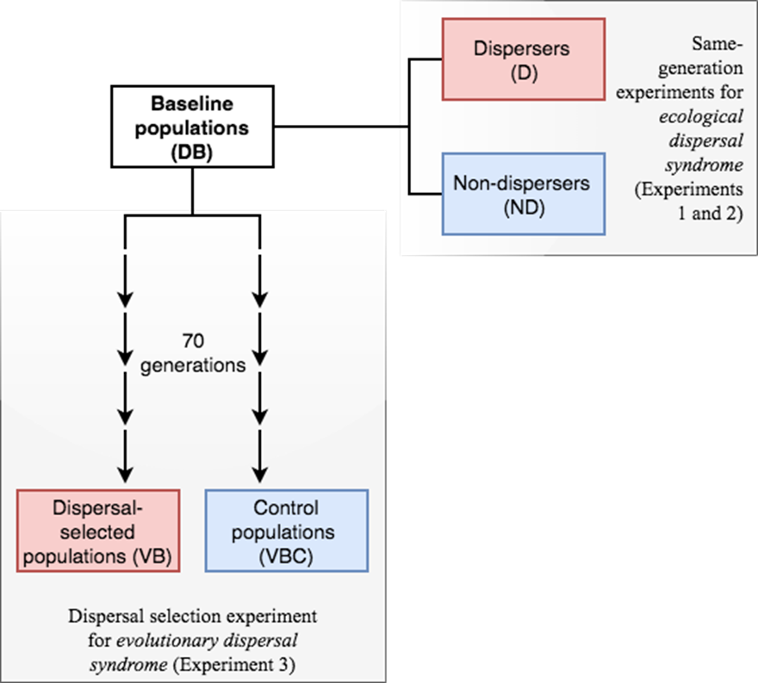
Fig. S1 Drosophila melanogaster populations used in the study. Starting from a baseline population (DB₄), flies were taken for the same-generation experiments (Experiments 1 and 2). The same DB₄ population also served as the ancestral population for a pair of the dispersal-selected (VB₄) and control (VBC₄) populations in the dispersal evolution experiment (Experiment 3).

Text S1.4 Experiment 1: Ecological dispersal syndrome under low nutrition
For this experiment, eggs were collected from the DB₄ population at a density of ~60 eggs in 640 vials, each containing ~6 mL of nutrient-limited food. This food was prepared by adding only 33% of the nutrient ingredients compared with the standard banana-jaggery medium of same volume. The eggs were reared at 25°C with constant light and 80–90% humidity until they became adults. Subsequently, the adults were segregated into dispersers and non-dispersers using a three-step protocol, explained below:
- On the 12th day from the day of egg collection, eclosed adults from 40 vials (i.e. ~2400 flies) were introduced into a plastic container (~1.5 L volume), i.e. source. The source container was connected to a 4 m path, which is a transparent plastic tube of inner diameter ~1 cm. The path led to a destination container (similar to source). Sixteen such source-path-destination setups (similar to selection setup mentioned in text S1.3, also see [3]) were used, and the flies were allowed to disperse through the path to destination for 6 hours. At the end of this event, the flies found in the path were discarded, while the flies present in source and destination were collected separately. The two groups of flies (i.e. source and destination groups) were allowed to rest for the next two days (until the 14th day) under maintenance on standard banana-jaggery food.
- On the 14th day from egg collection, the process of dispersal was repeated, but this time, it was done separately for the source and the destination groups obtained above, with 5 dispersal setups for each group (Figure S2). The total number of dispersal setups were reduced in this round because the path flies from the last round had been discarded and not a part of this round. At the end of this round of dispersal (6 hours), only the flies among the source group that did not disperse, and the flies among the destination group that successfully dispersed were collected separately, while the rest of the flies in both kinds of setups were discarded. Therefore, these new groups of source and destination flies were the individuals that had shown a consistent dispersal phenotype (non-dispersive and dispersive, respectively) across both rounds of dispersal. They were maintained separately on standard banana-jaggery medium for the next 2 days (until the 16th day) to allow some rest after the dispersal run.
- On the 16th day from egg collection, the new groups of source and destination flies were subjected to a final, third round of segregation, this time with 2 dispersal setups per group. Again, the flies from the source and destination group which had shown a consistent dispersal phenotype (non-dispersive and dispersive, respectively) were chosen while the rest were discarded. These two groups (henceforth, non-dispersers and dispersers) were maintained for a final 2-day rest period (until the 18th day) on standard banana-jaggery medium before they were subjected to the assays.

Thus, on the 18th day from egg collection, we had two distinct groups of flies with a consistent dispersal phenotype (non-dispersers and dispersers), which were compared through the following assays (text S1.6) to assess the ecological dispersal syndrome under low nutrition.

It should be noted here that the length of the path used to separate the dispersers and the non-dispersers was 4 m in Experiments 1 and 2, while during the process of dispersal selection, the length of the path increased from 2m to 21 m. Thus, the aim of experiment 3 was to see whether the sex-specificity of dispersal syndromes are altered while the flies adapt to this increasing path-length.
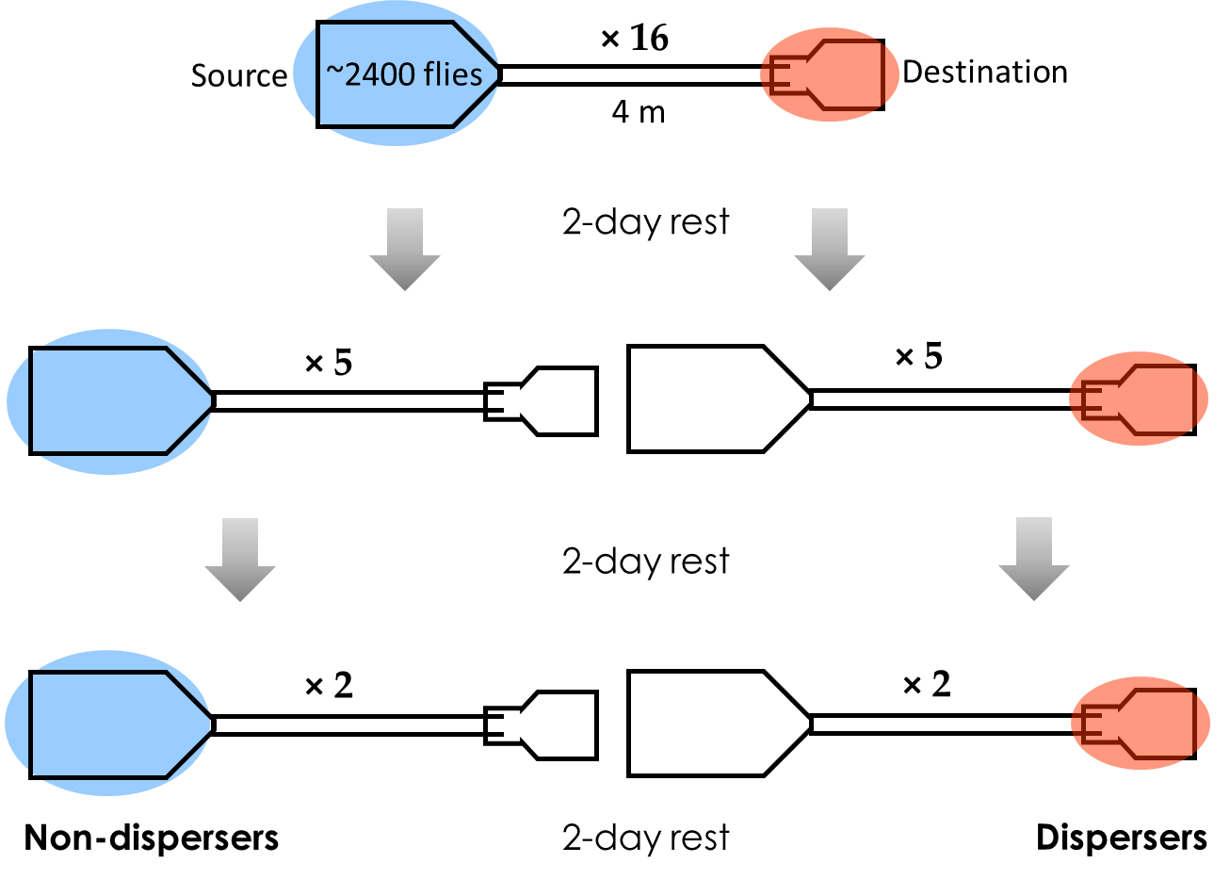
Fig. S2 Schematic diagram for segregation of dispersers and non-dispersers in the same-generation experiments (Experiments 1 and 2).

Text S1.5 Experiment 2: Ecological dispersal syndrome under standard nutrition
This experiment was performed identically as Experiment 1 above, with the sole exception that, here, the larvae were reared under standard nutrition conditions (i.e. standard banana-jaggery medium). Upon emergence from the pupae, the adult flies were subjected to three rounds of segregation such that by the 18th day, we obtained distinct groups of dispersers and non-dispersers (similar to Text S1.4). These two groups of flies were subjected to the assays (Text S1.7) and the data were compared to study the ecological dispersal syndrome under standard nutrition.
Text S1.6 Experiment 3: Evolutionary dispersal syndrome under standard nutrition
For this experiment, VB and VBC populations were subjected to the assays for the three traits (see text S1.7), and the results were compared to assess the evolutionary dispersal syndrome under standard nutrition. Before performing the assays, the VB and VBC populations were reared under common conditions for one generation to minimize the influence of non-genetic parental effects (Watson & Hoffmann 1996). From these flies, eggs were collected for the assays while maintaining a low egg density (~50 eggs on ~6 mL food in each vial) to avoid any confounding effect of larval crowding on the traits assayed. On the 12th day from egg collection, assays were performed on the adult flies. For all the assays, environmental (constant light, 25°C temperature, 80–90% humidity, abundant nutritional availability, low rearing density) and physiological (similar age) conditions of the flies were strictly controlled and maintained identically across all VB and VBC populations.

Text S1.7 Dispersal syndrome assays
Text S1.7.1 Dry body weight assay
Dry body weight of the adult flies was measured as a proxy for body size. For this, the flies were first sorted by sex, then killed by flash freezing and dried at 60°C for 72 hours in a hot-air oven. After thawing to the room temperature, the flies were weighed to the nearest 0.1 mg using Shimadzu (model AUY220) weighing balance. In Experiments 1 and 2, 10 batches of 20 males or 20 females were weighed for both non-dispersers and dispersers. In Experiment 3, 10 batches of 20 males or 20 females were weighed for each pair of VB and VBC populations.
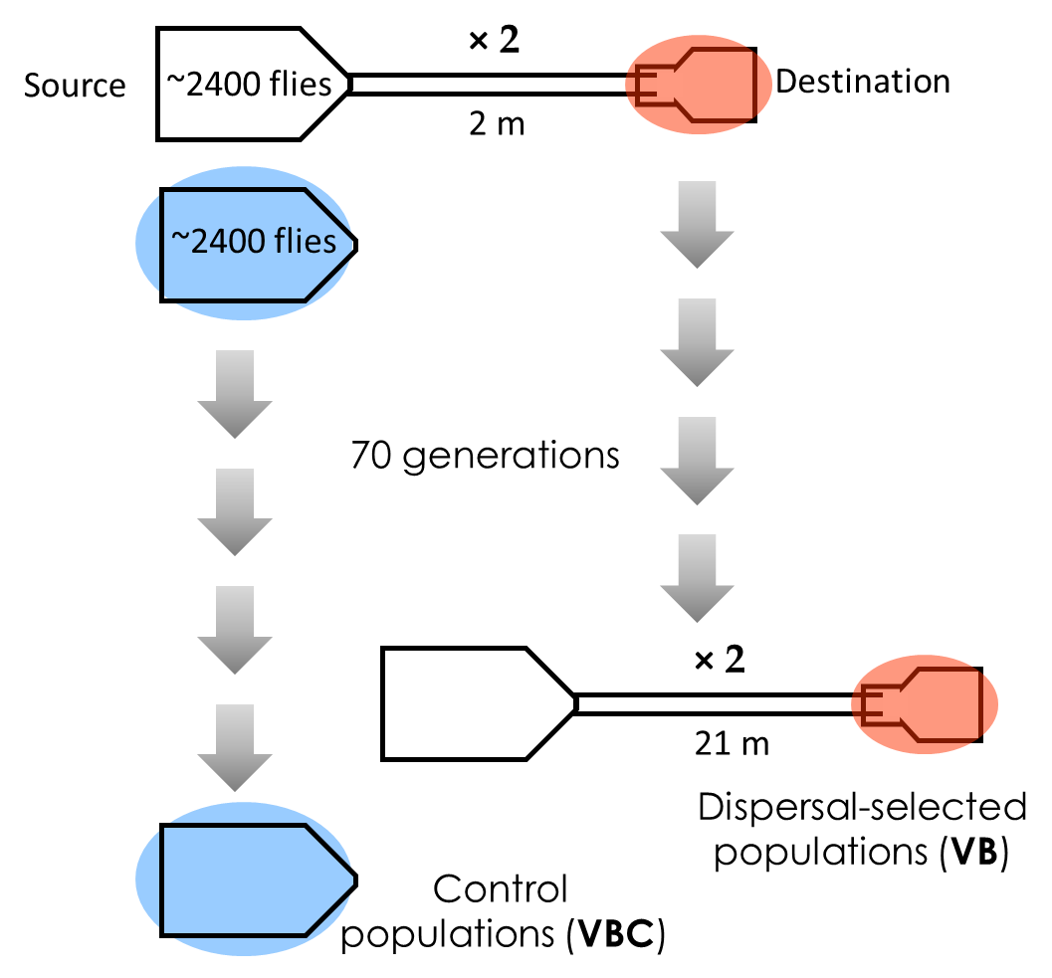
Fig. S3 Schematic diagram for selection of dispersal in the dispersal evolution experiment (Experiment 3).

Text S1.7.2 Desiccation resistance assay
Desiccation resistance for a fly was measured as the duration that it can survive without food and moisture. To quantify this trait in Experiments 1 and 2, 10 flies of either sex from non-dispersers and dispersers were introduced into empty transparent vials and monitored until the death of the last fly in each vial. The survivorship checks were conducted every 2 hours and 10 such replicates were used per sex. Similarly, in Experiment 3, for each of the VB and VBC populations, the duration of survival in the absence of food and moisture was recorded for 10 sets of 10 flies of either sex.
Text S1.7.3 Exploratory tendency assay
For this assay, flies of either sex were aspirated from the egg-collection vials and introduced individually into the experimental arena (modified from [4] and identical to [5]), which comprised a clear polycarbonate petri dish lid of 10-cm inner diameter. The flies typically prefer to walk along the boundary of the arena (i.e. the side-wall of the lid) and avoid the inner zone. Thus, movements away from the boundary indicate the exploratory tendency of an individual [4]. After introduction into the arena, we allowed 1 minute for each fly to acclimatize to the new environment, after which it was observed for 10 subsequent minutes. Following an established paradigm [6], the number of times it entered the inner two-third area of the experimental arena (marked a priori) was recorded as the number of exploratory trips.
In Experiments 1 and 2, the number of exploratory trips was measured for 32 individuals per sex for both non-dispersers and dispersers. For Experiment 3, we used a part of the dataset presented in [5], comprising the exploratory tendency data for 32 individuals per sex of the VB and VBC populations.

Table S1. ANOVA results for dry body weight data from Experiments 1, 2 and 3.
 | Factor | df Effect | MS Effect | df Error | MS Error | F value | p-value
Experiment 1 | dispersal | 1 | 0.004 | 36 | 0.00011 | 36.38 | 6.3 × 10⁻⁷
 | sex | 1 | 0.12 | 36 | 0.00011 | 1020.56 | 5.1 × 10⁻²⁸
 | dispersal × sex | 1 | 1.6 × 10⁻⁵ | 36 | 0.00011 | 0.13 | 0.71
Experiment 2 | dispersal | 1 | 0.003 | 36 | 0.00014 | 21.21 | 4.9 × 10⁻⁵
 | sex | 1 | 0.08 | 36 | 0.00014 | 587.91 | 6.8 × 10⁻²⁴
 | dispersal × sex | 1 | 0.0005 | 36 | 0.00014 | 3.60 | 0.06
Experiment 3 | dispersal | 1 | 0.018 | 3 | 0.004 | 4.30 | 0.13
 | sex | 1 | 0.79 | 3 | 0.022 | 35.32 | 0.01
 | dispersal × sex | 1 | 0.006 | 3 | 0.001 | 5.56 | 0.1

Table S2. Tukey’s HSD p-values for the pairwise differences in dry body weight data from Experiments 1, 2 and 3. Cohen’s d is computed as a measure of effect size for the significant pairwise differences. M: male, F: female.
 | p-value for dispersal × sex interaction | Pairwise difference | Tukey’s HSD p | Cohen’s d | Effect size interpretation
Experiment 1 | 0.71 | M Dispersers –  M Non-dispersers | Not applicable
F Dispersers –
F Non-dispersers
M Dispersers –
F Dispersers
M Non-dispersers –
F Non-dispersers
Experiment 2 | 0.06 | M Dispersers –  M Non-dispersers | 0.24 | - | -
 |  | F Dispersers –  F Non-dispersers | 0.00043 | 1.7 | Large
 |  | M Dispersers –  F Dispersers | 0.00016 | 9.7 | Large
 |  | M Non-dispersers –  F Non-dispersers | 0.00016 | 6.8 | Large
Experiment 3 | 0.1 | M Dispersers –  M Non-dispersers | Not applicable
F Dispersers –
F Non-dispersers
M Dispersers –
F Dispersers
M Non-dispersers –
F Non-dispersers

Table S3. ANOVA results for desiccation resistance data from Experiments 1, 2 and 3.
 | Factor | df Effect | MS Effect | df Error | MS Error | F value | p-value
Experiment 1 | dispersal | 1 | 56.64 | 36 | 1.86 | 30.42 | 3.1 × 10⁻⁶
 | sex | 1 | 462.4 | 36 | 1.86 | 248.34 | 9.8 × 10⁻¹⁸
 | dispersal × sex | 1 | 40.80 | 36 | 1.86 | 21.91 | 3.9 × 10⁻⁵
Experiment 2 | dispersal | 1 | 11.02 | 36 | 0.57 | 19.27 | 9.5 × 10⁻⁵
 | sex | 1 | 113.57 | 36 | 0.57 | 198.51 | 3.2 × 10⁻¹⁶
 | dispersal × sex | 1 | 17.16 | 36 | 0.57 | 29.99 | 3.5 × 10⁻⁶
Experiment 3 | dispersal | 1 | 421.04 | 3 | 55.86 | 7.54 | 0.07
 | sex | 1 | 1223.51 | 3 | 11.94 | 102.54 | 0.002
 | dispersal × sex | 1 | 69.63 | 3 | 6.33 | 10.99 | 0.04

Table S4. Tukey’s p-values for the pairwise differences in desiccation resistance data from Experiments 1, 2 and 3. Cohen’s d is computed as a measure of effect size for the significant pairwise differences. M: male, F: female.
 | p-value for dispersal × sex interaction | Pairwise difference | Tukey’s HSD p | Cohen’s d | Effect size interpretation
Experiment 1 | 4.0 × 10⁻⁵ | M Dispersers –  M Non-dispersers | 0.93 | - | -
 |  | F Dispersers –  F Non-dispersers | 0.00016 | 2.8 | Large
 |  | M Dispersers –  F Dispersers | 0.00016 | 6.5 | Large
 |  | M Non-dispersers –  F Non-dispersers | 0.00016 | 3.9 | Large
Experiment 2 | 3.5 × 10⁻⁶ | M Dispersers –  M Non-dispersers | 0.87 | - | -
 |  | F Dispersers –  F Non-dispersers | 0.00016 | 2.9 | Large
 |  | M Dispersers –  F Dispersers | 0.00016 | 6.2 | Large
 |  | M Non-dispersers –  F Non-dispersers | 0.00016 | 3.0 | Large
Experiment 3 | 0.04 | M Dispersers –  M Non-dispersers | 1.2×10⁻⁵ | 0.6 | Small
 |  | F Dispersers –  F Non-dispersers | 7.7 × 10⁻⁶ | 2.0 | Large
 |  | M Dispersers –  F Dispersers | 7.7 × 10⁻⁶ | 1.8 | Large
 |  | M Non-dispersers –  F Non-dispersers | 7.7 × 10⁻⁶ | 2.4 | Large

Table S5. ANOVA results for exploratory tendency data from Experiments 1, 2 and 3.
 | Factor | df Effect | MS Effect | df Error | MS Error | F value | p-value
Experiment 1 | dispersal | 1 | 110.63 | 124 | 79.74 | 1.39 | 0.24
 | sex | 1 | 4429.76 | 124 | 79.74 | 55.55 | 1.4 × 10⁻¹¹
 | dispersal × sex | 1 | 532.20 | 124 | 79.74 | 6.67 | 0.01
Experiment 2 | dispersal | 1 | 19.53 | 124 | 56.41 | 0.35 | 0.56
 | sex | 1 | 1785.03 | 124 | 56.41 | 31.64 | 1.2 × 10⁻⁷
 | dispersal × sex | 1 | 55.12 | 124 | 56.41 | 0.98 | 0.32
Experiment 3 | dispersal | 1 | 1485.12 | 3 | 124.14 | 11.96 | 0.04
 | sex | 1 | 3949.38 | 3 | 145.64 | 27.12 | 0.01
 | dispersal × sex | 1 | 1.53 | 3 | 167.93 | 0.01 | 0.93

Table S6. Tukey’s p-values for the pairwise differences in exploratory tendency data from Experiments 1, 2 and 3. Cohen’s d is computed as a measure of effect size for the significant pairwise differences. M: male, F: female.
 | p-value for dispersal × sex interaction | Pairwise difference | Tukey’s HSD p | Cohen’s d | Effect size interpretation
Experiment 1 | 0.01 | M Dispersers –  M Non-dispersers | 0.04 | 0.6 | Medium
 |  | F Dispersers –  F Non-dispersers | 0.75 | - | -
 |  | M Dispersers –  F Dispersers | 0.003 | 0.8 | Large
 |  | M Non-dispersers –  F Non-dispersers | 0.000007 | 1.9 | Large
Experiment 2 | 0.32 | M Dispersers –  M Non-dispersers | Not applicable
F Dispersers –
F Non-dispersers
M Dispersers –
F Dispersers
M Non-dispersers –
F Non-dispersers
Experiment 3 | 0.93 | M Dispersers –  M Non-dispersers | Not applicable
F Dispersers –
F Non-dispersers
M Dispersers –
F Dispersers
M Non-dispersers –
F Non-dispersers

Table S7. Pooled three-way ANOVA for dry body weight data over Experiments 1, 2 and 3.
Factor | df Effect | MS Effect | df Error | MS Error | F value | p-value
experiment | 2 | 0.13 | 108 | 0.00015 | 864.49 | < 1 × 10⁻²⁸
dispersal | 1 | 0.003 | 108 | 0.00015 | 21.66 | 9.3 × 10⁻⁶
sex | 1 | 0.50 | 108 | 0.00015 | 3410.52 | < 1 × 10⁻²⁸
experiment × dispersal | 2 | 0.002 | 108 | 0.00015 | 14.12 | 3.5 × 10⁻⁶
experiment × sex | 2 | 0.03 | 108 | 0.00015 | 203.95 | < 1 × 10⁻²⁸
dispersal × sex | 1 | 6.8 × 10⁻⁵ | 108 | 0.00015 | 0.46 | 0.50
experiment × dispersal × sex | 2 | 0.0003 | 108 | 0.00015 | 1.96 | 0.15

Table S8. Pooled three-way ANOVA for desiccation resistance data over Experiments 1, 2 and 3.
Factor | df Effect | MS Effect | df Error | MS Error | F value | p-value
experiment | 2 | 301.73 | 108 | 1.85 | 162.86 | < 1 × 10⁻²⁸
dispersal | 1 | 13.33 | 108 | 1.85 | 7.2 | 0.008
sex | 1 | 726.19 | 108 | 1.85 | 391.97 | < 1 × 10⁻²⁸
experiment × dispersal | 2 | 174.59 | 108 | 1.85 | 94.24 | < 1 × 10⁻⁶
experiment × sex | 2 | 30.23 | 108 | 1.85 | 16.32 | 6.4 × 10⁻⁷
dispersal × sex | 1 | 14.14 | 108 | 1.85 | 7.64 | 0.007
experiment × dispersal × sex | 2 | 29.97 | 108 | 1.85 | 16.18 | 7.1 × 10⁻⁶

Table S9. Post-hoc (Tukey’s HSD) results for experiment×dispersal×sex interaction for desiccation resistance data.
 | Tukey’s HSD p-value for difference between dispersers and non-dispersers
 | Males | Females
Experiment 1 | 0.99 | 1.2 × 10⁻⁴
Experiment 2 | 0.99 | 0.009
Experiment 3 | 1.2 × 10⁻⁵ | 7.7 × 10⁻⁶

Table S10. Pooled three-way ANOVA for exploratory tendency data over Experiments 1, 2 and 3.
Factor | df Effect | MS Effect | df Error | MS Error | F value | p-value
experiment | 2 | 1021.94 | 372 | 59.85 | 17.07 | 8.0 × 10⁻⁸
dispersal | 1 | 2.34 | 372 | 59.85 | 0.039 | 0.84
sex | 1 | 5642.67 | 372 | 59.85 | 94.28 | < 1 × 10⁻²⁸
experiment × dispersal | 2 | 102.20 | 372 | 59.85 | 1.71 | 0.18
experiment × sex | 2 | 512.94 | 372 | 59.85 | 8.57 | 2.3 × 10⁻⁴
dispersal × sex | 1 | 263.34 | 372 | 59.85 | 4.40 | 0.04
experiment × dispersal × sex | 2 | 164.84 | 372 | 59.85 | 2.75 | 0.06

Table S11. Post-hoc (Tukey’s HSD) results for experiment×dispersal×sex interaction for exploratory tendency data.
 | Tukey’s HSD p-value for difference between dispersers and non-dispersers
 | Males | Females
Experiment 1 | 0.09 | 0.99
Experiment 2 | 0.99 | 0.99
Experiment 3 | 0.99 | 0.99

REFERENCES
[1] Ives, P. 1970 Further genetic studies of the South Amherst population of Drosophila melanogaster. Evolution 24, 507-518.
[2] Joshi, A. 1997 Laboratory studies of density-dependent selection: adaptations to crowding in Drosophila melanogaster. Curr. Sci. 72, 555-562.
[3] Tung, S., Mishra, A., Shreenidhi, P.M., Aamir Sadiq, M., Joshi, S., Shree Sruti, V.R. & Dey, S. 2018 Simultaneous evolution of multiple dispersal components and kernel. Oikos 127, 34-44.
[4] Soibam, B., Mann, M., Liu, L., Tran, J., Lobaina, M., Kang, Y., Gunaratne, G., Pletcher, S. & Roman, G. 2012 Open‐field arena boundary is a primary object of exploration for Drosophila. Brain and Behavior 2, 97-108.
[5] Tung, S., Mishra, A., Gogna, N., Sadiq, M., Shreenidhi, P., Sruti, V., Dorai, K. & Dey, S. 2018 Evolution of dispersal syndrome and its corresponding metabolomic changes. Evolution (accepted), 10.1111/evo.13560.
[6] Liu, L., Davis, R. & Roman, G. 2007 Exploratory activity in Drosophila requires the kurtz nonvisual arrestin. Genetics 175, 1197-1212.

