Appendix S2. Summary of methods for lipid content hierarchical Bayesian state-space model from Schick et al. 2013.

To link resource selection to energy gain in individual seals, we used published estimates of absolute lipid content in 29 individual seals from Schick et al. (2013). Daily lipid stores and derived information on daily lipid gain/loss were estimated from a hierarchical Bayesian state-space model that links observations of daily drift rate (m/s) to lipid content (kg). The starting and ending values of absolute lipid and lean tissue status measured in the field before and after each migration (Schick et al. 2013). While Schick et al. (2013) assumed these beginning and ending measurements were observed without error, an observation model linking daily drift rate to lipid status was built to account for uncertainty. The observation model assumed a normal distribution around median daily drift rate, where the mean of the Normal parameterized as a linear predictor of the form $α$₁ + $α$₂ * ($Li,t/Ri,t$). The $α$₁ term is the intercept, and the $α$₂ term describes the slope of the relationship between the ratio of lipid $(L_i,t)$ to lean tissue $(R_i,t)$. Schick et al. (2013) assumed a linear form for the relationship between lipids and lean tissue. They did not estimate lean tissue gain; instead they used a functional form whereby the gain in lean tissue occurs during the first third of the trip, and remains constant for the remaining two thirds (Figure 3 in Schick et al. 2013; reprinted below). Schick et al. (2013) divided the observation variance of the normal distribution by the observed numbers of drift dives per day. This leads to a form where the observation variance decreases with an increasing number of recorded drift dives. This accounts for the uncertainty in the observation component of the model.

Lipid gain was also represented with a Normal distribution. For the variance parameter $σ^{2}$, Schick et al. (2013) included an informative Inverse Gamma prior. The prior was centred around a value of 4kg, which meant that after accounting for the growth in lipids, there can be at most 2kg/day of unexplained error in the lipids estimate. We do not have at-sea estimates for this; the prior was informed by on-land measurements of lipid gain and loss (Crocker et al. 2001). With this structure, Schick et al. (2013) account for the uncertainty in the observations - individual drift rates, as well as the uncertainty in the process - daily lipid status in the animal. For further specifics of the model and the algorithms used in the Gibbs sampler, see Schick et al. (2013).

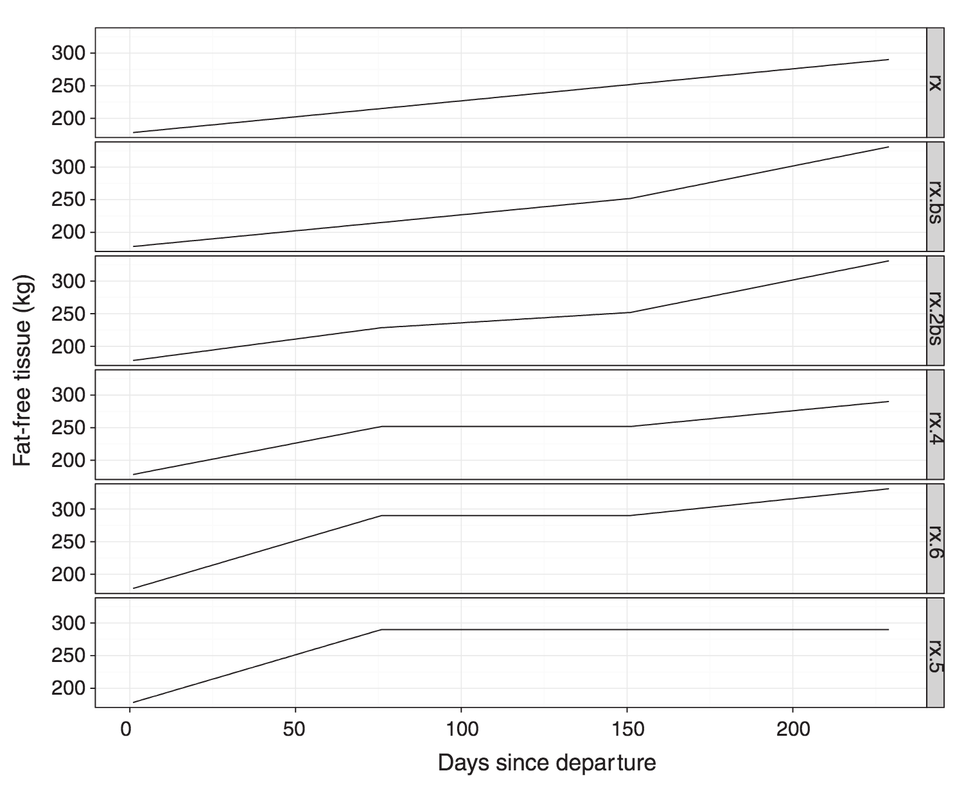
Fig. 3. Six different assumptions we tested for the fixed fat-free tissue time series between the known initial measurement and the known
final measurement. Top panel assumes a constantly linear increase between measurements. Second panel has a higher rate of increase in
the final third of the trip to account for the weight of the pup. Third panel has higher initial gain, then slower, then higher again. Fourth
panel is higher, flat and higher but unlike panels 2 and 3, does not account for the weight of the pup. Panel 5 is like panel 4, but does
account for the weight of the pup. Finally, panel 6 – the assumption we used following model selection – assumes all gain in the first
third of the trip.
Fig. 3. Six different assumptions we tested for the fixed fat-free tissue time series between the known initial measurement and the known
final measurement. Top panel assumes a constantly linear increase between measurements. Second panel has a higher rate of increase in
the final third of the trip to account for the weight of the pup. Third panel has higher initial gain, then slower, then higher again. Fourth
panel is higher, flat and higher but unlike panels 2 and 3, does not account for the weight of the pup. Panel 5 is like panel 4, but does
account for the weight of the pup. Finally, panel 6 – the assumption we used following model selection – assumes all gain in the first
third of the trip.
Figure 3 from Schick et al. 2013. Six different assumptions tested for the fixed fat-free tissue time series between the known initial measurement and the known final measurement. Top panel assumes a constantly linear increase between measurements. Second panel has a higher rate of increase inthe final third of the trip to account for the weight of the pup. Third panel has higher initial gain, then slower, then higher again. Fourth panel is higher, flat and higher but unlike panels 2 and 3, does not account for the weight of the pup. Panel 5 is like panel 4, but does account for the weight of the pup. Finally, panel 6 – the assumption used following model selection – assumes all gain in the first third of the trip. Reprinted with permission from Robert Schick.

Literature Cited

Crocker, D.E., Williams, J.D., Costa, D.P. & Le Boeuf, B.J. 2001. Maternal traits and reproductive effort in northern elephant seals. Ecology, 82, 3541–3555.
Schick, R. S. et al. 2013. Estimating resource acquisition and at-sea body condition of a marine predator. J Anim Ecol 82, 1300–1315.

