Appendix S3. Evidence of increased foraging activity during the month of September.

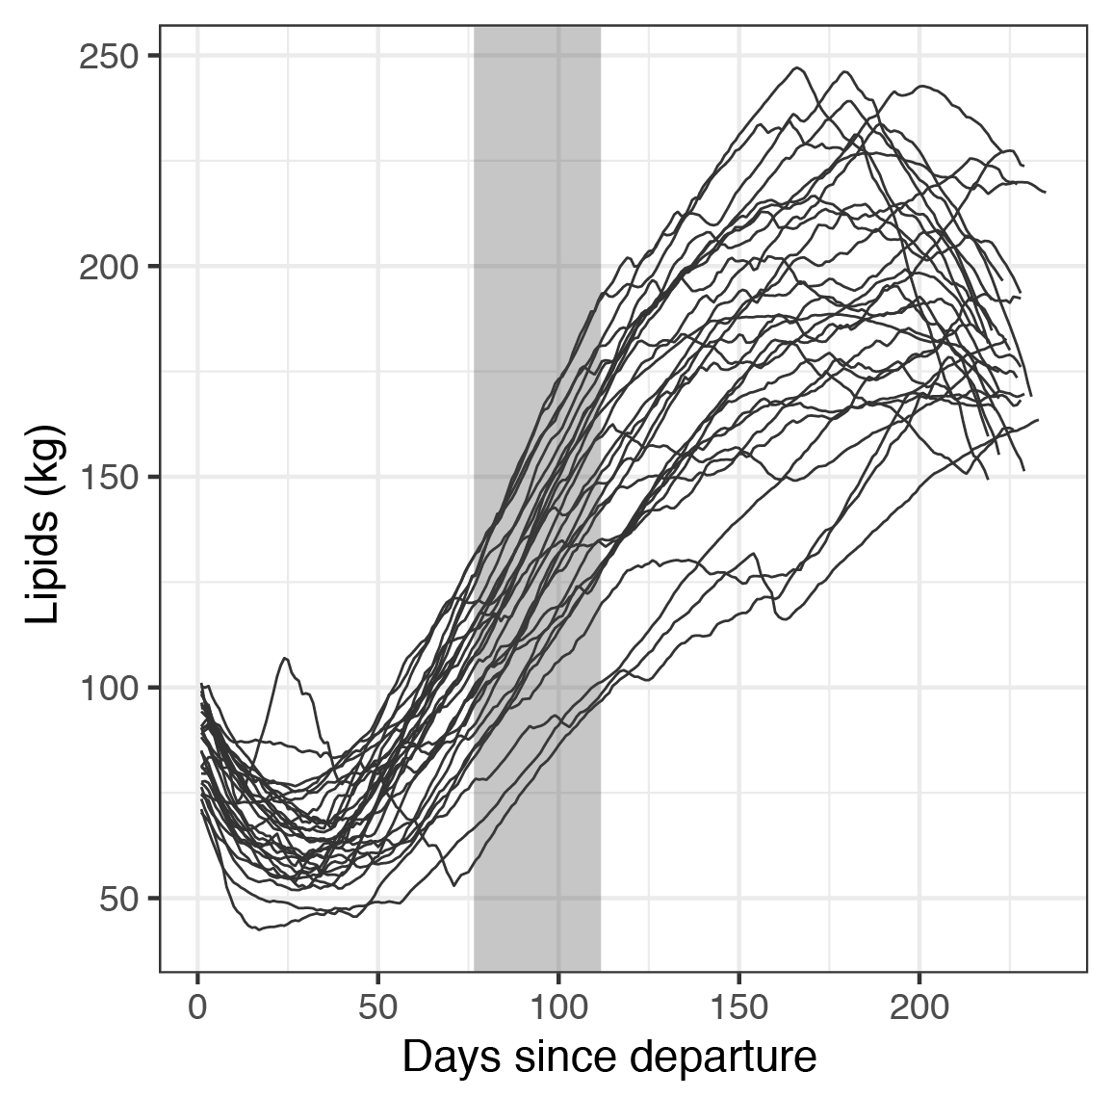

Figure S1. Lipid content over the migration period for 29 seals used in analysis, highlighting rapid lipid gain during September. Days in September are shaded in gray.
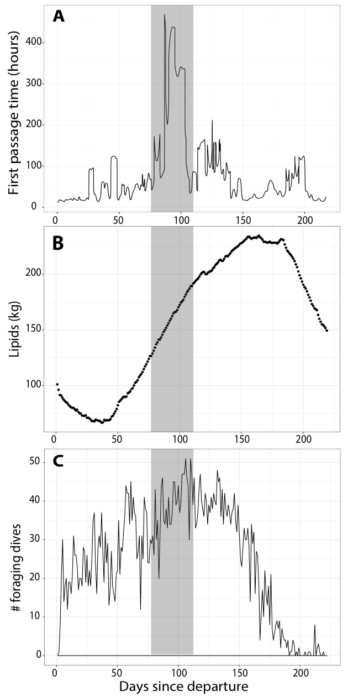

Figure S2. Representative examples from three individuals of increased foraging activity during September along the migration period, as measured by A) First Passage Time, B) daily lipid content, and C) number of foraging dives per day. Days in September are shaded in gray.

