Before platelets: the production of platelet activating factor during growth and stress in a basal marine organism

Ines Galtier d’Auriac, Robert A. Quinn, Heather Maughan, Louis-Felix Nothias, Mark Little, Clifford A. Kapono, Ana Cobian, Brandon T. Reyes, Kevin Green, Steven D. Quistad, Matthieu Leray, Jennifer E. Smith, Pieter C. Dorrestein, Forest Rohwer, Dimitri D. Deheyn, Aaron C. Hartmann

ELECTRONIC SUPPLEMENTARY MATERIAL
Figure S1—S6
Movies S1—S2

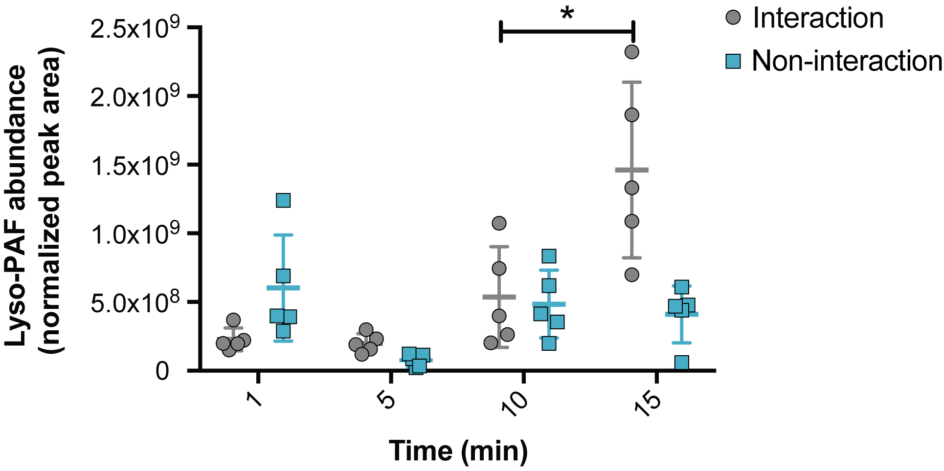

Figure S1. Normalized abundance (mean ± SD) of Lyso-PAF in Pocillopora damicornis after 1, 5, 10 and 15 minutes of interacting with Acropora yongei (grey circles; p < 0.001, one-way ANOVA test, p = 0.02) and when not interacting (teal squares; p = 0.069).

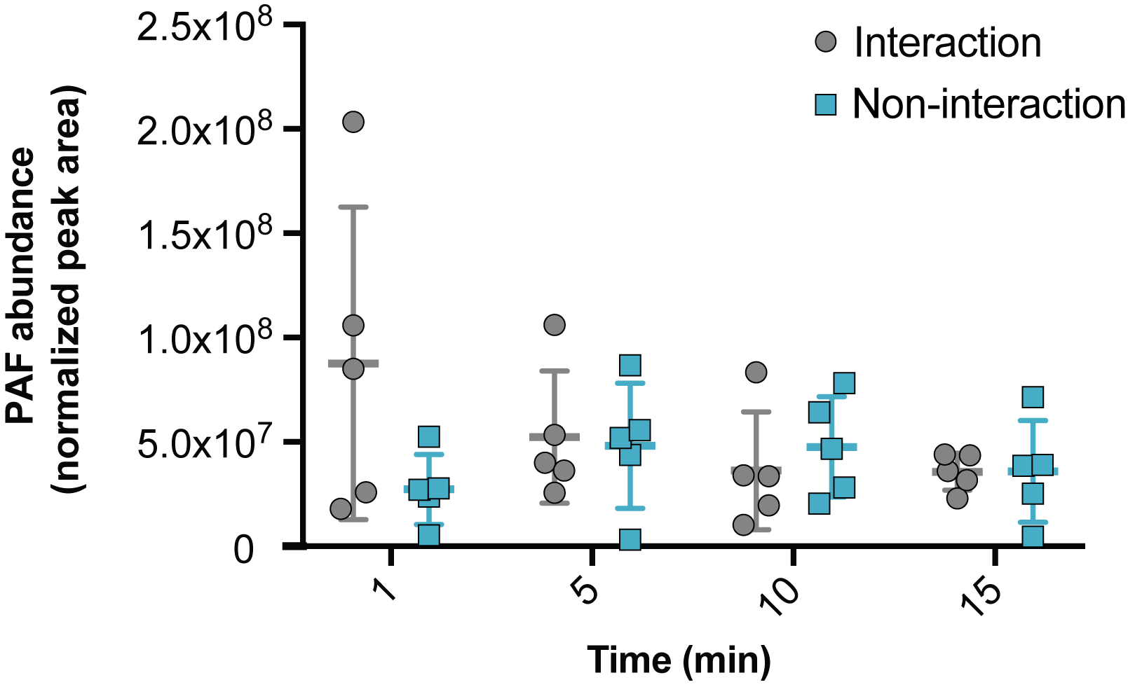

Figure S2. Normalized abundance (mean ± SD) of PAF in Acropora yongei after 1, 5, 10 and 15 minutes of interaction (grey circles) with Pocillopora damicornis (p = 0.2311; one-way ANOVA test) and when not interacting (teal squares) with P. damicornis.

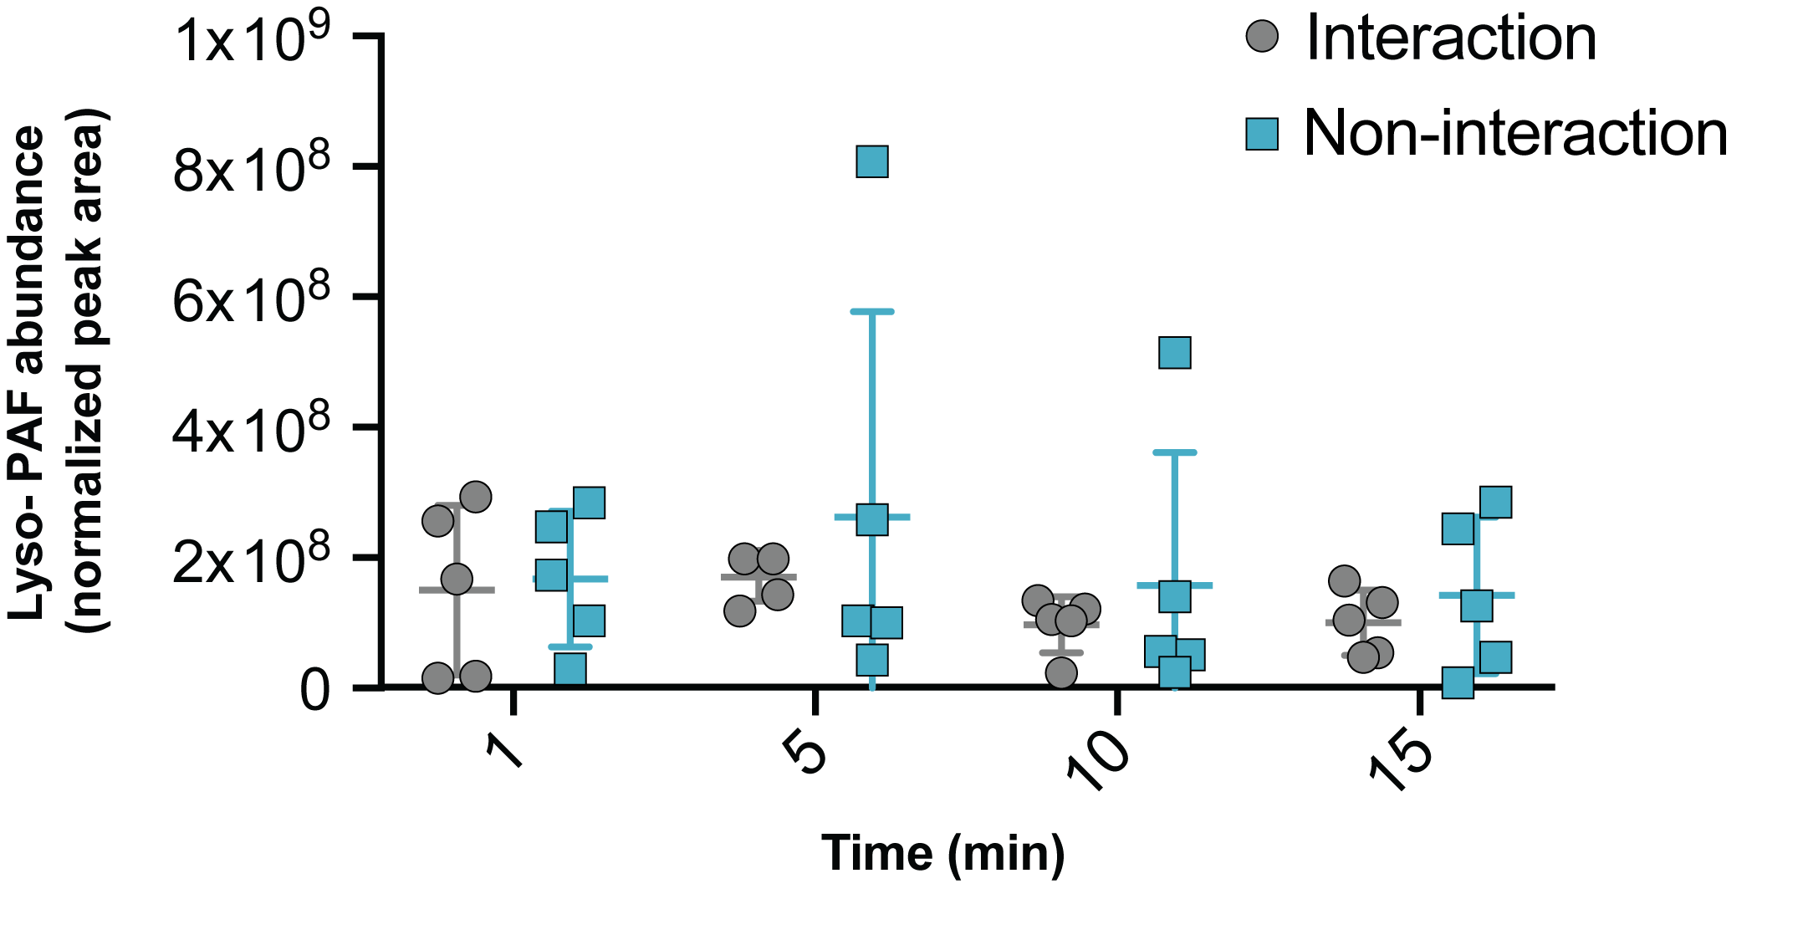

Figure S3. Normalized abundance (mean ± SD) of Lyso-PAF in Acropora yongei after 1, 5, 10 and 15 minutes of interaction (grey circles) with Pocillopora damicornis (p = 0.3535, one-way ANOVA test) and when not interacting (teal squares) with P. damicornis.

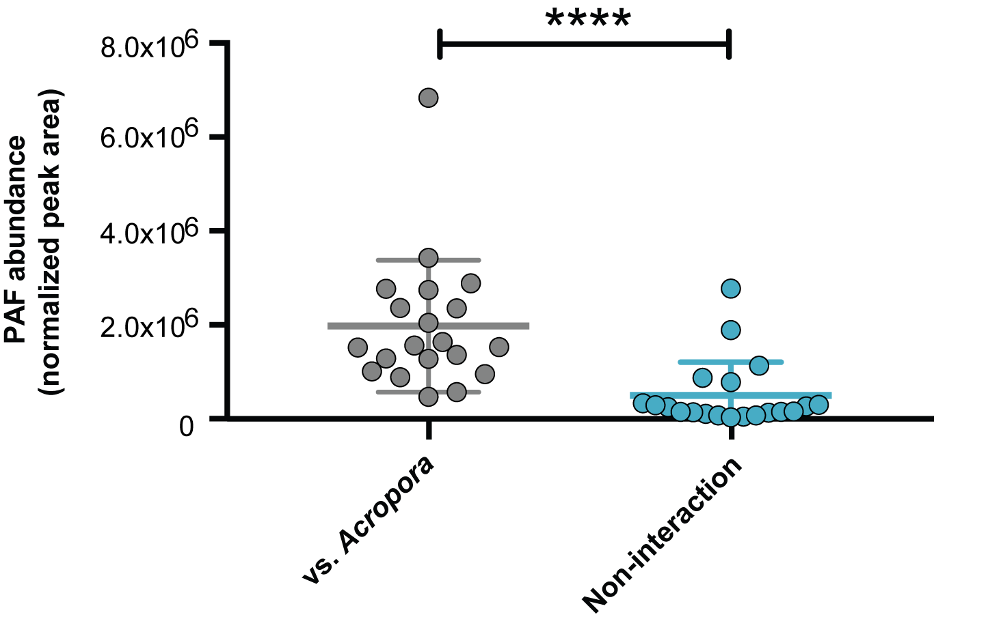

Figure S4. Normalized abundances (mean ± SD) of PAF in Porites porites during interaction (grey circles) with Acropora cervicornis (p < 0.001) and when not interacting (teal circles) with A. cervicornis in Bocas del Toro, Panama (n = 20).

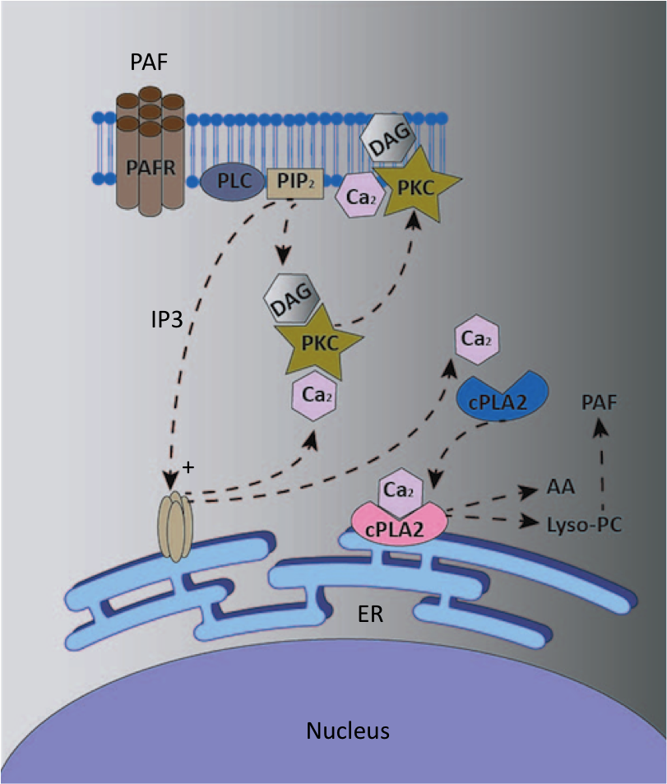

Figure S5. Schematic representation of PAF molecular mode of action. PAF binds to its receptor (PAFR) which activates the breakdown of phosphoinositol biphosphate (PIP2) by phospholipase C (PLC), which then releases inostitol triphosphate (IP3) and diacyl glycerol (DAG). IP3 activates the endoplasmic reticulum (ER) Ca²⁺ pump. DAG and Ca²⁺ activates protein kinase C (PKC) and Ca²⁺ also activates cytosolic phospholipase A2 (cPLA2). cPLA2 catalyzes the biosynthesis of arachidonic acid (AA) and Lyso-PC (precursor of PAF) from ER phosphatidylcholine.
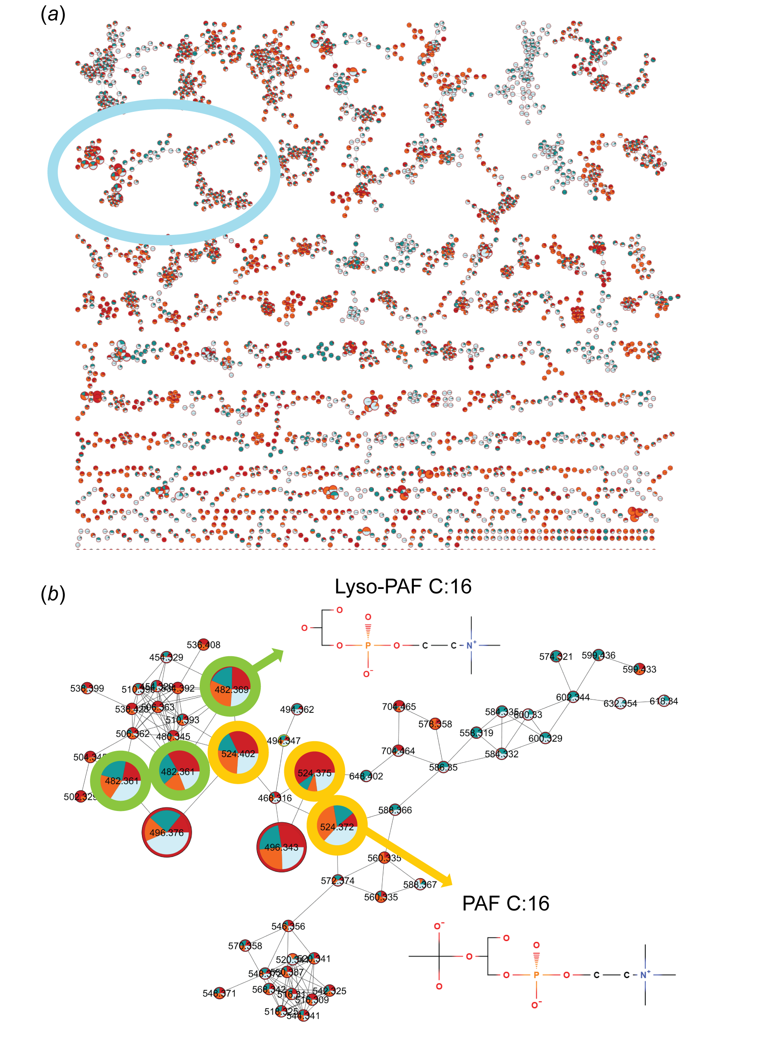
Figure S6. Molecular network from Acropora cervicornis and Porites porites interactions in situ (a) where each node represents a compound connected by a mass translation, red represents A. cervicornis not interacting, orange is A. cervicornis interacting with P. porites, blue is P. porites not interacting and light blue is P. porites interacting with A. cervicornis. (b) Molecular network of PAF and Lyso-PAF from A. cervicornis and P. porites interactions in Panama.
Movie S1. A stop motion video of an Acropora yongei coral colony attacking a Pocillopora damicornis colony, made over 72 hours of interaction, and available at https://www.youtube.com/watch?v=HYD5XJR4CVA. A. yongei senses the neighboring coral and extrudes its mesenteries onto the P. damicornis, resulting in tissue loss in the latter.

Movie S2. A rotating image of a 3D model of Acropora cervicornis coral interacting with Porites porites, including the PAF molecular cartography, available at: https://ili.embl.de/?https://github.com/lfnothias/coral_PAF/raw/master/3D_Mol_Cartography/Coral_PAF_3D_model.stl;https://github.com/lfnothias/coral_PAF/raw/master/3D_Mol_Cartography/Coral_PAF_ili_table.csv;https://github.com/lfnothias/coral_PAF/raw/master/3D_Mol_Cartography/Platelet_Activating_Factor_(PAF)_C-16(ID_%20116).json.

