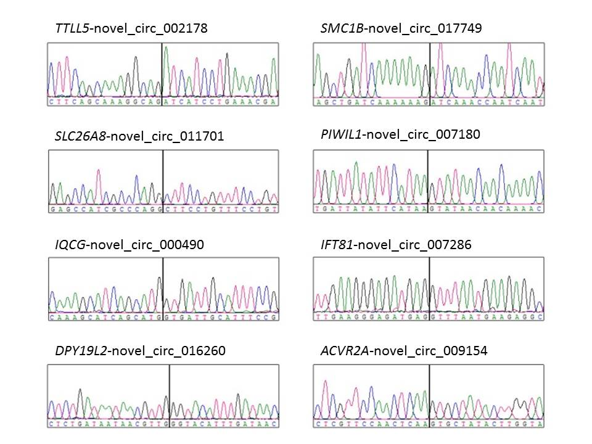
Figure S1 Sanger sequencing map of the validated circRNAs.
Black vertical line: splicing junction.

