ELECTRONIC SUPPLEMENTARY MATERIAL 1

New highly pachyostotic nothosauroid interpreted as a filter-feeding Triassic marine reptile

Carlos de Miguel Chaves¹, Francisco Ortega¹ and Adán Pérez-García¹

¹ Grupo de Biología Evolutiva, Facultad de Ciencias, UNED, Paseo de la Senda del Rey 9, 28040 Madrid, Spain.

1. INTRODUCTION TO EL ATANCE FOSSIL SITE
El Atance fossil site was found in 2008. It is located at the coast of the reservoir the same name, belonging to the Municipality of Sigüenza (Guadalajara Province, Spain). Two excavations were performed at this site, the first in 2008 and the second in 2015.
This fossil site is located in the Castilian Branch of the Iberian Range, in Keuper Facies. The geological information currently available allows us to assert that correspond to the Carnian–Norian interval (Upper Triassic) [1, 2, 3]. The site is composed of a succession of marly, sandy-marly and sandy centimetric to decametric beds, deposited in a shallow marine environment [4].
Thus far, three different taxa have been identified in El Atance, all of which correspond to sauropterygians. In addition to Paludidraco multidentatus gen. et sp. nov., which was tentatively classified as Simosaurus in 2009 [4], a new henodontid placodont found at this fossil site has recently been described, Parahenodus atancensis [5]. Finally, some isolated remains of indeterminate nothosaurians of small size have also been recovered [6].
More detailed information about the geology, age, taphonomy and environment of this fossil site is not currently available. Future research in El Atance will likely provide more information relative to all of these topics.

2. DATA MATRIX
Paludidraco multidentatus gen et sp. nov. was coded in the modified version of the matrix of [7] proposed by [8]. The Chinese Middle Triassic sauropterygians Chinchenia sungi, Kwangsisaurus orientalis and Sanchiaosaurus dengi were excluded following previous proposals [7, 8]. The Italian Late Triassic pistosauroid Bobosaurus forojuliensis was included following [9] and [10]. In addition to the 141 characters from the matrix of [8], an additional character relative to the position of the supraoccipital has been included following the proposal of [10]:
C. 142: Supraoccipital: below the occipital exposure of the parietal (0); sutured with the parietal horizontally (1).
Two new characters have also been added in the data matrix, relative to the zygapophyseal articulations of the vertebrae and the presence of an anterior process of the clavicle:
C. 143: Infraprezygapophyses and infrapostzygapophyses in dorsal to anterior caudal vertebrae: absent (0); present, the prezygapophyses and the infraprezygapophyses conforming a wedge-like structure (1); present, the postzygapophyses and infrapostzygapophyses conforming a wedge-like structure (2).
C. 144: Anterolateral process of the clavicle: absent (0); present, located medially (1); present, located laterally in continuation with the clavicular corner (2).
Finally, the character 64 from [7] has been redefined here:
C. 64: Number of premaxillary teeth: between four and fifteen (0); three or less (1); more than fifteen (2).

3. CODIFICATION OF PALUDIDRACO MULTIDENTATUS
02001 ??0?? 20001 ?1100 0?101 11020 2000? ?100? 01211 ?21?0 02001 1?101 01021 01211 00011 ????0 0011? ?1?00 0??10 111?? ?1010 2?1?? 1011? ????? ????1 12??? ????? ??003 0111

4. RECODINGS OF CHARACTERS OF SIMOSAURUS GAILLARDOTI
C. 16: Distinct posterolateral processes of frontal(s): absent (0); present (1). Recoded from 0 to 0&1, due to some skulls of Simosaurus gaillardoti (e.g. SMNS 18520) present these processes.
C. 17: Frontal: widely separated from upper temporal fossa (0); narrowly approaching upper temporal fossa (1); entering the anteromedial margin of upper temporal fossa (2). Recoded from 0 to 0&1, considering that the frontal of some specimens of S. gaillardoti (e.g. SMNS 18520) approaches the upper temporal fossa.
C. 42: Occipital crest: absent (0); present but squamosals not meeting behind parietal (1); present and squamosals meeting behind parietal (2). Recoded from 0 to 0&1, due to some skulls of S. gaillardoti present a small occipital crest (e.g. SMNS 16767).

5. DISCUSSION OF THE PHYLOGENETIC RESULTS
The resulting consensus tree shows Paludidraco multidentatus as being a member of Nothosauroidea, a clade here characterised by: bones in dermatocranium distinctly sculptured (character 1; state 0), constricted parietal skull table (character 23; states 1, 2 and 3), upper temporal fossa distinctly larger than the orbit (character 29; state 2), splenial bone excluded from the mandibular symphysis (character 56; state 1), presence of a lateral ridge of the surangular defining the insertion area for superficial adductor muscles (character 58; state 1), maxillary tooth row extending backwards from a level below the posterior corner of orbit to one half of upper temporal fossa (character 68; states 1 and 2), and three carpal ossifications (character 119; state 1). It should be noted that the total number of carpal ossifications is not known in P. multidentatus.
The results of the phylogenetic analysis show that Simosaurus gaillardoti and P. multidentatus are sister taxa within Nothosauroidea. They constitute the clade Simosauridae, characterised by the following synapomorphies: mandibular articulations displaced to a level distinctly behind occipital condyle (character 44; state 1); vertebral centra distinctly constricted in ventral view (character 72; state 0); distinct expansion of distal head of sacral ribs (character 89; state 0); infraprezygapophyses and infrapostzygapophyses at least in dorsal, sacral and most anterior caudal vertebrae (character 143; state 1); and anterolateral process of the clavicle (character 144; state 1). Simosaurus gaillardoti is here characterised by the following autapomorphies: supraoccipital exposed more or less vertically on occiput (character 45; state 0), absence of zygapophyseal pachyostosis (character 75; state 0), and absence of pachyostosis of dorsal ribs (character 87; state 0). The autapomorphies of P. multidentatus within Simosauridae as given by the results of the phylogenetic analysis are: teeth superficially attached to the bone (character 62; state 1), and more than 15 premaxillary teeth (character 64; state 2).

6. DIAGNOSIS OF SIMOSAURUS GAILLARDOTI
Sauropterygia Owen, 1860
Eosauropterygia Rieppel, 1994
Nothosauroidea Baur, 1889
Simosauridae Huene, 1948
Simosaurus gaillardoti Meyer, 1842

Synonyms. Simosaurus guilielmi Meyer, 1847-1855; Simosaurus guilielmi var. angusticeps Huene, 1959.
Neotype. MNHN AC.9028, an almost complete skull.
Type locality and type horizon. Réhainvillers (Lunéville, France). Upper Muschelkalk, Ladinian (Middle Triassic) [11].
Distribution. Ladinian of France and Germany [12].
Emended diagnosis. Simosauridae with the following autapomorphies according to the results of the phylogenetic analysis: supraoccipital exposed more or less vertically on occiput; absence of zygapophyseal pachyostosis; and absence of pachyostosis of dorsal ribs. In addition, it differs from Paludidraco multidentatus by the following unique characters within Simosauridae: relatively short snout; external nares not retracted; wide and oval upper temporal fenestra; oval pineal foramen, weakly displaced posteriorly; supraoccipital located below the occipital parietal exposure; relatively robust jaw; splenial located in the lingual surface of the jaw; teeth located dorsally in the jaw; big, conical and blunt teeth, settled in deep sockets (thecodont implantation); five premaxillary teeth; platycoelous centra; absence of a marked distal expansion of the dorsal ribs. In addition, a distinct lateral process of the squamosals is considered as an autapomorphy of S. gaillardoti, but due to preservation, this character is not known in P. multidentatus.

7. ANATOMICAL COMPARISON BETWEEN PALUDIDRACO MULTIDENTATUS AND SIMOSAURUS GAILLARDOTI
According to [12], the estimated size for Simosaurus gaillardoti is 3-4 meters in length. The preservation of any of the specimens of S. gaillardoti does not allow a more precise size estimation, due to the lacking of most of the cervical and caudal series. The skulls of P. multidentatus (Fig. 2, Fig. S1) present a range of size compatible with the specimens described by [12]. Therefore, the two known taxa of the clade Simosauridae are eosauropterygians of medium-to-large size.
Paludidraco multidentatus and Simosaurus gaillardoti share several characters traditionally considered as exclusive of the latter. Within the clade Nothosauroidea, both taxa present skulls with large upper temporal fossae, relatively short and blunt snouts, and, contrary to the nothosaurs, they lack rostral constriction. The preorbital region is not well preserved in both MUPA-ATZ0101 and MUPA-ATZ0102. However some sutures on this area can be seen, and allow for identification of the dorsal exposure of the prefrontals as unreduced, as in S. gaillardoti but contrasting with the members of Nothosauria. The postero-lateral region of the frontals of P. multidentatus are close to the upper temporal fossae, but do not reach them. A relatively wide distance is present between the frontals and these fossae in most specimens of S. gaillardoti, but specimens showing a closeness between these structures are also identified. Therefore, the condition identified in P. multidentatus is compatible with the intraspecific variability range known for for S. gaillardoti. The jugals reach the anterolateral margins of the orbits in both S. gaillardoti and P. multidentatus, in contrast with the condition of the nothosaurs. Paludidraco multidentatus, as well as S. gaillardoti and many other Triassic sauropterygians, presents a relatively high temporal region of the skull, differing from the condition in the nothosaurs, with a strongly depressed temporal region. Paludidraco multidentatus presents an occipital crest, as in some specimens of S. gaillardoti.
The mandibular articulation of P. multidentatus is located in a level distinctly behind occipital condyle, as in S. gaillardoti. In contrast with the nothosaurs, both P. multidentatus and S. gaillardoti lack premaxillary and dentary fangs, as well as enlarged teeth on the maxilla.
Whereas the Nothosauria present vertebral centra with parallel edges in ventral view [13], S. gaillardoti and P. multidentatus present a lateral constriction of the vertebral centra in that view. In addition, the neural arches of P. multidentatus present additional articulations known as infraprezygapophyses and infrapostzygapophyses in dorsal, sacral and, at least, most anterior caudal vertebrae. This character had until now been deemed autapomorphic for S. gaillardoti [12, 13].
Another character hence far considered exclusive to S. gaillardoti - the presence of a small anterolateral process of the clavicle [12, 13] - is also shared with P. multidentatus.
Finally, another character shared by S. gaillardoti and P. multidentatus but not by the members of Nothosauria is the presence of an expanded distal head of the sacral ribs.
In spite of the numerous characters shared by S. gaillardoti and P. multidentatus, other characters enable us to establish some differences between the taxa. The recovered skulls of P. multidentatus seem more dorsoventrally compressed than those of S. gaillardoti, but given the taphonomical deformation of MUPA-ATZ0101 and MUPA-ATZ0102 we cannot assert with certainty the degree to which the skull of this new eosauropterygian is flattened. Paludidraco multidentatus presents a relatively long rostrum, elongated in comparison with that of S. gaillardoti. The form and size of the external nares of P. multidentatus are not know due to the poor preservation of that area, but they are identified as located more posteriorly than in S. gaillardoti. In this sense, the internal nares of P. multidentatus also seem to be more posteriorly located than those of S. gaillardoti. Whereas the upper temporal fenestrae of S. gaillardoti are oval, those of P. multidentatus are slightly stout, being posteriorly narrow. In the same way, the pineal foramen of P. multidentatus is narrow and elongated, being located close to the middle region of the parietal table, contrary to the small and oval pineal foramen of S. gaillardoti, weakly posteriorly displaced in the parietal skull table. Simosaurus gaillardoti and P. multidentatus also differ in the position of the supraoccipital. The new taxon described here presents a supraoccipital exposed horizontally at the end of the parietal skull table, sutured with the parietal horizontally, as in the nothosaurs. The supraoccipital of S. gaillardoti is vertically exposed, located below the occipital exposure of the parietal.
One of the most remarkable characteristics of P. multidentatus is its mandibular morphology. In contrast to the mandibles of S. gaillardoti and all the other sauropterygians, the jaws of P. multidentatus are very slender and fragile, and both mandibular rami are bowed. The symphysis is less reinforced than that in S. gaillardoti. The anterior half of the jaws are rotated laterally outwards, the splenials being located dorsally to the dentaries instead of medially.
The teeth of P. multidentatus are superficially set to the bone, and supported on the dentaries (in the lower jaws) and on the premaxillae and maxillae (on the upper jaws), being implanted in a pleurodont way, and oriented outwards. This dental configuration is different from that of all the other members of Sauropterygia (including Simosaurus), where the implantation is thecodont, with the teeth set in individual sockets [14]. The teeth of P. multidentatus are small and sickle-like, and very compressed (mediolaterally in the most anterior teeth and anteroposteriorly in the other), being flat in section. However, the teeth of S. gaillardoti are markedly bigger, conical and blunt, with only the most anterior ones being oriented outwards, whereas others are oriented vertically. The recurved teeth of P. multidentatus are very numerous, with 15 dental alveoli in the preserved portion of the premaxilla, and a minimum of 20 premaxillary teeth being estimated. Simosaurus gaillardoti, however, presents a much smaller number of teeth, with only five premaxillary ones, as is typical of most sauropterygians.
The postcranial skeleton of P. multidentatus is similar to that of S. gaillardoti, but its axial elements are extremely pachyostotic. The vertebrae of P. multidentatus present robust and highly ossified zygapophyses, as well as thick neural spines. In addition, the dorsal ribs are very pachyostotic, and the distal areas are strongly expanded mediolaterally. The vertebrae and ribs of S. gaillardoti are not pachyostotoic, and the distal expansion of the dorsal ribs is much smaller. Although some ribs assigned to the genus Simosaurus present expanded distal areas [15], they are not as wide and pachyostotic as those of Paludidraco multidentatus. The transverse processes of P. multidentatus lack the ventral notch present in those of S. gaillardoti. The centra of P. multidentatus are amphicoelous whereas those from S. gaillardoti are platycoelous or very weakly amphicoelous. It should be noted that some vertebrae attributed to Simosaurus sp. present centra more amphicoelous than those of S. gaillardoti, and their transverse processes lack the ventral notch present in this species [15, 16, 17]. These remains also lack the pachyostosis that characterises the vertebrae of P. multidentatus, and therefore cannot be attributed to either this taxon or to S. gaillardoti.
The scarce appendicular elements recovered from P. multidentatus also seem slightly more robust and pachyostotic than those of S. gaillardoti, but more detailed studies are required.
Finally, S. gaillardoti presents a distinct lateral process in the squamosals, a character that has been considered as unique to this taxon [12]. Due to this region is broken in the two preserved skulls of P. multidentatus, we cannot assert if this character represents an autapomorphy of S. gaillardoti or a synapomorphy of the clade Simosauridae.

7. SUPPLEMENTARY FIGURES

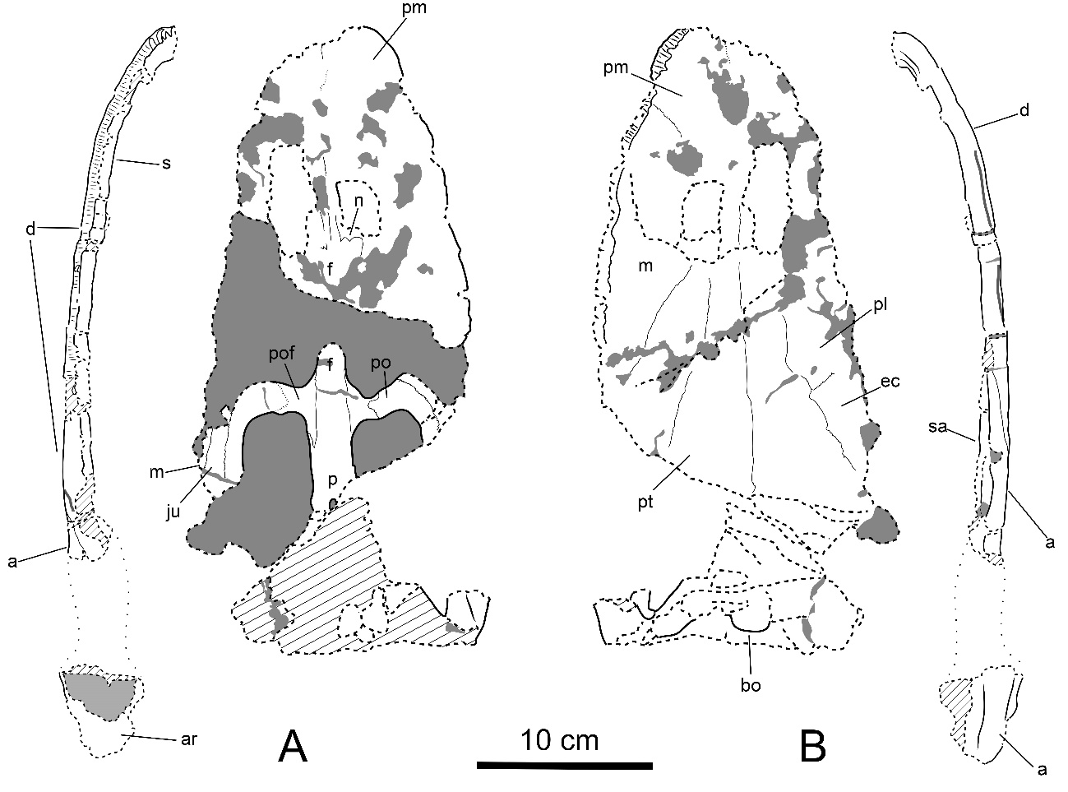
Figure S1. Schematic interpretation of the paratype (MUPA-ATZ0102) of Paludidraco multidentatus. A, skull and mandible of MUPA-ATZ0102 in dorsal view. B, skull and mandible of MUPA-ATZ0102 in ventral view. Anatomical abbreviations: a, angular; ar, articular; bo, basioccipital; d, dentary; ec, ectopterygoid ; f, frontal; ju, jugal; m, maxilla; n, nasal; p, parietal; pl, palatine; pm, premaxilla; po, postorbital; pof, postfrontal; pt, pterigoyd; s, splenial; sa, surangular. Dashed lines indicate broken margins of bone, diagonal lines indicate altered surface of bone, and pointed lines indicate hypothetical contours of the bones.

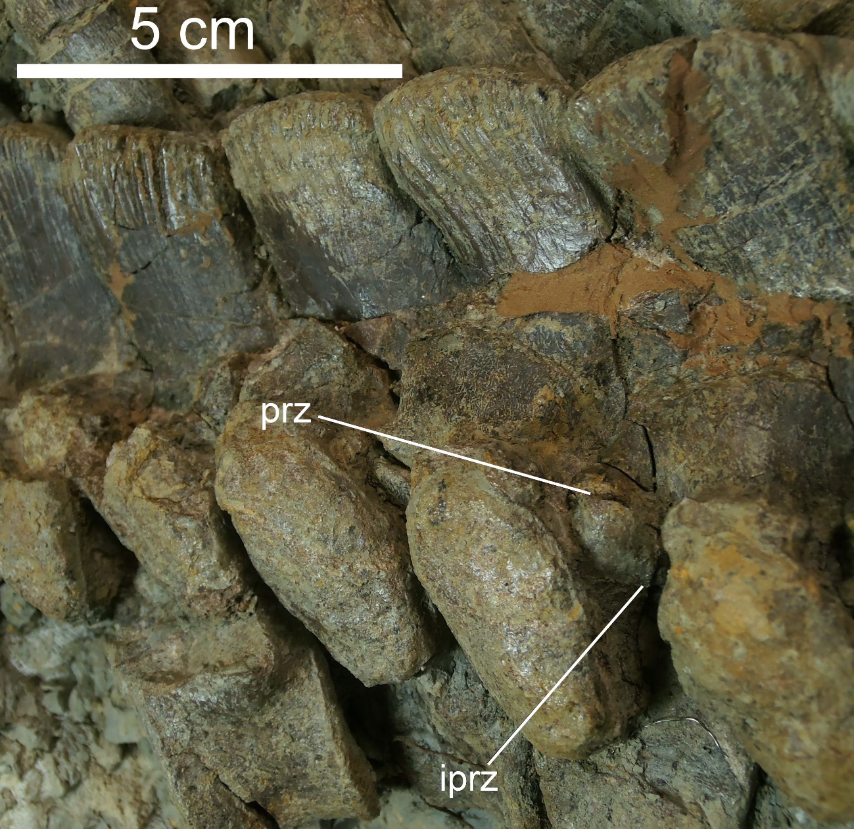
Figure S2. Detail of some dorsal vertebrae of the holotype of Paludidraco multidentatus (MUPA-ATZ0101). The neural spine, the transverse processes and the zygapophyses are pachyostotic. These vertebrae present infraprezygapophyses, a character previously considered as exclusive for S. gaillardoti. The transverse processes lack the ventral notch present in Simosaurus gaillardoti. The centra are amphicoelus and laterally constricted. Anatomical abbreviations: iprz, infraprezygapophysis; prz, prezygapophysis.

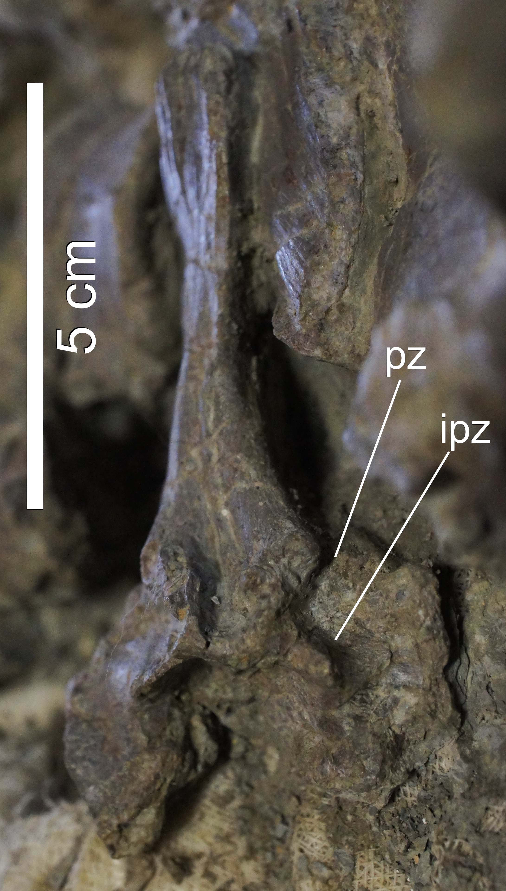
Figure S3. Detail of an anterior caudal vertebra of the holotype of Paludidraco multidentatus (MUPA-ATZ0101), in posterior view. It presents infrapostzygapophyses, a character previously considered as exclusive for Simosaurus gaillardoti. Anatomical abbreviations: ipz, infrapostzygapophysis; pz, postzygapophysis.
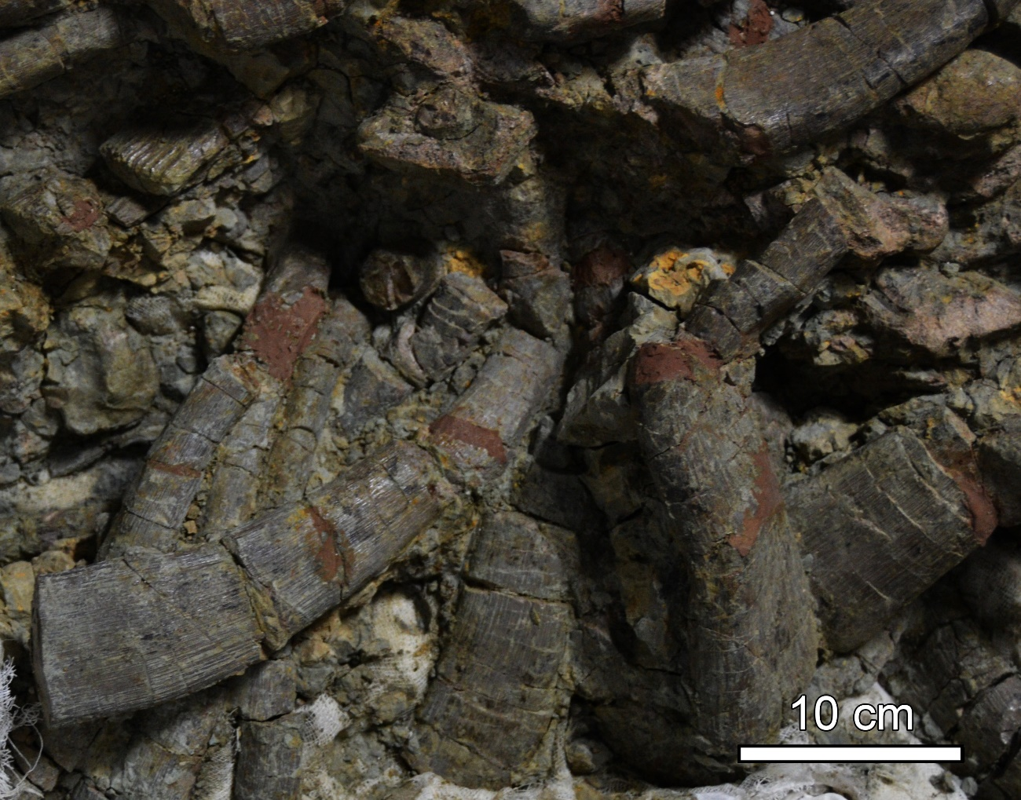
Figure S4. Detail of the dorsal ribs of the holotype of Paludidraco multidentatus (MUPA-ATZ0101). These elements are highly robust, and present an expanded and thickened distal end. These characters are not shared with Simosaurus gaillardoti.

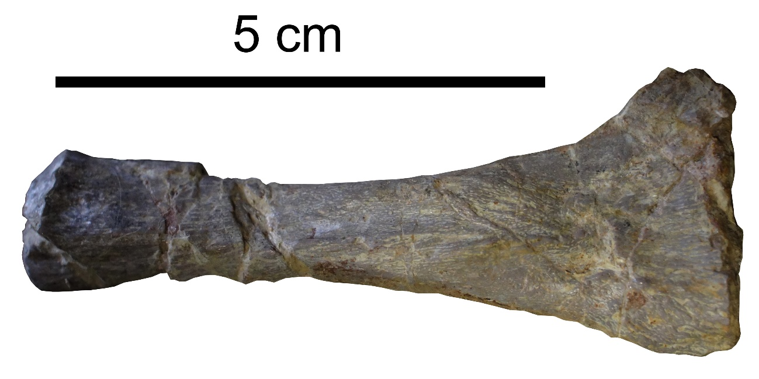
Figure S5. Detail of a sacral rib of the holotype of Paludidraco multidentatus (MUPA-ATZ0101). It presents an expanded distal end, just like Simosaurus gaillardoti and opposite to the members of Nothosauria.

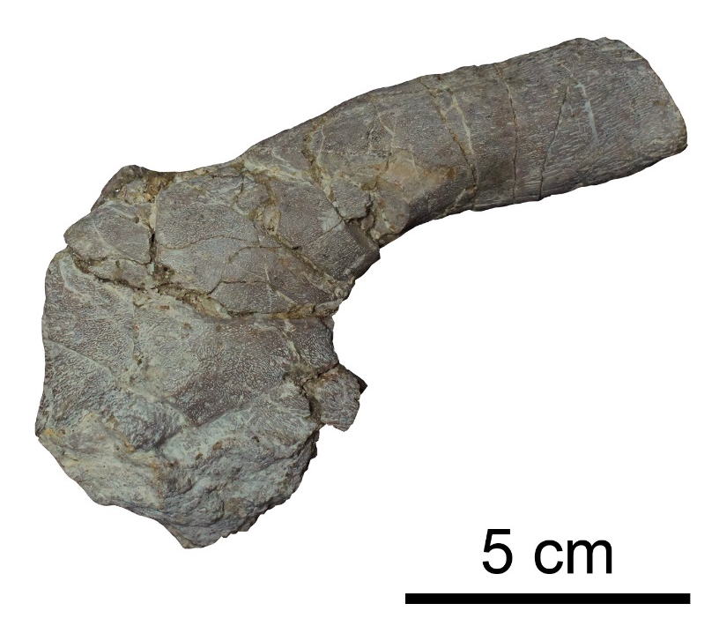
Figure S6. Partial left scapula of the holotype of Paludidraco multidentatus (MUPA-ATZ0101), in lateral view. It shares with most eosauropterygians the presence of both a dorsal scapular blade and a ventral glenoid area. Most of the glenoid area is lost in this specimen.
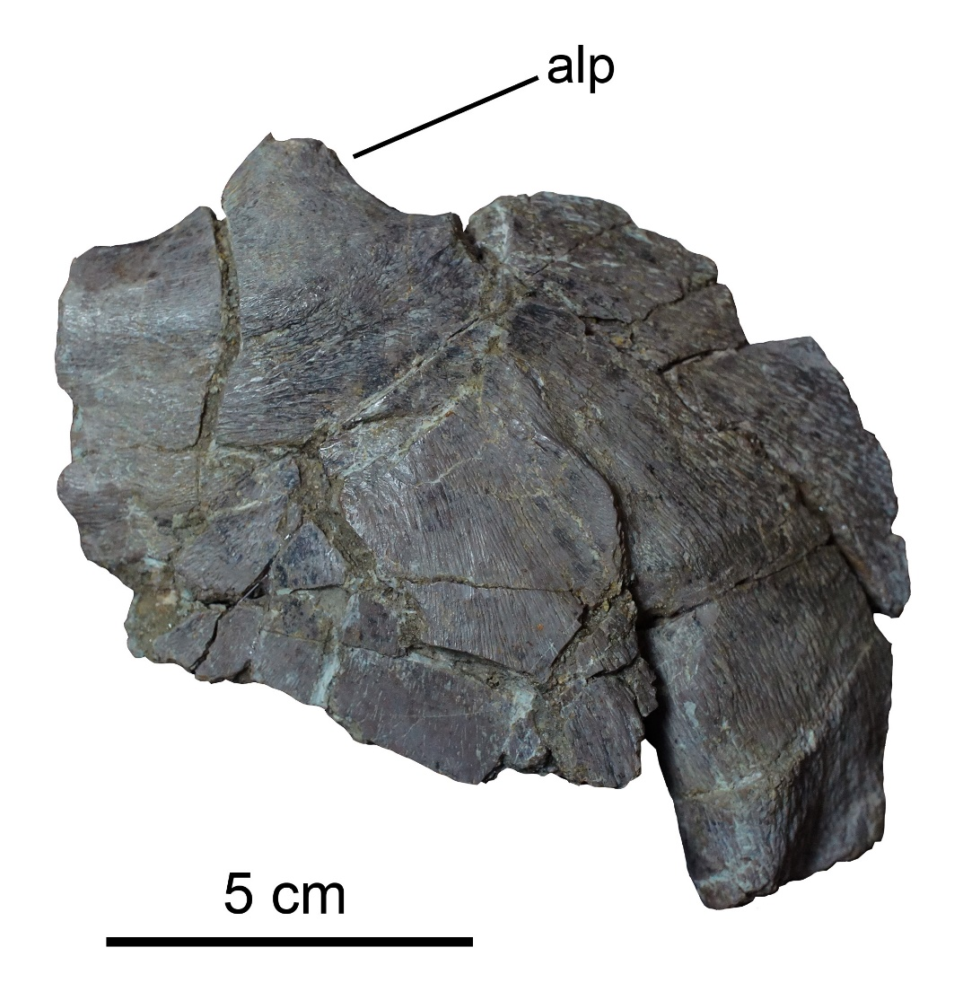
Figure S7. Partial left clavicle of the holotype of Paludidraco multidentatus (MUPA-ATZ0101), in ventral view. It presents an expanded “clavicular corner”, which is an exclusive character of Eosauropterygia. It also presents an anterolateral process, a character previously considered as exclusive for Simosaurus gaillardoti. Anatomical abbreviations: alp, anterolateral process.

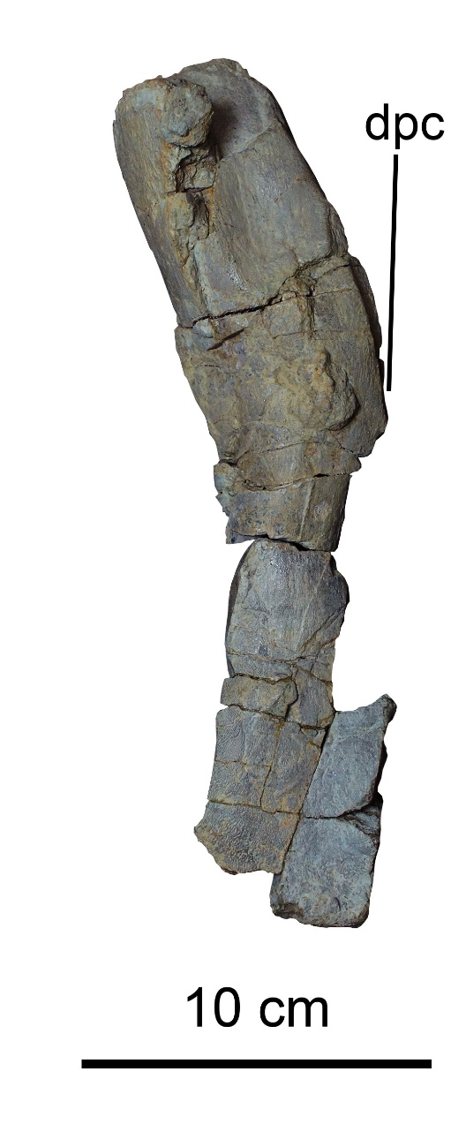
Figure S8. Right humerus of the holotype of Paludidraco multidentatus (MUPA-ATZ0101), in dorsal view. It is curved, with a massive proximal head, a constricted diaphysis and an expanded and flattened distal end. This character combination is shared with the humerus of other eosauropterygians. It presents a well-developed deltopectoral crest. This bone is slightly more robust than that of Simosaurus gaillardoti. Anatomical abbreviations: dpc, deltopectoral crest.

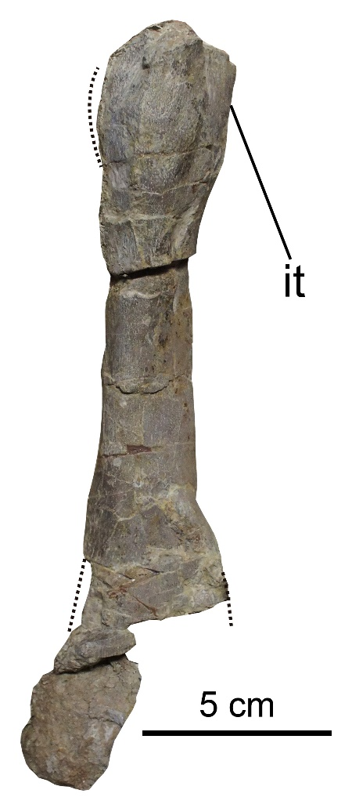
Figure S9. Partial left femur of the holotype of Paludidraco multidentatus (MUPA-ATZ0101), in lateral view. It is slightly sigmoidal, with a massive proximal head and an internal trochanter not set-off of the articular head, as in other eosauropterygians. It is slightly more robust than the femur of Simosaurus gaillardoti. Anatomical abbreviations: it, internal trochanter. Dotted lines indicate hypothetical contours of the bones.

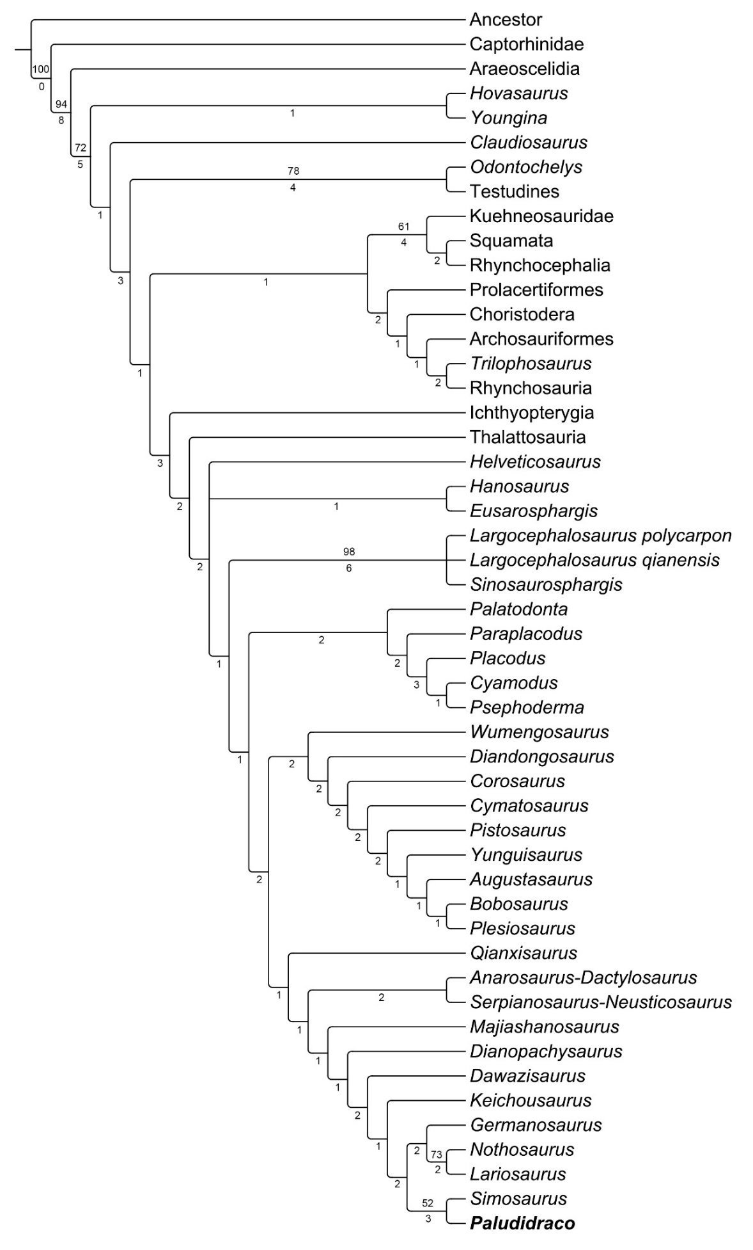
Figure S10. Strict consensus tree based on the data matrix modified from [2]. Bootstrap frequencies that exceed 50 per cent (top) and Bremer support values (bottom) are indicated here.
8. REFERENCES
1. Adell Argiles F, Bascones Alvira L, Martínez Álvarez F, Tena-Dávila Ruiz M, González Lodeiro F, La Moneda González E, Rodríguez González A. 1981 Hoja geológica num. 461 (Sigüenza). Mapa Geológico de España E. 1:50000. Segunda serie, I.G.M.E., Madrid.
2. Liesa CL, Simón JL. 2009. Evolution of intraplate stress fields under multiple remote compressions: The case of the Iberian Chain (NE Spain). Tectonophysics 474(1), 144–159. (doi:10.1016/j.tecto.2009.02.002).
3. Pueyo EL, Izquierdo-Llavall E, Rodríguez Pintó A, Rey-Moral C, Oliva-Urcia B, Casas AM, Calvín P, Ayala C, Ramajo J, Del Rio P, Rubio FM, García-Lobón JL. 2016. Petrophysical properties in the Iberian Range and surrounding areas (NE Spain): 1-density. J. Maps 12(5), 836–844. (doi:10.1080/17445647.2015.1084545).
4. Quesada J, Pérez-García A, Ortega F, Escaso F, Sánchez-Chillón B. 2009. Simosaurus (Nothosauria) fossil site: a new Spanish window to the Upper Triassic. J. Vertebr. Paleontol. 29(3), 168A.
5. Miguel Chaves C de, Ortega F, Pérez-García A. 2018 A new placodont from the Upper Triassic of Spain provides new insights on the acquisition of the specialized skull of Henodontidae. Pap. Palaeontol. (doi: 10.1002/spp2.1218).
6. Miguel Chaves C de, Pérez-García A, Quesada J, Ortega F. 2015. Restos de notosaurios (Sauropterygia, Nothosauria) del yacimiento del Triásico Superior de El Atance (Guadalajara, España). In Current trends in paleontology and evolution. XIII EJIP Conference Proceedings (ed L Domingo, MS Domingo, O Fesharaki, B García Yelo, AR Gómez Cano, V Hernández-Ballarín, D Hontecillas, JL Cantalapiedra, P López Guerrero, A Oliver, J Pelegrín, M Pérez de los Ríos, M Ríos, O Sanisidro, A Valenciano), pp. 80–81.
7. Neenan JM, Klein N, Scheyer TM. 2013 European origin of placodont marine reptiles and the evolution of crushing dentition in Placodontia. Nat. Commun. 4: 1621. (doi:10.1038/ncomms2633).
8. Cheng Y, Wu X, Sato T, Shan H. 2016 Dawazisaurus brevis, a new eosauropterygian from the Middle Triassic of Yunnan, China. Acta Geol. Sin.-Engl. 90(2), 401–424. (doi:10.1111/1755-6724.12680).
9. Fabbri M, Dalla Vecchia FM, Cau A. 2013 New information on Bobosaurus forojuliensis (Reptilia: Sauropterygia): implications for plesiosaurian evolution. Hist. Biol. 26, 661–669. (doi: http://dx.doi.org/10.1080/08912963.2013.826657).
10. Ma L-T, Jiang D-Y, Rieppel O, Motani R, Tintori A. 2015 A new pistosauroid (Reptilia, Sauropterygia) from the late Ladinian Xingyi marine reptile level, southwestern China. J. Vertebr. Paleontol. 35(1), 1–6. (doi:10.1080/02724634.2014.881832).
11. Hagdorn H, Rieppel O. 1999 Stratigraphy of marine reptiles in the Triassic of central Europe. Zbl. Geo. Pal. I, 651-678.
12. Rieppel O. 1994 Osteology of Simosaurus gaillardoti and the relationships of stem–group Sauropterygia. Fieldiana Geology 28, pp. 85.
13. Rieppel O. 2000 Part 12A. Sauropterygia I. In Handbuch der Paläoherpetologie (ed P Wellnhofer), pp. 1–134. Verlag Friedrich Pfeil, München.
14. Rieppel O. 2001 Tooth implantation and replacement in Sauropterygia. Palaont. Z. 75(2), 207-217.
15. Rieppel O. 1996 The status of the sauropterygian reptile Partanosaurus zitteli Skuphos from the Middle Triassic of the Austrian Alps, with comments on Microleptosaurus schlosseri Skuphos. Palaont. Z. 70, 567–577.
16. Dalla Vecchia FM. 2008 First record of Simosaurus (Sauropterygia, Nothosauroidea) from the Carnian (Late Triassic) of Italy. Riv. Ital. Paleontol. Stratigrafia 114, 273–285.
17. Miguel Chaves C de, Pérez-García A, Cobos A, Royo-Torres R, Ortega F, Alcalá L. 2015 A diverse Late Triassic tetrapod fauna from Manzanera (Teruel, Spain). Geobios 48, 479–490. (doi:10.1016/j.geobios.2015.09.002).

