Electronic supplementary material

Figure S1 Pairwise correlations among trophic groups. Considering the potential influence of the difference on the areas of geographic units, we used species density, which was calculated as species richness divided by log-transformed geographic area. Pearson's product moment correlation coefficients and the significance of P values are shown in the upper panel, while locally-weighted polynomial regression (LOWESS) lines are drawn in red in the lower panel. Significant levels: *** < 0.001, ** < 0.01, and * < 0.05.

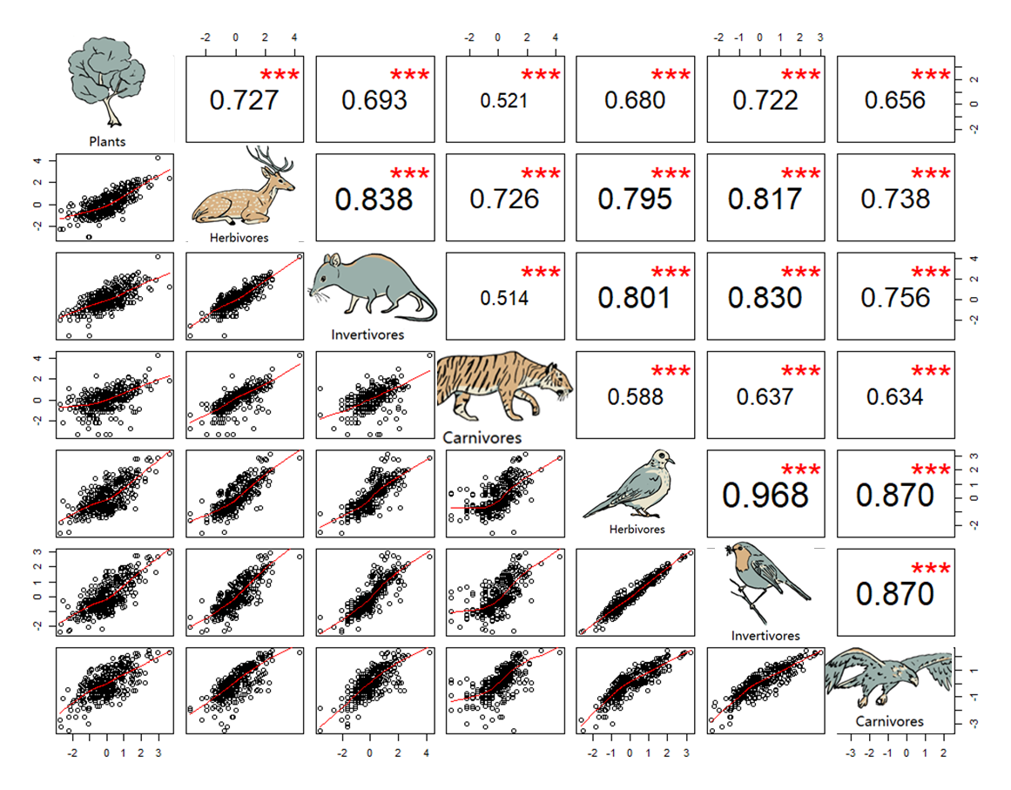

Figure S2 Pairwise correlations among selected environmental variables. Other explanations are as in Figure S1.

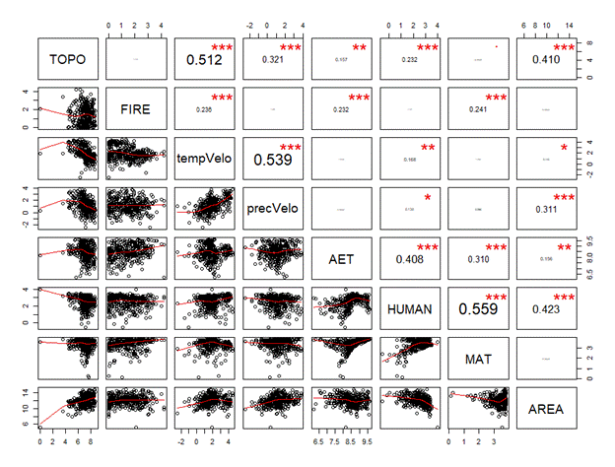

Figure S3 Global-scale non-recursive SEM results for mammals and birds after excluding the oceanic island regions. Other explanations are as in Figure 3.
(a) Mammals (b) Birds
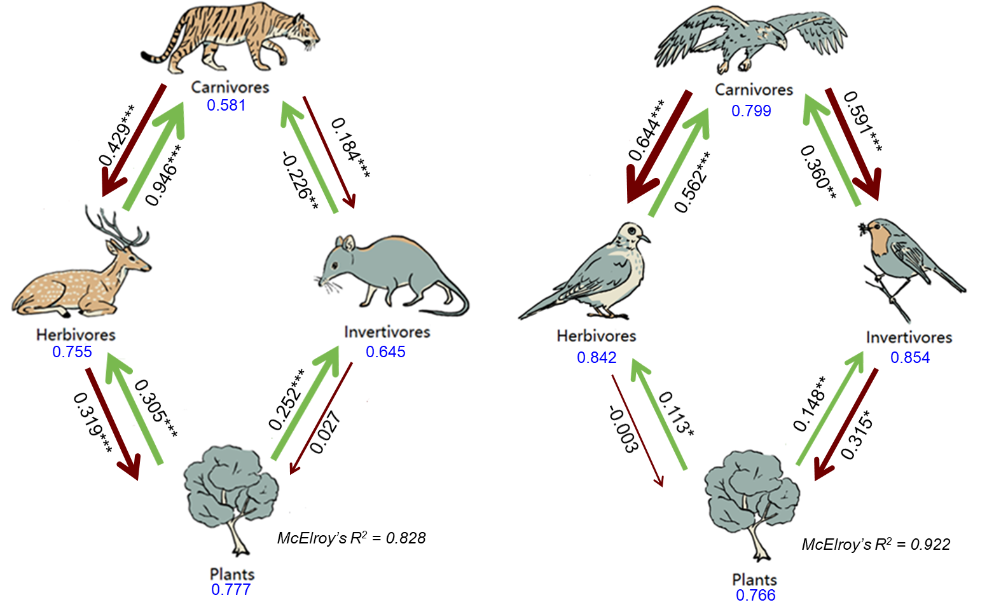

Figure S4 Direct effects of trophic interactions among plants, mammals and birds across six biogeographic realms. Other explanations are as in Figure 4.

