Supplementary Information for: Artificial Light at Night decreases metamorphic duration and increases juvenile growth in a widespread amphibian
Authors: Kacey L. Dananay and Michael F. Benard
Supplementary Tables:
Table 1: Repeated measures analysis of relative algal biomass.
Explanatory | Num | Den | Periphyton |  | Phytoplankton
Variable | df | df | F value | p value | F value | p value
Between Subject Tests:  Light Treatment | 1 | 32 | 7.43 | 0.01 | 0.032 | 0.9
Colonization Treatment | 1 | 32 | 0.87 | 0.4 | 4.17 | 0.05
Toad Treatment | 1 | 32 | 0.82 | 0.4 | 0.39 | 0.5
Within Subject Tests:  Time | 1 | 32 | 0.4 | 0.5 | 0.11 | 0.7
Light: Time Interaction | 1 | 32 | 0.17 | 0.7 | 0.005 | 0.9
Colonization: Time Interaction | 1 | 32 | 0.44 | 0.5 | 0.5 | 0.5
Toad: Time Interaction | 1 | 32 | 0.8 | 0.4 | 1.1 | 0.3

Table 2: ANOVA and general linear model analysis of invertebrate and hylid colonization
Explanatory Variable | Num df | Den  df | Total Invert Colonization |  | Invertebrate Orders |  | Predator Presence |  | Non-Predator Presence |  | Hylid Colonization
 |  |  | F value | p value | F value | p value | F value | p value | z value | p value | t value | p value
Light Treatment | 1 | 28 | 1.3 | 0.26 | 0.3 | 0.59 | 0.32 | 0.58 | 0.5 | 0.62 | 0.85 | 0.42
Colonization Treatment | 1 | 28 | 3.32 | 0.08 | 6.94 | 0.01 | 2.15 | 0.15 | -1.36 | 0.17 | -0.0001 | 1.0
Toad Treatment | 1 | 28 | 0.001 | 0.97 | 0.14 | 0.71 | 0.09 | 0.76 | 1.05 | 0.29 | 2.94 | 0.008
Light*Colonization | 1 | 28 | 0.01 | 0.9 | 1.11 | 0.3 | 0.03 | 0.86 | -1.57 | 0.14 | <-0.0001 | 1.0
Light *Toad | 1 | 28 | 0.03 | 0.85 | 0.002 | 0.97 | 0.7 | 0.41 | 0.68 | 0.5 | -3.24 | 0.004
Colonization * Toad | 1 | 28 | 0.46 | 0.5 | 0.14 | 0.71 | 0.18 | 0.67 | 1.41 | 0.18 | 0.0001 | 1.0
Light*Colonization*Toad | 1 | 28 | 0.15 | 0.7 | 0.64 | 0.43 | 0.03 | 0.87 | -1.46 | 0.14 | -0.00005 | 1.0

Table 3: Repeated measures analysis of post-metamorphic toad growth
Explanatory Variable | Num df | Den df | F-value | p-value
Between Subject Tests:  Juvenile Light Treatment | 1 | 14 | 6.46 | 0.02
Larval Light Treatment | 1 | 14 | 0.93 | 0.3
Initial Mass | 1 | 14 | 11.34 | 0.005
Within Subject Tests:  Time | 5 | 10 | 4.12 | < 0.03
Juvenile Light Treatment: Time | 5 | 10 | 1.3 | 0.3
Larval Light Treatment: Time | 5 | 10 | 0.44 | 0.8
Initial Mass: Time | 5 | 10 | 3.67 | 0.04

Table 4: ANOVA analysis of juvenile toad activity
Explanatory Variable | Num df | Den df | F-value | p-value
Between Subject Tests:  Juvenile Light Treatment | 1 | 14 | 0.44 | 0.5
Larval Light Treatment | 1 | 14 | 4.17 | 0.06
Juvenile: Larval Light Treatment | 1 | 14 | 0.44 | 0.5
Within Subject Tests:  Time | 1 | 14 | 16.6 | 0.001
Juvenile Light Treatment: Time | 1 | 14 | 14.56 | 0.002
Larval Light Treatment: Time | 1 | 14 | 0.41 | 0.5
Juvenile Light: Larval Light: Time | 1 | 14 | 3.09 | 0.1

Supplementary Figures:
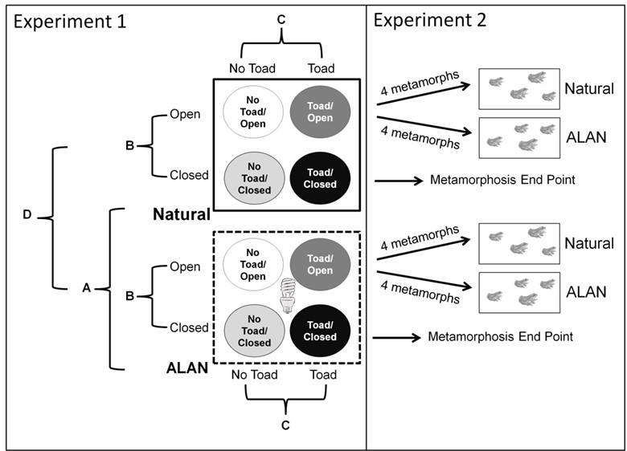
Figure 1: Diagram of experimental design. In experiment 1 (larval stage), we employed a 2x2x2 factorial design manipulating the presence and absence of artificial light (ALAN vs. natural), colonization (lidded vs. unlidded mesocosms to affect colonization) and toad presence or absence. Several of the comparisons we made are indicated by letters. A: comparing mesocosms with ALAN vs natural light tested for the main effect of light at night. B: comparing mesocosms with lids present or absent tested for main effects of colonization. C: comparing mesocosms with toads present or absent determined if toads affect the growth of periphyton, their primary food source. D: Evaluating an interaction effect between light and colonization tested if light changed the community composition through differential colonization, and if those differences in colonization affected toad growth, development and survival. In experiment 2 (post-metamorphic stage) we took the first eight metamorphosing toads from mesocosms with lids absent and moved them into laboratory terraria to determine direct and carry-over effects of ALAN. We tested for direct effects of ALAN on juvenile toads and asked whether larval or post-metamorphic exposure to ALAN affected post-metamorphic toad growth or activity in laboratory terraria. If there were carry-over effects of ALAN, we expected there to be a larval light or larval and juvenile light interaction effect on juvenile survival, growth or activity.
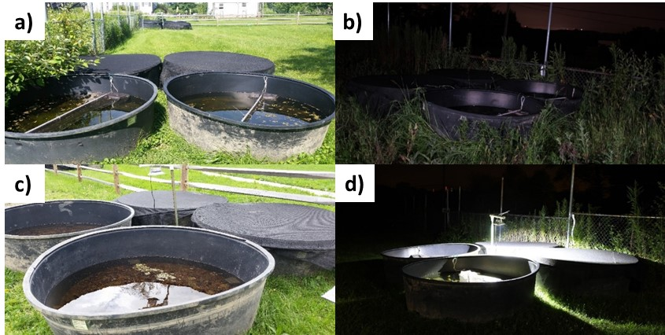
Figure 2: Photos of experimental set-up. a) Natural light treatment group shown in the daytime. b) Natural light treatment group shown at nighttime. c) ALAN light treatment group shown in the daytime. d) ALAN light treatment group shown at nighttime. Lids made of 60% shadecloth completely covered all mesocosms in the colonization-limited treatments. Lights in ALAN treatments were mounted in the middle of each ALAN treatment group.
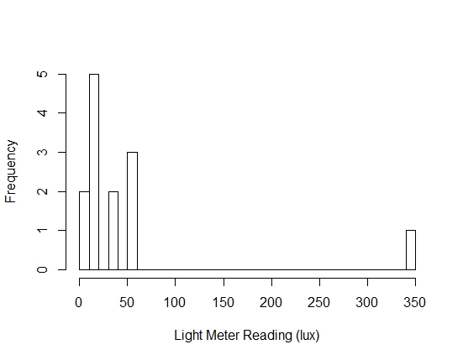
Figure 3: Measurement of light (lux) near wetlands around greater Cleveland, Ohio. Measurements were taken by walking around wetlands and measuring illuminance. Average light levels for our experimental ponds measured at water surface was 15.07 lux + 7.42 SE without lids and 3.12 lux + 1.84 SE with lids.

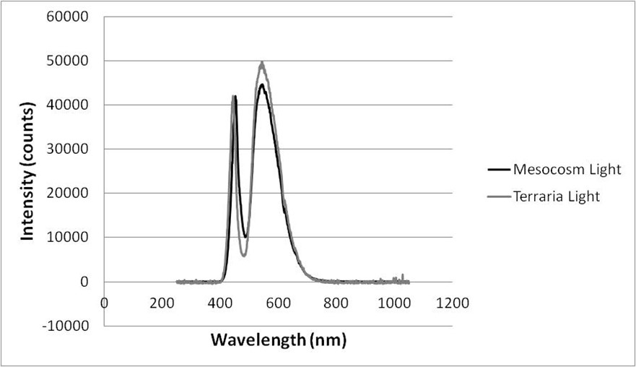
Figure 4: Spectrometer readings for outdoor mesocosm and laboratory terraria LED lights. Both lights have peak wavelengths in the blue-green spectrums.

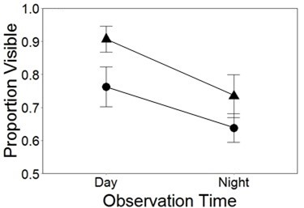
Figure 5: Effects of larval stage light on juvenile toad activity. Effects of larval-stage ALAN exposure on proportion of visible toads (i.e., activity). Toads raised in ALAN treatments as larvae were marginally more active than toads raised under natural light treatments.

