Additional information on methods

Subjects and tissue collection protocol (full)
Zebra finches (Taeniopygia guttata) from our own breeding colony at the University of Liège or kindly provided by Dr Veerle Darras (KU Leuven) were used for this study. They had been raised in a common indoor aviary containing nesting material, along with their parents and a large group of conspecifics allowing complex social interactions and tutor song exposure. Throughout their live, birds were held on a 13L:11D dark/light cycle and they received food and water ad libitum. Egg food, perches, cuttlebones and sand were provided as enrichments. Subjects were distributed into 8 groups of developmental ages (10, 20, 30, 40, 50, 60, 90 and 120 dph; 3-6 females and 4-7 males/group).
Birds were anesthetized with pentobarbital (0.5 ml Nembutal™ at 0.6 mg/ml) and perfused with 200 ml phosphate buffer saline (PBS) followed by paraformaldehyde (4% in PBS). Brains were dissected out of the skull, post-fixed for 24 hours in the same fixative, cryoprotected in 30% sucrose in PBS, frozen on dry ice and stored at -80°C until used. The brains were cut in 30 µm coronal sections at -20°C in a cryostat, collected in 6 series of 4 wells (each series containing 1 section every 180µm) and conserved at -20°C in a cryoprotectant solution until processed.
Immunohistochemistry protocol (full)
Sections were blocked in 5% Normal Goat Serum (NGS) diluted in Tris-buffered Saline (TBS) with 0.1% Triton-X-100 (TBST) for 30 minutes. They were incubated overnight at 4°C in a mixture of 2 primary antibodies diluted in TBST: a mouse monoclonal anti-chondroitin sulfate (CS-56, 1:500; C8035, Sigma Aldrich) specific for the glycosaminoglycan portion of the chondroitin sulfate proteoglycans that are main components of the PNN and a polyclonal rabbit anti-parvalbumin (1:1000; ab11427, Abcam). Sections were then incubated at room temperature in a mixture of secondary antibodies diluted in TBST. A goat anti-mouse IgG coupled with Alexa488 (green, 1:100, Invitrogen) was used to visualize PNN staining and a goat anti-rabbit IgG coupled with Alexa 546 (red, 1:200, Invitrogen) was used to visualize PV cells. Finally, sections were mounted on slides using TBS with gelatin and coverslipped with Vectashield containing DAPI (H-1500, Vector laboratories) used to confirm that PNN that were not surrounding PV-positive cells were localized around a cell nucleus.
PV & PNN quantification protocol (full)
The numbers of PV-positive cells (PV), of cells surrounded by PNN (PNN) and of PV-positive cells surrounded by PNN were counted in 4 song control nuclei (HVC, RA, Area X and LMAN) and in 4 auditory areas (CMM, NCM, Field and NCC in all photomicrographs with Image J software (https://imagej.nih/ij). Each photomicrograph contained only the ROIs so that quantifying the entire image always sampled a similar area. For each ROI, the mean between left and right data for each section was calculated and this result was then averaged between sections to obtain the number of stained structures per counted surface in a given ROI. This measure was standardized by converting in densities/mm² and was also used to compute the % PV surrounded by PNN (%PVwithPNN) and the % PNN surrounding PV (%PNNwithPV).
For each ROI and each dependent measure, the potential influence of the position in the rostro-caudal axis was first tested using One-Way Repeated measures ANOVAs. These analyses identified no rostro-caudal difference for the density of PV and PNN in any of the ROIs (data not shown). This factor is consequently not taken into account in the rest of this paper.
Volume quantification protocol (full)
Pictures were taken at 5X magnification were acquired of all sections (within 1 or 2 full series) containing the nuclei HVC, RA and Area X to quantify their volume as previously described³⁴. First, the area of the ROIs (mm²) within each section was measured using Image J. The volume of each ROI was then estimated by multiplying the measured surface in each section by the distance between sections (120 µm) and then adding the results for all sections. Finally, the means of the left and right hemispheres was calculated. These volumes were used to estimate the total number of PV and PNN/ROI (see ²⁹ for details).

SI Figure 1
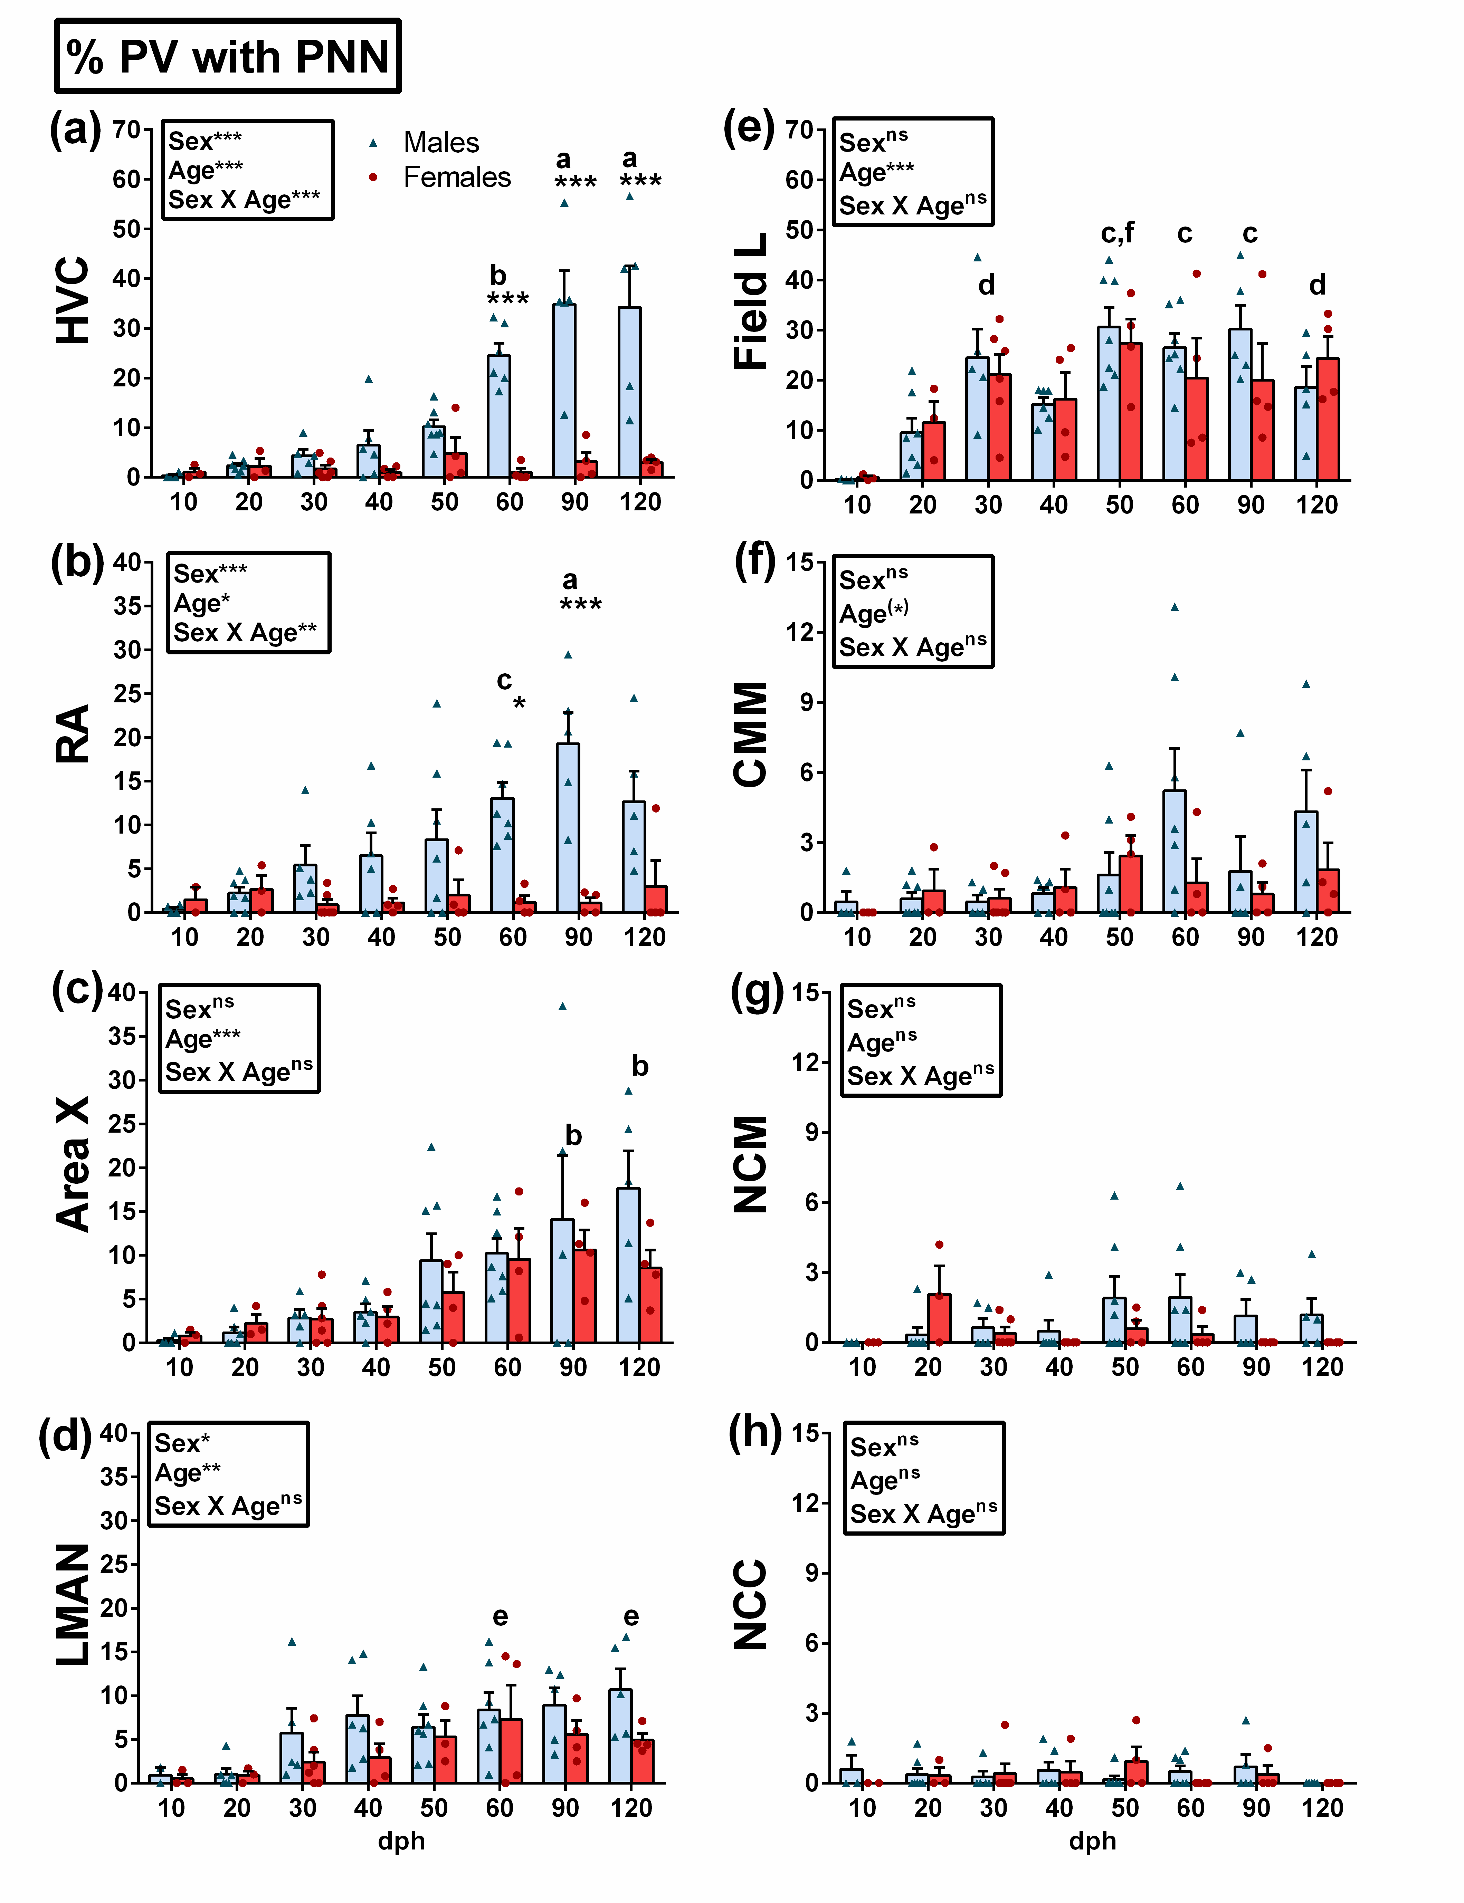
SI Figure 1: (a-h): % PV with PNN in the song control system (left) and in auditory nuclei (right) of males (blue) and females (red) across ages 10-120 dph. In the upper frame, statistical results of the ANOVA are shown. When the interaction is significant, Tukey post hocs significant sex differences within age groups are shown. *p<0.05, **p<0.01, ***p<0.001, (*) p<0.10. Letters indicates significant (p<0.05) age differences within males only (when interaction is significant), within all birds (when a main effect of age without interaction is found): a= different from 10-50 dph, b= different from 10-40 dph, c= different from 10-20 dph, d= different from 10dph, e= different from 20 dph, f= different from 40 dph.

SI Figure 2
SI Figure 2: (a-h): % PNN around PV in the song control system of males (blue) and females (red) across ages 10-120 dph. In the upper frame, statistical results of the ANOVA are shown. When the interaction is significant, Tukey post hocs significant sex differences within age groups are shown. *p<0.05, **p<0.01, ***p<0.001, (*) p<0.10. Letters indicates significant (p<0.05) age differences within all birds (when a main effect of age without interaction is found): a= different from 20dph.

SI Figure 3
SI Figure 3: (a-d): PNN density in auditory nuclei of males (blue) and females (red) across ages 10-120 dph. In the upper frame, statistical results of the ANOVA are shown. When the interaction is significant, Tukey post hocs significant sex differences within age groups are shown. *p<0.05, **p<0.01, ***p<0.001, (*) p<0.10. Letters indicates significant (p<0.05) age differences within all birds: a= different from 10-20dph, b= different from 10dph, c= different from 40 dph.

SI Figure 4

SI Figure 4: (a-d): PV density in auditory nuclei of males (blue) and females (red) across ages 10-120 dph. In the upper frame, statistical results of the ANOVA are shown. When the interaction is significant, Tukey post hocs significant sex differences within age groups are shown. *p<0.05, **p<0.01, ***p<0.001, (*) p<0.10. Letters indicates significant (p<0.05) age differences within all birds: a= different from 20-120 dph, b= different from 120 dph.

SI TABLE 1
Statistical Results of 2-Way ANOVA in figure 1,2 and 3 (1-Way ANOVA for Area X volume and total cell number/nuclei)
F values + statistical significance p<0.05*, p<0.01**, p<0.001***.
Measures/Nuclei | SEX | AGE | SEX x AGE
VOLUME
HVC | 65.81*** | 2.79* | 2.43*
RA | 78.38*** | 6.28*** | 8.16***
Area X | na | 4.35** | na
PNN DENSITY (/MM²)
HVC | 56.76*** | 12.58*** | 9.39***
RA | 18.73*** | 2.13^{ns} | 2.94*
Area X | 0.87^{ns} | 7.57*** | 0.51^{ns}
LMAN | 1.38^{ns} | 5.84*** | 1.01^{ns}
TOTAL PNN (/NUCLEI)
HVC | 78.79*** | 10.29*** | 9.09***
RA | 20.18*** | 2.12^{ns} | 2.88*
Area X | na | 5.94*** | na
PV DENSITY (/MM²)
HVC | 7.21** | 26.22*** | 2.10^{ns}
RA | 0.88^{ns} | 13.42*** | 0.46^{ns}
Area X | 13.97*** | 6.58*** | 1.90^{ns}
LMAN | 5.42* | 16.80*** | 1.79^{ns}
TOTAL PV (/NUCLEI)
HVC | 43.78*** | 0.86^{ns} | 1.32^{ns}
RA | 50.66*** | 3.81** | 6.69***
Area X | na | 3.17* | na

SI TABLE 2
Statistical Results of 2-Way ANOVA in SI figures 1, 2, 3, 4 and 5.
F values + statistical significance p<0.05*, p<0.01**, p<0.001***.
Measures/Nuclei | SEX | AGE | SEX x AGE
PNN DENSITY (/MM²)
Field L | 0.02^{ns} | 7.86*** | 0.66^{ns}
CMM | 0.001^{ns} | 1.90^{ns} | 1.33^{ns}
NCM | 0.61^{ns} | 0.69^{ns} | 0.79^{ns}
NCC | 2.02^{ns} | 0.37^{ns} | 0.35^{ns}
PV DENSITY (/MM²)
Field L | 0.95^{ns} | 114.10*** | 1.00^{ns}
CMM | 21.64*** | 6.62*** | 0.19^{ns}
NCM | 7.62** | 4.06** | 2.28*
NCC | 7.49** | 0.28^{ns} | 0.75^{ns}
CS intensity
HVC | 2.39^{ns} | 1.00^{ns} | 0.68^{ns}
RA | 1.64^{ns} | 1.11^{ns} | 0.87^{ns}
Area X | 2.53^{ns} | 1.40^{ns} | 2.10^{ns}
LMAN | 0.37^{ns} | 2.68* | 0.36^{ns}
Field L | 2.53^{ns} | 1.77^{ns} | 1.04^{ns}
CMM | 3.57^{ns} | 5.49*** | 0.48^{ns}
NCM | 3.55^{ns} | 7.71*** | 1.35^{ns}
NCC | 4.64* | 10.24*** | 1.22^{ns}
% PV with PNN
HVC | 54.47*** | 9.45*** | 8.49***
RA | 29.72*** | 2.87* | 3.06**
Area X | 1.81^{ns} | 5.40*** | 0.62^{ns}
LMAN | 5.42* | 3.19** | 0.49^{ns}
Field L | 0.53^{ns} | 6.92*** | 0.61^{ns}
CMM | 1.94^{ns} | 2.13^{ns} | 1.17^{ns}
NCM | 2.41^{ns} | 0.91^{ns} | 1.24^{ns}
NCC | 0.15^{ns} | 0.54^{ns} | 0.73^{ns}
% PNN around PV
HVC | 7.01* | 1.21^{ns} | 1.78^{ns}
RA | 15.77*** | 0.15^{ns} | 0.82^{ns}
Area X | 9.12** | 0.87^{ns} | 0.22^{ns}
LMAN | 1.32^{ns} | 2.21* | 0.37^{ns}

