Supplementary material

Contents
Equation S1. The mixed model used to calculate rates of change of absolute and relative dominance in each assemblage. This model was applied separately to the two dominance metrics 2
Equation S2. The mixed model calculating rates of change of assemblage size for each assemblage. The slope outputs of this model ($β+ Sn)$were incorporated into Equation 3 as $l$ 3
Equation S3. The mixed model that includes an interaction effect of mean centred year against assemblage size change., as calculated in Equation 2. 3
The study selection process 3
Figure S1. The worksflow we followed when selecting appropriate studies from the BioTIME database to include in our analysis. We removed timesereis that were too short, those without abundance data, and those where abundance was quantified in terms of presence/absence. 4
Figure S2. A flowchart documenting the analysis process. 6
Figure S3. A flowchart illustrating the steps involved in applying sample based rarefaction to the study datasets 7
Figure S4. The structure of the cyclical permutation null model, as applied to each assemblage individually. 8
Figure S5. An illustration of how different combinations of relative and absolute dominance changing with assemblage size provide information about the prevalence of dominance structural regulation. 9
Figure S6. A box plot of changes in absolute (a) and relative (b) dominance in terrestrial, marine and freshwater ecosystems. 10
Figure S7. A box plot of changes in absolute (a) and relative (b) dominance, split by taxonomic groups. Groups were split to different taxonomic levels to reflect amounts of data for each taxa. 11
Figure S8. Z scores of (A) Absolute Dominance and (B) Relative Dominance from the null model plotted against the number of sampling years. 12
Figure S9. Rates of change of assemblage size. 13
Figure S10. Mean relative dominance (D_{r}) of assemblages. 14
A discussion on potential mechanisms of regulation 15
Table S1 – a list of all studies used in the analysis. 16
References 42

To analyse trends in dominance, we used mixed models with random slopes for each assemblage. Supp. Equation 1 shows the model structure for the absolute and relative dominance models. The output of these models was in log₂ number of dominant individuals (absolute dominance) or % dominance (relative dominance) lost/gained per year. A model of the same structure, shown in Supp. Equation 2, was used to calculate changes in assemblage size. The output of this model was in log₂ numbers of individuals lost/gained per year. Finally, the last model used (Supp. Equation 3) included the slope of assemblage change calculated in Equation 2 as a fixed effect in when regressing relative and absolute dominance. To assess possible relationships between assemblage size change and relative and absolute dominance change, we used model fitting to decide if the models including assemble size change explained the data better than those without.

Equation S1. The mixed model used to calculate rates of change of absolute and relative dominance in each assemblage. This model was applied separately to the two dominance metrics
$$y_{i}= α+ β_{i}x_{i}+ b_{n}+S_{n}x_{i}+ ϵ$$
Where:
$y_{i}$ is dominant abundance for value _{i}, quantified in terms of either log₂ abundance for absolute dominance model or percentage dominance for the relative dominance model
$x_{i}$ is the mean centred year for value _{i}
$α$ is the overall intercept
$β_{i}$ is the overall slope for mean centred year
$b_{n}$ is the change in intercept for values with the random effect n
$S_{n}$ is the change in slope for values with the random effect n
$ϵ$ is residual error

Equation S2. The mixed model calculating rates of change of assemblage size for each assemblage. The slope outputs of this model ($β+ S_{n})$were incorporated into Equation 3 as $l_{}$
$$z_{i}= α+ β_{i}x_{i}+ b_{n}+S_{n}x_{i}+ ϵ$$
Where:

$z$ is log₂ assemblage size
$x_{i}$ is the mean centred year for value _{i}
$α$ is the overall intercept
$β_{i}$ is the overall slope for mean centred year
$b_{n}$ is the change in intercept for values with the random effect n
$S_{n}$ is the change in slope for values with the random effect n
$ϵ$ is residual error

Equation S3. The mixed model that includes an interaction effect of mean centred year against assemblage size change., as calculated in Equation 2.

$$y_{i}= α+ β_{i}x_{i}+m_{i}l_{i}+d(x_{i}+ l_{i})+ b_{n}+S_{n}x_{i}+ ϵ$$
Where:

$y$ is for Model 1 log₂ absolute dominance for value _{i,} and for Model 2 it is the relative dominance for value _{i}
$x_{i}$ is the mean centred year for value _{i}
$α$ is the overall intercept
$β_{i}$ is the overall slope for mean centred year $x$
$l_{i}$ is the change in assemblage size for value i
$m_{i}$ is the overall slope for change in assemblage size $l$
$d(x_{i}+ l_{i})$ is the interaction between mean centred year and assemblage size
$b_{n}$ is the change in intercept for values with the random effect n
$d_{n}$ is the rate of change of assemblages size for assemblage n
$S_{n}$ is the change in slope for values with the random effect n
$ϵ$ is residual error

The study selection process
To be accepted into the BioTIME database, a study must meet the following four criteria:
- The abundance observations come from samples of assemblages where all individuals within the sample were counted and identified (i.e. assemblage rather than population data),
- Most of the individuals were identified to species level
- The sampling methods were constant through time
- The time series spans a minimum of two years.
(Dornelas et al [1])

We gave additional attention to further vetting studies before including them in our analysis (Figure S1). First we selected only the datasets with at least 10 sampling years, as we decided that fewer sampling points than this might influence trends to a higher than acceptable level. Next, we selected only studies were numerical abundance was recorded. We removed studies in which abundance was quantified in terms of presence/absence, but retained studies where abundance was quantified in terms of counts, density or mean count. We make the assumption that, by collecting numerical abundance data, the authors of the study are making a judgement that this data contains useful information. For instance numerical abundance may hold useful ecological information for vegetation data when point quadrats are used, despite biomass or cover metrics being the usual measurement methods for vegetation sampling.

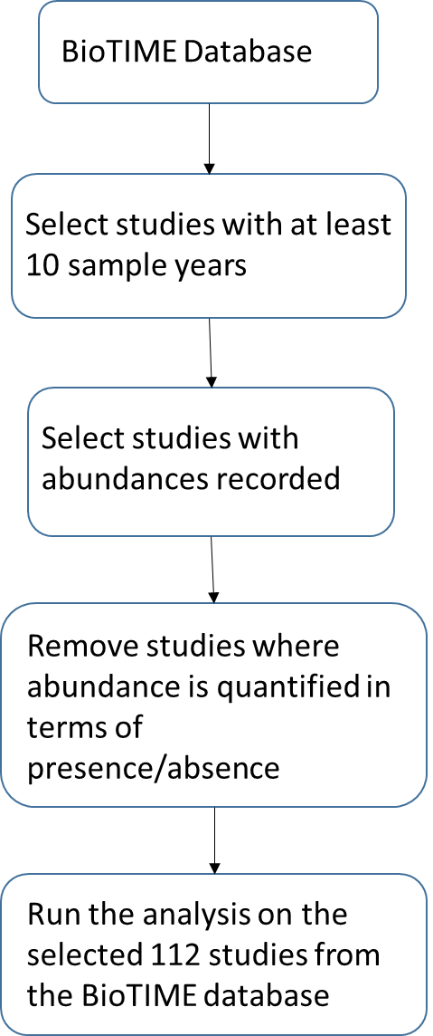

Figure S1. The worksflow we followed when selecting appropriate studies from the BioTIME database to include in our analysis. We removed timesereis that were too short, those without abundance data, and those where abundance was quantified in terms of presence/absence.

Taxonomic groups/definition of an assemblage
We accept the definition of an assemblage suggested by the authors of the study and the BioTIME database. In some cases this means multiple taxa in the same study (i.e. amphibians and reptiles together), but we assume this collection of species has some ecological relevance, and so is useful data for our analysis. Studies with a broader definition of assemblage are also in the minority, with only 9 studies listed as having multiple taxonomic groups, so we do not think they overly influence the result. This is demonstrated by the fact that removing these studies from the analysis does not change non-significance of the rates of change of absolute and relative dominance (absolute dominance: slope =0.005, SE = 0.007; relative dominance: slope = -0.01, SE = -0.03). There are 20 studies of benthic assemblages that may contain multiple taxa (i.e. fish and shrimp), however in these cases we believe that grouping these species that all live together in the same ecological niche is appropriate for capturing community dynamics in benthic habitats. As with the removal of the “multiple” taxa, when we remove both benthic and multiple taxa assemblages, the model results still give non-significant results (absolute dominance: slope = 0.006, SE = 0.009; relative dominance slope = -0.04, SE = 0.05). To conclude, we believe that including the datasets where the assemblages are more broadly defined are worthwhile to include a broader range of species, habitats and locations, particularly as including or removing them does not change the result of the analysis.

Spatial extent

We decided to retain the integrity of the study assemblages despite different spatial extents to avoid autocorrelation within studies, and because the original data collectors chose the spatial extent and grain based on expert knowledge of the taxon and system. In addition, the body size of the taxon varies considerably from assemblages of plankton to assemblages of mammals and birds. We therefore decided splitting data by grid cells would not help answer our research questions. We acknowledge that differences in spatial scale are both interesting and important, but believe addressing spatial scale questions are outside the remit of this particular analysis.
Experimental studies
We decided to retain the most of the experimental data because the nature of the experiments and the data collection mean these data still contain useful information on how assemblages change over time. Most experimental studies (studies 44, 214, 221, 300, 313 and 336) contain assemblages undergoing various levels of succession and regeneration. These are conditions that many empirical observation studies and other non-experimental assemblages will be experiencing. Study 59 involves various treatments such as removing ants, adding seeds, and removing some rodents. As with the successional studies, this sort of manipulation is representative of changing conditions in many non-experimentally manipulated assemblages. We did remove one experimental study: Study 248. This study involved experimentally warming assemblages. We decided that the magnitude of the temperature increase (2°C) and the methodology (heat lamps) meant this assemblage was under conditions outside of normal disturbance. This removal has not modified the results of the study.

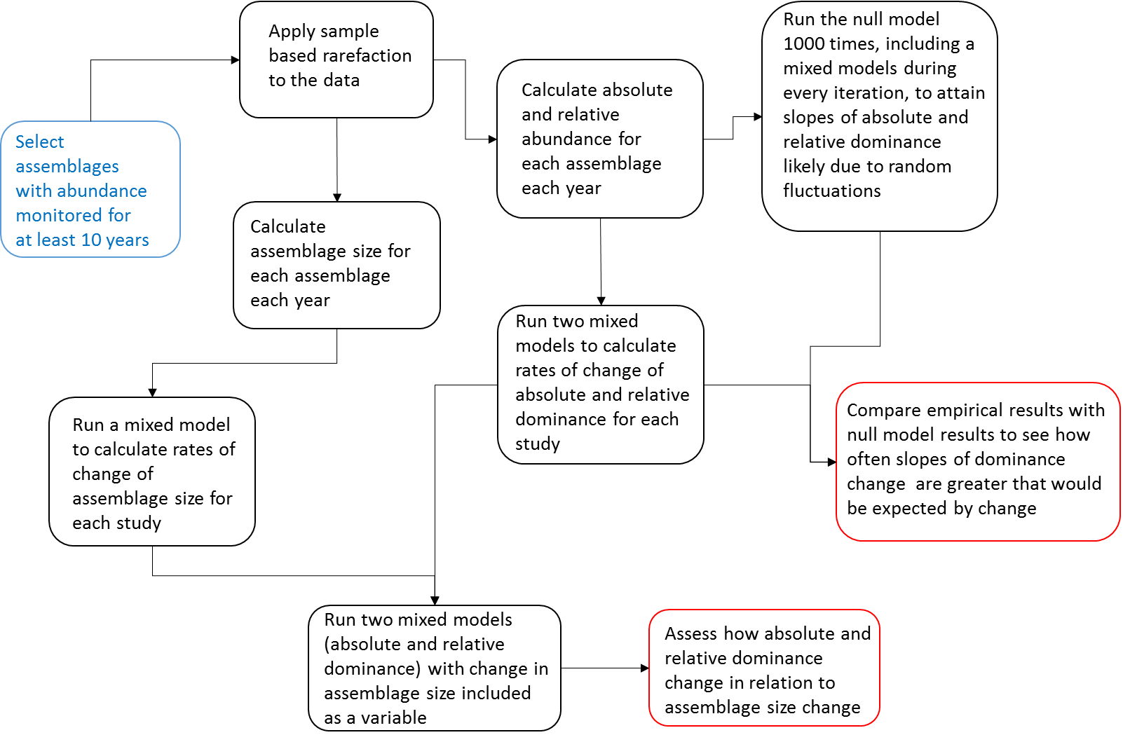

Figure S2. A flowchart documenting the analysis process.
The last processes leading to results are highlighted in red. Further information on the rarefaction process can be found in Figure S3.

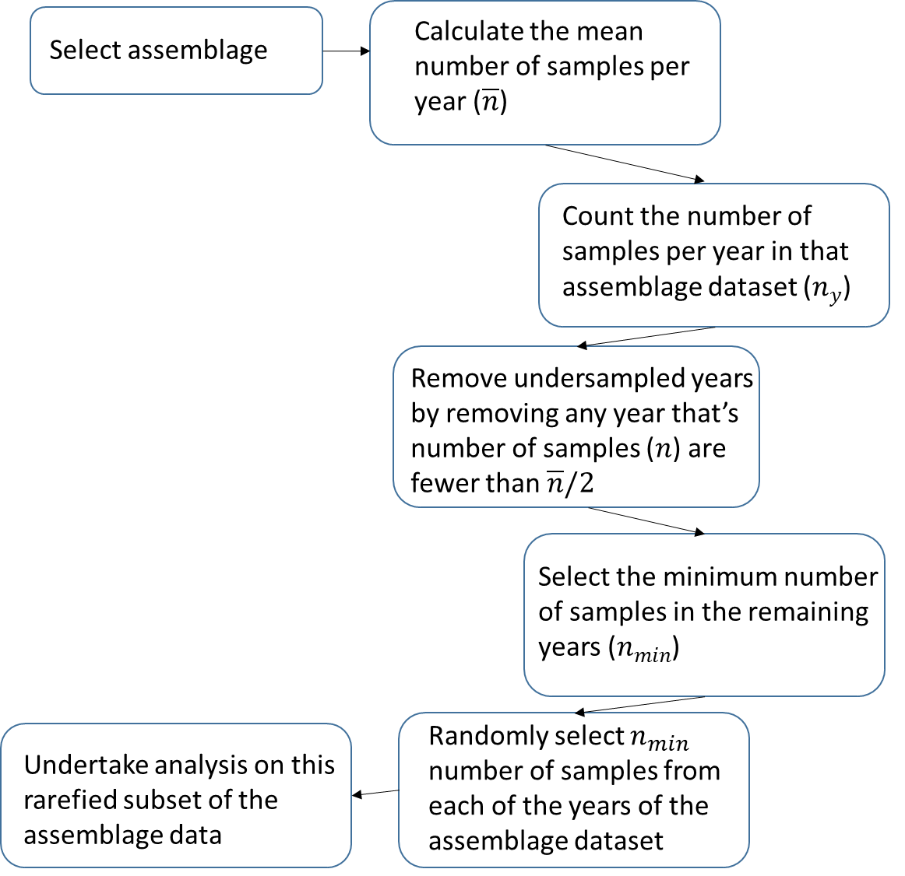

Figure S3. A flowchart illustrating the steps involved in applying sample based rarefaction to the study datasets.

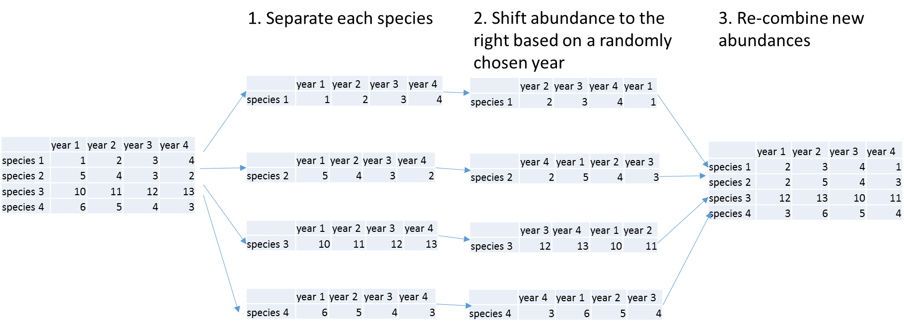

Figure S4. The structure of the cyclical permutation null model, as applied to each assemblage individually.
The model is based on the concept of a cyclical permutation model as described in Hallet et al. [2]. Each iteration of the null model entails randomly shifting the abundances of each species within each assemblage, and then applying the mixed model analysis. The whole process is then repeated another 999 times, giving an output of 1000 rates of change for each assemblage for each metric of change.

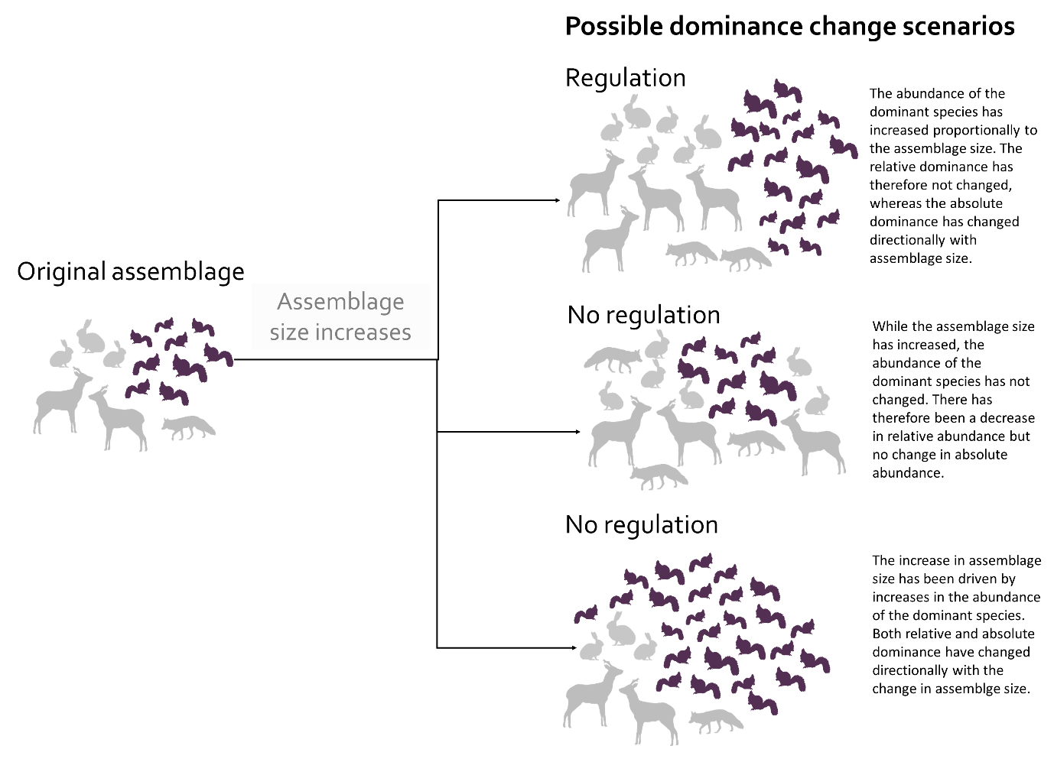

Figure S5. An illustration of how different combinations of relative and absolute dominance changing with assemblage size provide information about the prevalence of dominance structural regulation.
There are different ways in which relative and absolute dominance can change under changing assemblage size. In this example, an assemblage of mammals increases. If there is regulation then relative dominance will not change, whereas absolute dominance will. Other combinations of relative and absolute change, relative dominance increasing but absolute dominance not changing, or both relative and absolute dominance changing, indicate no regulation of the dominance structure.
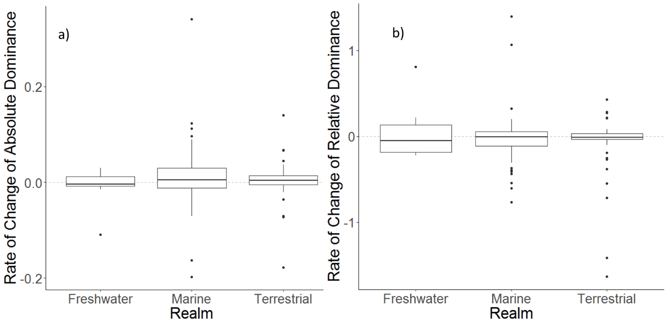

Figure S6. A box plot of changes in absolute (a) and relative (b) dominance in terrestrial, marine and freshwater ecosystems.
There are no clear differences in changes in dominance between the three realms. This is reflected in the lack of any significant interaction effects between any realms and mean centred year (this model structure was absolute or relative abundance regressed against mean centred year and realm, with an interaction effect between these two fixed effects and a random effect of study).

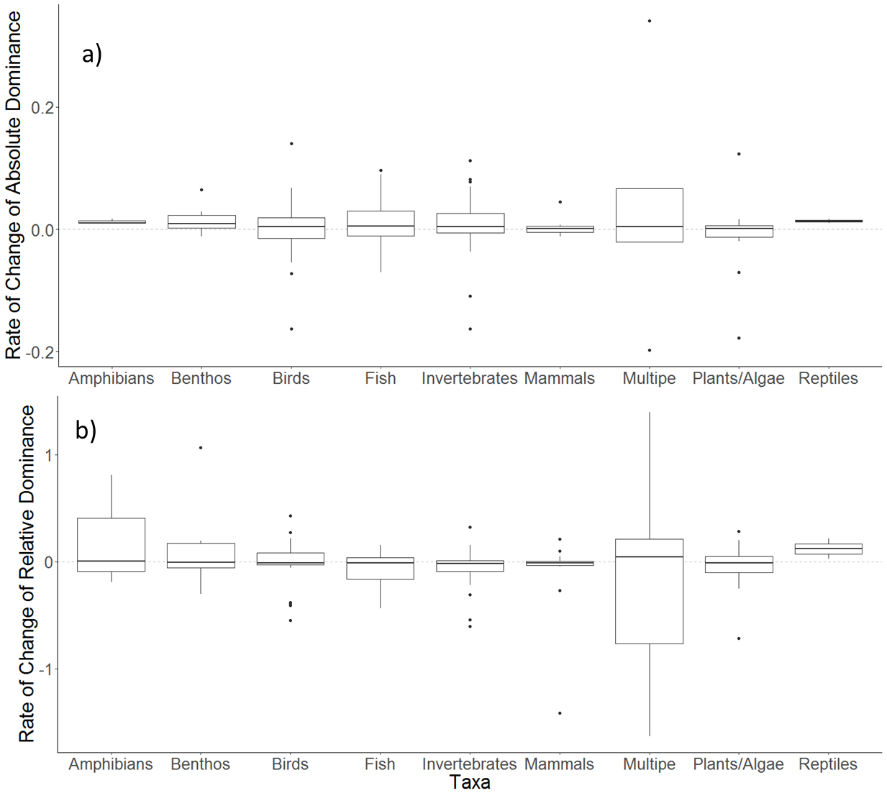

Figure S7. A box plot of changes in absolute (a) and relative (b) dominance, split by taxonomic groups. Groups were split to different taxonomic levels to reflect amounts of data for each taxa.
No clear patterns emerge from splitting slopes of change by taxonomic group. There is some suggestion that absolute dominance might be increasing in reptiles, and relative dominance increasing in reptiles and amphibians. However there is insufficient data to support a significant difference. This is supported by the fact that neither an absolute nor a relative dominance model found a significant interaction effects between taxonomic group and mean centred year. (This model structure was absolute or relative abundance regressed against mean centred year and taxa, with an interaction effect between these two fixed effects and a random effect of study).

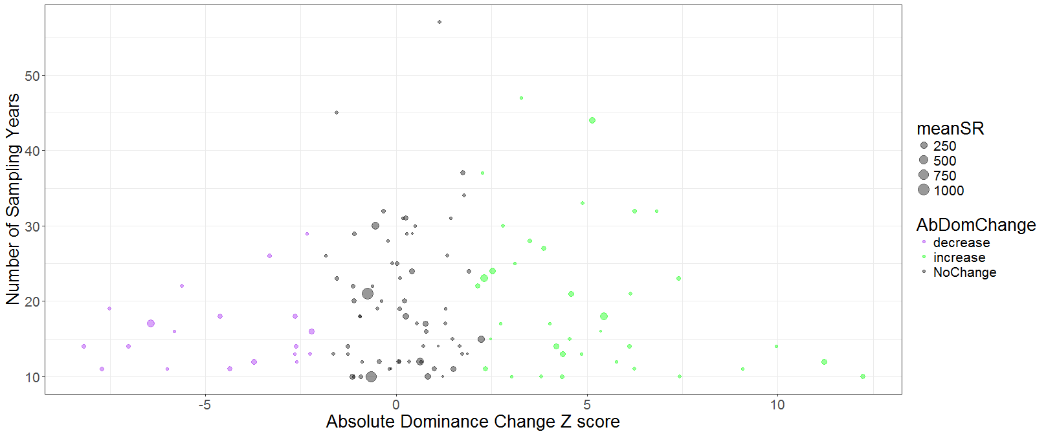
(A)
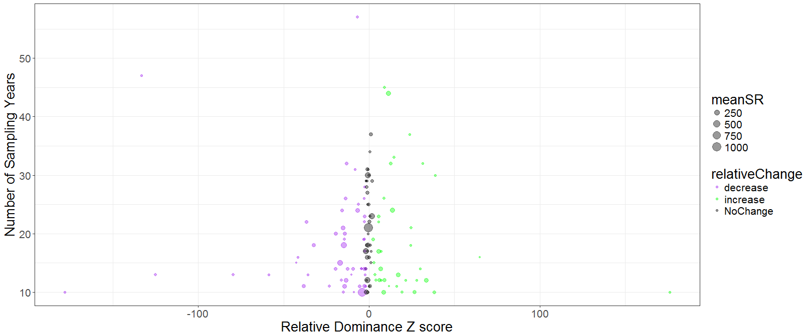
(B)

Figure S8. Z scores of (A) Absolute Dominance and (B) Relative Dominance from the null model plotted against the number of sampling years.
Points are coloured based on whether the assemblage they represent displayed a systematic increase (green), decrease (purple) or no change (grey). Points are sized based on the mean species richness of the assemblage, with the largest points having a species richness close to 1000 species. These plots show that assemblages with longer time-periods sampled are not more likely to exhibit change.

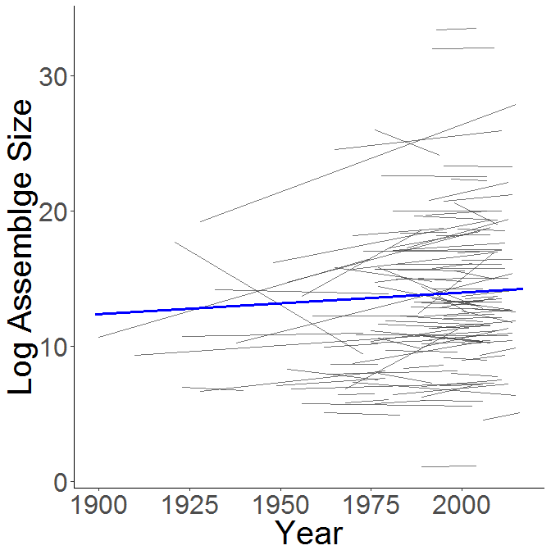

Figure S9. Rates of change of assemblage size.
Each thin grey line represents the trend in dominance within a single assemblage as calculated by the random slopes in the mixed model. The bold blue line across the plot shows the overall trend line of the whole model.

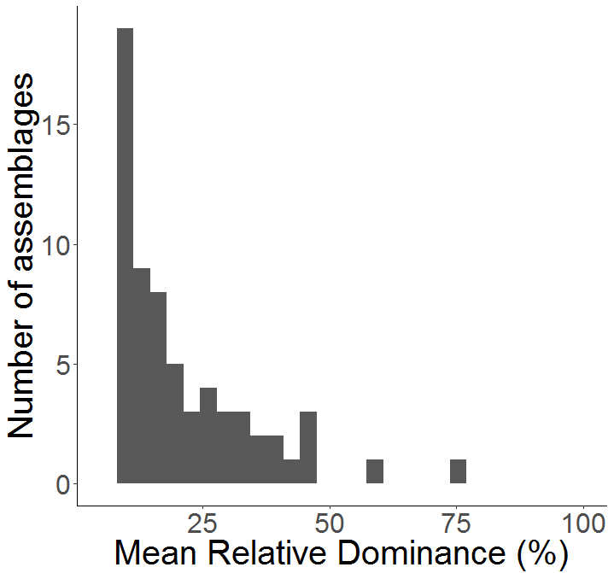

Figure S10. Mean relative dominance (D_{r}) of assemblages.
In most cases (89 assemblages), the mean D_{r} of dominant species within assemblages is less than 20% of the total abundance (N). Although dominant species are by definition more numerous than other species within the assemblages, they do not often contribute extremely high proportions of N.

A discussion on potential mechanisms of regulation
The dominance structure arises from a combination of stabilizing niche differences and relative fitness differences which are intricately linked to the environmental and biological conditions of the assemblage[3]. Assemblages that are increasing or decreasing in N are likely undergoing some form of change in environmental and biological conditions. This driver (or drivers) of change may cause a shift in the fitness differences between species, perhaps favouring smaller but more numerous species[4]. For the dominance structure in this scenario to be regulated, stabilizing niche differences between species are likely to remain stable. This suggests that the number and sizes of realised niches of the species within the modified assemblage are not modified with change in N. An interesting question that arising from this theory is whether the identity of the dominance species is changing in the regulated assemblages, and if they are then whether their traits are similar to other previous dominant species. Are dominant species remaining proportionally dominant but getting smaller? Further work needs to focus on turnover of dominant species, in addition to the dominance structure.

Table S1 – a list of all studies used in the analysis.
These studies were sourced from the BioTIME database. This database is currently in press as a data paper [1] and can be access from http://biotime.st-andrews.ac.uk/home.php
Study ID | Realm | Climate | Taxa | Title | Number of years | Start year | End year | Central latitude | Central longitude | Number of Species | Total records | Reference
18 | Terrestrial | Temperate | Terrestrial plants | Mapped quadrats in sagebrush steppe long-term data for analyzing demographic rates and plant to plant interactions | 29 | 1923 | 1973 | 44.33 | -112.33 | 98 | 8034 | Zachmann L, Moffet C, Adler P. Mapped quadrats in sagebrush steppe: long‐term data for analyzing demographic rates and plant–plant interactions. Ecology. 2010;91(11):3427.
33 | Marine | Temperate | Marine plants | Long-term phytoplankton community dynamics in the Western English Channel | 18 | 1992 | 2009 | 50.25 | -4.217 | 170 | 35676 | Widdicombe CE, Eloire D, Harbour D, Harris RP, Somerfield PJ. Long-term phytoplankton community dynamics in the Western English Channel. J Plankton Res. 2010;fbp127
39 | Terrestrial | Temperate | Birds | Bird community dynamics in a temperate deciduous forest Long-term trends at Hubbard Brook | 45 | 1970 | 2015 | 43.91 | -71.75 | 52 | 959 | Holmes RT, Sherry TW, Sturges FW. Bird Community Dynamics in a Temperate Deciduous Forest: Long‐Term Trends at Hubbard Brook. Ecol Monogr. 1986;56(3):201–20.
41 | Terrestrial | Temperate | Birds | Time and space and the variation of species | 10 | 1923 | 1940 | 39.5 | -82.48 | 56 | 418 | Preston FW. Time and space and the variation of species. Ecology. 1960;41(4):611–27.
42 | Terrestrial | Temperate | Birds | Eastern Wood | 30 | 1949 | 1979 | 51.2965 | -0.38352 | 45 | 954 | Beven G. Changes in breeding bird populations of an oak-wood on Bookham Common, Surrey, over twenty-seven years. London Nat. 1976;55:23–42.
44 | Terrestrial | Temperate | Terrestrial plants | Plant succession and biomass dynamics following logging and burning in the Andrews Experimental Forest Watersheds 1 and 3. 1962-Present | 16 | 1962 | 1977 | 44.33 | -122.33 | 158 | 25571 | Halpern CB, Dyrness C. “Plant succession and biomass dynamics following logging and burning in the Andrews Experimental Forest Watersheds 1 and 3, 1962-Present”. Long-Term Ecological Research. Forest Science Data Bank, Corvallis. 2010;Available at: http://andrewsforest.oregonstate.edu/data/abstract.cfm?dbcode=TP073:accessed 2012.
46 | Terrestrial | Temperate | Birds | Skokholm Bird Observatory | 47 | 1928 | 1979 | 51.698 | -5.277 | 29 | 528 | Vickery WL, Nudds TD. Detection of Density‐Dependent Effects in Annual Duck Censuses. Ecology. 1984;65(1):96–104.
47 | Terrestrial | Temperate | Birds | Detection of Density-Dependent Effects in Annual Duck Censuses | 26 | 1952 | 1977 | 50.845447 | -107.446257 | 13 | 392 | Vickery WL, Nudds TD. Detection of Density‐Dependent Effects in Annual Duck Censuses. Ecology. 1984;65(1):96–104.
51 | Terrestrial | Temperate | Birds | Fluctuations and long-term in the relative densities of tetraonid populations in Finland. 1964-77 | 14 | 1964 | 1977 | 61.9241 | 25.7482 | 4 | 56 | Lindén H, Rajala P. Fluctuations and long-term trends in the relative densities of tetraonid populations in Finland, 1964-77. Finnish Game Res. 1981;39:13–34.
52 | Terrestrial | Polar | Mammals | A transect survey of small land carnivore and red fox populations on a subarctic fell in Finnish forest Lapland over 13 winters | 13 | 1968 | 1980 | 67.75 | 29.5 | 3 | 144 | Pulliainen E. A transect survey of small land carnivore and red fox populations on a subarctic fell in Finnish Forest Lapland over 13 winters. Ann Zool Fennici. 1981;270–8.
53 | Terrestrial | Temperate | Mammals | An 11-year study of small mammal populations at Mont St. Hilaire. Quebec | 10 | 1966 | 1976 | 45.564 | -73.179 | 5 | 44 | Grant PR. An 11-year study of small mammal populations at Mont St. Hilaire, Quebec. Can J Zool. 1976;54(12):2156–73.
54 | Terrestrial | Tropical | Terrestrial invertebrates | El Verde Grid invertebrate data (Big Grid Snail Captures 1991-2007) | 24 | 1991 | 2014 | 18.1667 | -65.5 | 19 | 21702 | Willig C. P. MR& B. “El Verde Grid long-term invertebrate data: Luquillo Long Term Ecological Research Site Database: Data Set 107.” 2016;Available at:http://luq.lternet.edu/data/luqmetadata107/7427:accessed 2016. Available from: http://sev.lternet.edu/data/sev-187
56 | Terrestrial | Temperate | Mammals | Small Mammal Mark-Recapture Population Dynamics at Core Research Sites | 20 | 1989 | 2008 | 34.2 | -106.43 | 28 | 16657 | Friggens, M. (2008) "Sevilleta LTER Small Mammal Population Data", Albuquerque, NM: Sevilleta Long Term Ecological Research Site Database: SEV008. Available at: http://sev.lternet.edu/data/sev-8, accessed 2012.
57 | Freshwater | Temperate | Fish | North Temperate Lakes LTER Fish Abundance | 32 | 1981 | 2012 | 43.9928 | -89.4946 | 76 | 10892 | LTER NTL. “NTLFI02 North Temperate Lakes LTER: Fish Abundance 1981 - current”. North Temperate Lakes Long Term Ecological Research program, NSF. Center for Limnology, University of Wisconsin-Madison. Available at: https://lter.limnology.wisc.edu/dataset/north-temperate-lakes-lter-fish-abundance-1981-current:accessed 2012.
58 | Terrestrial | Tropical | Birds | Avian populations long-term monitoring dataset. San Juan. Puerto Rico Luquillo Long Term Ecological Research Site Database Grid points bird counts DBAS 23 | 18 | 1991 | 2008 | 18.19 | -65.43 | 31 | 1171 | Waide RB. “Bird abundance - point counts. El Verde Field Station, Puerto Rico: Luquillo Long Term Ecological Research Site Database: Data Set 23.” 2010;Available at: http:/luq.lter net.edu/data/luqmetadata23:accessed 2012.
59 | Terrestrial | Temperate | Mammals | Long-term monitoring and experimental manipulation of a Chihuahuan Desert ecosystem near Portal. Arizona. USA | 26 | 1977 | 2002 | 30.3226 | -103.501 | 29 | 427 | Ernest SK, Valone TJ, Brown JH. Long‐term monitoring and experimental manipulation of a Chihuahuan Desert ecosystem near Portal, Arizona, USA. Ecology. 2009;90(6):1708.
63 | Terrestrial | Temperate | Terrestrial invertebrates | The development of dragonfly communities and the consequences of territorial behaviour A 27-year study on small ponds at Woodwalton Fen. Cambridgeshire. United Kingdom | 29 | 1959 | 1988 | 52.4221 | -0.180928 | 5 | 132 | Moore NW. The development of dragonfly communities and the consequences of territorial behaviour: a 27 year study on small ponds at Woodwalton Fen, Cambridgeshire, United Kingdom. Odonatologica. 1991;20(2):203–31
67 | Terrestrial | Temperate | Birds | Animal Demography Unit - Coordinated Waterbird Counts (CWAC) (AfrOBIS) | 24 | 1983 | 2006 | -28.954467 | 24.950961 | 68 | 15448 | “Animal Demography Unit - Coordinated Waterbird Counts (CWAC) - AfrOBIS”. . Available at: http://www.iobis.org/mapper/?dataset=603:accessed 2012.
70 | Terrestrial | Temperate | Terrestrial invertebrates | Belgian Migrating Lepidoptera | 14 | 1983 | 1996 | 51 | 4 | 25 | 303 | Vanholder B. “Belgian Migrating Lepidoptera”. NERC Centre for Population Biology, Imperial College. The Global Population Dynamics Database v2.0. . 1997;Available at: https://www.imperial.ac.uk/cpb/gpdd2/secure/register.aspx:accessed 2012.
78 | Marine | Temperate | Benthos | IOW Macrozoobenthos monitoring Baltic Sea (1980-2005) (EurOBIS) | 25 | 1980 | 2005 | 56.729642 | 18.236359 | 212 | 3587 | Zettler ML. Macrozoobenthos baltic sea (1980-2005) as part of the IOW-Monitoring. Institut für Ostseeforschung Warnemünde, Germany. 2005;Available at: http://www.iobis.org/mapper/?dataset=2289:accessed 2012. Available from: http://www.iobis.org/mapper/?dataset=2289
81 | Marine | Temperate | Mammals | CRRU Cetacean sighting in Scotland waters 1997-2010 | 14 | 1997 | 2010 | 57.767014 | -2.642995 | 9 | 1613 | Robinson KP. “CRRU (Cetacean Research and Rescue Unit) Cetacean sightings in Scotland waters.” 2010;Available at: http://www.emodnet-biology.eu/component/imis/?module=dataset&dasid=2819:accessed 2012.
85 | Marine | Temperate | Marine invertebrates | North Sea observations of Crustacea. Polychaeta. Echinodermata. Mollusca and some other groups between 1986 and 2003 | 12 | 1992 | 2003 | 53.604782 | 4.248107 | 354 | 9984 | Addinck W, de Kluijver M. North Sea observations of Crustacea, Polychaeta, Echinodermata, Mollusca and some other groups between 1986 and 2003. Expert Centre for Taxonomic Idenditification (ETI), the Netherlands. 2003;Available at: http://www.emodnet-biology.eu/data-catalog?module=dataset&dasid=1037:accessed 2012.
97 | Marine | Polar/Temperate | Marine invertebrates | Archives of the Arctic Seas Zooplankton (ARC) | 22 | 1921 | 1973 | 72.739441 | 10.694448 | 402 | 15016 | Markhaseva EL, Golikov AA, Agapova TA, Beig AA. Archives of the Arctic Seas Zooplankton. 1985;Available at: http://www.iobis.org/mapper/?dataset=4470:accessed 2012.
100 | Marine | Temperate | Fish | Community level response to climate change The long-term study of the fish and crustacean community of the Bristol Channel | 31 | 1981 | 2011 | 51.14 | -3.08 | 83 | 5199 | Henderson PA. The long-term study of the fish and crustacean community of the Bristol Channel. Available at http://www.pisces-conservation.com/:accessed 2013.
101 | Marine | Temperate | Marine invertebrates | Community level response to climate change The long-term study of the fish and crustacean community of the Bristol Channel | 31 | 1981 | 2011 | 51.14 | -3.08 | 15 | 2210 | Henderson PA. The long-term study of the fish and crustacean community of the Bristol Channel. Available at http://www.pisces-conservation.com/:accessed 2013.
108 | Marine | Global | Birds | Seabirds of the Southern and South Indian Ocean (Australian Antarctic Data Centre) | 29 | 1977 | 2006 | -27.17355 | 3.945813 | 123 | 116226 | Woehler E. “Seabirds of the Southern and South Indian Ocean - Australian Antarctic Data Centre.” Available at: http://www.iobis.org:accessed 2012.
112 | Marine | Temperate/Tropical | Fish | NOAA Southeast Fishery Science Center (SEFSC) Commercial Pelagic Observer Program (POP) Data (SEFSC_POP) | 22 | 1973 | 2005 | 24.981493 | -51.374069 | 540 | 466437 | "South Western Pacific Regional OBIS Data Asteroid Subset", NIWA (National Institute of Water and Atmospheric Research - New Zealand) MBIS (Marine Biodata Information System) accessed through South Western Pacific OBIS. Available at: http://www.iobis.org/mapper/?dataset=219, accessed 2012.
117 | Marine | Temperate | Marine invertebrates | South Western Pacific Regional OBIS Data Asteroid Subset (South Western Pacific OBIS) | 44 | 1956 | 2003 | -39.371733 | 3.081897 | 156 | 2253 | “South Western Pacific Regional OBIS Data Asteroid Subset”, NIWA (National Institute of Water and Atmospheric Research - New Zealand) MBIS (Marine Biodata Information System) accessed through South Western Pacific OBIS. Available at: http://www.iobis.org/mapper/?dataset=219:accessed 2012. Available from: http://www.iobis.org/mapper/?dataset=219
119 | Marine | Temperate | Fish | DFO Maritimes Research Vessel Trawl Surveys Fish Observations (OBIS Canada) | 41 | 1970 | 2010 | 43.987425 | -63.669701 | 231 | 121804 | Clark D, Branton B. DFO Maritimes Research Vessel Trawl Surveys, OBIS Canada Digital Collections. Bedford Inst Oceanogr Dartmouth, Nov Scotia, Canada, OBIS Canada. 2007;
125 | Marine | Temperate | Fish | MARMAP Chevron Trap Survey 1990-2009 (OBIS-USA) | 12 | 1988 | 2000 | 31.441647 | -78.848859 | 101 | 15092 | Reichert M. “MARMAP Chevron Trap Survey 1990-2009”. SCDNR/NOAA MARMAP Program, SCDNR MARMAP Aggregate Data Surveys, The Marine Resources Monitoring, Assessment, and Prediction (MARMAP) Program, Marine Resources Research Institute, South Carolina Department of Natural Resources U.S.A. 2009;Available at: http://www.usgs.gov/obis-usa/data_search_and_access/participants.html:accessed 2012.
152 | Marine | Temperate | Marine invertebrates | CMarZ (Census of Marine Zooplankton)-Asia Database | 15 | 1977 | 2002 | 43.855961 | 3.065693 | 163 | 2493 | “CMarZ (Census of Marine Zooplankton)-Asia Database”. Accessed through OBIS- SCAR-MarBIN. Available at: http://www.iobis.org/mapper/?dataset=1500:accessed 2012. Available from: http://www.iobis.org/mapper/?dataset=1500
163 | Marine | Temperate | Benthos | North Pacific Groundfish Observer (North Pacific Research Board) | 12 | 1993 | 2004 | 56.5 | -168.15 | 355 | 419940 | “The Observer Program database”, accessed through the OBIS-USA North Pacific Groundfish Observer (North Pacific Research Board). Available at: http://www.iobis.org:accessed 2012.
166 | Marine | Global | All | PIROP Northwest Atlantic 1965-1992 (SEAMAP) | 25 | 1965 | 1992 | 36.075242 | -70.991806 | 213 | 155600 | “PIROP Northwest Atlantic 1965-1992 - OBIS SEAMAP”. Available at: http://www.iobis.org/mapper/?dataset=2245:accessed 2012. Available from: http://www.iobis.org/mapper/?dataset=2245
169 | Marine | Temperate | All | CalCOFI and NMFS Seabird and Marine Mammal Observation Data. 1987-2006 (SEAMAP) | 20 | 1987 | 2006 | 34.858456 | -121.614941 | 185 | 61730 | Jahncke C. J& R. “CalCOFI and NMFS Seabird and Marine Mammal Observation Data, 1987-2006”. California Cooperative Oceanic Fisheries Investigations (CalCOFI) and National Marine Fisheries Service (NMFS) cruises, 1987-2006 - OBIS SEAMAP. 2006;Available at: http://www.iobis.org:accessed 2012.
172 | Marine | Temperate | All | POPA cetacean. seabird. and sea turtle sightings in the Azores area 1998-2009 (OBIS SEAMAP) | 12 | 1998 | 2009 | 35.009739 | -24.224698 | 47 | 52291 | “POPA cetacean, seabird, and sea turtle sightings in the Azores area 1998-2009 - OBIS SEAMAP”. . Available at: http://www.iobis.org/mapper/?dataset=4257:accessed 2012. Available from: http://www.iobis.org/mapper/?dataset=4257
176 | Marine | Temperate | Marine invertebrates | Atlantic Zone Monitoring Program Maritimes Region (AZMP) plankton datasets. In Fisheries and Oceans Canada - BioChem archive (OBIS Canada) | 13 | 1998 | 2010 | 45.073359 | -60.564453 | 320 | 56938 | Kennedy MK, Spry JA. Atlantic Zone Monitoring Program Maritimes Region plankton datasets. Fish Ocean Canada-BioChem Arch OBIS Canada, Bedford Inst Oceanogr Dartmouth, Nov Scotia, Canada. 2011;
180 | Marine | Polar/Temperate | Fish | ECNASAP - East Coast North America Strategic Assessment (OBIS Canada) | 26 | 1970 | 1995 | 37.770564 | -50.792666 | 273 | 410802 | “East Coast North America Strategic Assessment Project, Groundfish Atlas for the East Coast of North America.” Available at: http://www.iobis.org:accessed 2012.
182 | Marine | Temperate | All | Snow crab research trawl survey database (Southern Gulf of St. Lawrence. Gulf region. Canada) from 1988 to 2010 (OBIS Canada) | 22 | 1988 | 2009 | 47.480915 | -62.76169 | 33 | 35005 | Wade EJ. Snow crab research trawl survey database (Southern Gulf of St. Lawrence, Gulf region, Canada) from 1988 to 2010. OBIS Canada, Bedford Inst Oceanogr Dartmouth, Nov Scotia, Canada. 2011;
183 | Marine | Temperate | Marine invertebrates | DFO Maritimes Research Vessel Trawl Surveys Invertebrate Observations (OBIS Canada) | 13 | 1999 | 2011 | 43.776648 | -63.751421 | 16 | 14906 | Wade EJ. Snow crab research trawl survey database (Southern Gulf of St. Lawrence, Gulf region, Canada) from 1988 to 2010. OBIS Canada, Bedford Inst Oceanogr Dartmouth, Nov Scotia, Canada. 2011;
190 | Marine | Tropical | Fish | St. Croix. USVI Fish Assessment and Monitoring Data (2002 - Present) (NOAA-CCMA) | 10 | 2001 | 2010 | 17.756969 | -64.604258 | 247 | 28017 | Wade EJ. Snow crab research trawl survey database (Southern Gulf of St. Lawrence, Gulf region, Canada) from 1988 to 2010. OBIS Canada, Bedford Inst Oceanogr Dartmouth, Nov Scotia, Canada. 2011;
191 | Marine | Temperate | Marine invertebrates | NEFSC Benthic Database (OBIS-USA) | 28 | 1900 | 1975 | 39.123056 | -66.64136 | 1614 | 51456 | “NEFSC Benthic Database (OBIS-USA)”, Northeast Fisheries Science Center, National Marine Fisheries Service, NOAA, U.S. Department of Commerce. 2010;Available at: http://www.iobis.org/mapper/?dataset=1694:accessed 2012. Available from: http://www.iobis.org/mapper/?dataset=1694
192 | Marine | Polar/Temperate | Mammals | Whale Catches in Southern Ocean (OBIS - Australian Antarctic Data Centre) | 42 | 1932 | 1980 | -62.076411 | 79.717188 | 6 | 7122 | “Whale Catches in Southern Ocean”. OBIS - Australian Antarctic Data Centre. Available at: http://www.iobis.org:accessed 2013.
193 | Marine | Temperate | Marine invertebrates | Community level response to climate change The long-term study of the fish and crustacean community of the Bristol Channel (plankton) | 29 | 1982 | 2011 | 51.14 | -3.08 | 7 | 775 | Henderson PA. The long-term study of the fish and crustacean community of the Bristol Channel. Available at http://www.pisces-conservation.com/:accessed 2013.
195 | Terrestrial | Temperate | Birds | Breeding birds survey North America | 30 | 1978 | 2007 | 40.809241 | -96.187269 | 385 | 699449 | USGS Patuxent Wildlife Research Center “North American Breeding Bird Survey” ftp data set, version 2014.0. Available at: ftp://ftpext.usgs.gov/pub/er/md/laurel/BBS/DataFiles/:accessed 2013.
196 | Marine | Temperate | Benthos | SOTEAG Rocky Shore Survey (Sullom Voe) | 35 | 1976 | 2012 | 60.466447 | -1.322878 | 252 | 91491 | Moore JJ, Howson CM. “Survey of the rocky shores in the region of Sullom Voe, Shetland, A report to SOTEAG from Aquatic Survey & Monitoring Ltd”, Cosheston, Pembrokeshire. 29 p. Available at: http://www.soteag.org.uk:accessed 2013.
197 | Marine | Temperate | Fish | Scottish West Coast Surveys - all species of fish (1985 - 2013) | 28 | 1985 | 2013 | 56.521156 | -6.528952 | 149 | 279726 | DATRAS. ICES Scottish West Coast Survey For Commercial Fish Species 1985-2013. 2013;Available at https://datras.ices.dk:accessed 2014. Available from: https://datras.ices.dk
198 | Marine | Temperate | Fish | Baltic international demersal trawl surveys | 23 | 1991 | 2013 | 56.359496 | 16.421731 | 142 | 751021 | DATRAS. ICES Baltic International Trawl Survey For Commercial Fish Species (1991 - 2013). 2013;Available at https://datras.ices.dk:accessed 2013.
200 | Marine | Temperate | Marine invertebrates | NEFSC Benthic Database (OBIS-USA) | 30 | 1956 | 1989 | 35.691706 | -74.090761 | 2105 | 102143 | “NEFSC Benthic Database (OBIS-USA)”, Northeast Fisheries Science Center, National Marine Fisheries Service, NOAA, U.S. Department of Commerce. 2010;Available at: http://www.iobis.org/mapper/?dataset=1694:accessed 2012. Available from: http://www.iobis.org/mapper/?dataset=1694
204 | Marine | Temperate | Benthos | MACROBEL Long term trends in the macrobenthos of the Belgian Continental Shelf | 19 | 1976 | 2001 | 51.439215 | 2.682711 | 344 | 15901 | Degraer Wittoeck, J., Appeltans, W., Cooreman, K., Deprez, T., Hillewaert, H., Hostens, K., Mees, J., Vanden Berghe, E. & Vincx, M. S. “Macrobel: Long term trends in the macrobenthos of the Belgian Continental Shelf.” Oostende, Belgium. 2006;Available at: http://www.emodnet-biology.eu/data-catalog?module=dataset&dasid=145:accessed 2013.
206 | Marine | Temperate | Fish | Northern Irish Ground Fish Trawl Survey | 16 | 1993 | 2008 | 52.175977 | -4.628473 | 108 | 13547 | DATRAS. “Fish trawl survey: Northern Irish Ground Fish Trawl Survey. ICES Database of trawl surveys (DATRAS).” The International Council for the Exploration of the Sea, Copenhagen. 2010;Available at: http://www.emodnet-biology.eu/data-catalog?%3Fmodule=dataset&dasid=2764:accessed 2013.
208 | Marine | Temperate | Fish | ICES French Southern Atlantic Bottom Trawl Survey for commercial fish species. ICES Database of trawl surveys (DATRAS) | 11 | 1997 | 2007 | 48.521775 | -6.248979 | 189 | 24867 | DATRAS. “Fish trawl survey: ICES French Southern Atlantic Bottom Trawl Survey for commercial fish species. ICES Database of trawl surveys (DATRAS).” The International Council for the Exploration of the Sea, Copenhagen. 2010;Available at: http://www.emodnet-biology.eu/data-catalog?%3Fmodule=dataset&dasid=2759:accessed 2013.
209 | Marine | Temperate | Fish | ICES Beam Trawl Survey for commercial fish species. ICES Database of trawl surveys (DATRAS) -UK | 18 | 1990 | 2007 | 51.09476 | 0.085737 | 115 | 19711 | DATRAS. “Fish trawl survey: ICES Beam Trawl Survey for commercial fish species. ICES Database of trawl surveys (DATRAS).” The International Council for the Exploration of the Sea, Copenhagen. 2010;Available at: http://www.emodnet-biology.eu/data-catalog?%3Fmodule=dataset&dasid=2761:accessed 2013.
210 | Marine | Temperate | Fish | ICES North Sea International Bottom Trawl Survey for commercial fish species. ICES Database of trawl surveys (DATRAS) | 47 | 1965 | 2011 | 56.463779 | 3.500367 | 254 | 296524 | DATRAS. “Fish trawl survey: ICES North Sea International Bottom Trawl Survey for commercial fish species. ICES Database of trawl surveys (DATRAS).” The International Council for the Exploration of the Sea, Copenhagen. 2010;Available at: http://www.emodnet-biology.eu/data-catalog?%3Fmodule=dataset&dasid=2763:accessed 2013.
213 | Marine | Temperate | Benthos | Northeast Fisheries Science Center Bottom Trawl Survey Data (OBIS-USA) | 48 | 1948 | 2008 | 36.625131 | -72.635974 | 1023 | 439452 | “NEFSC Benthic Database (OBIS-USA)”, Northeast Fisheries Science Center, National Marine Fisheries Service, NOAA, U.S. Department of Commerce. 2010;Available at: http://www.iobis.org/mapper/?dataset=1694:accessed 2012. Available from: http://www.iobis.org/mapper/?dataset=1694
214 | Terrestrial | Temperate | Terrestrial plants | Long-term growth mortality and regeneration of trees in permanent vegetation plots in the Pacific Northwest 1910 to present | 88 | 1910 | 2010 | 45.34296 | -122.799 | 39 | 37350 | Harmon J. M& F. “Long-term growth, mortality and regeneration of trees in permanent vegetation plots in the Pacific Northwest, 1910 to present.” Long-Term Ecological Research. Forest Science Data Bank, Corvallis. 2012;Available at: http://andrewsforest.oregonstate.edu/data/abstract.cfm?dbcode=TV010:accessed 2012.
215 | Terrestrial | Temperate/Tropical | Birds | Hawk Migration Association of North America (HMANA) | 57 | 1952 | 2008 | 38.40865 | -99.515743 | 39 | 991769 | HMANA. “Hawk Migration Association of North America (HMANA).” Available at: http://www.hmana.org/:accessed 2012.
217 | Terrestrial | Temperate | Birds | Landbird Monitoring Program (UMT-LBMP) | 14 | 1992 | 2006 | 46.828888 | -109.981603 | 268 | 336516 | USFS “Landbird Monitoring Program (UMT-LBMP).” US Forest Service. Available at: http://www.avianknowledge.net/:accessed 2012.
219 | Terrestrial | Temperate | Amphibians | Marsh Monitoring Program - Amphibian Surveys | 17 | 1995 | 2011 | 44.900466 | -84.776848 | 14 | 41914 | Bird Studies Canada (2012) “Marsh Monitoring Program.” NatureCounts, a node of the Avian Knowledge Network. Available at: http://www.birdscanada.org/birdmon/:accessed 2012.
220 | Terrestrial | Temperate | Birds | Marsh Monitoring Program - Bird Surveys | 17 | 1995 | 2011 | 46.885476 | -80.033171 | 243 | 144779 | Bird Studies Canada (2012) “Marsh Monitoring Program.” NatureCounts, a node of the Avian Knowledge Network. Available at: http://www.birdscanada.org/birdmon/:accessed 2012.
221 | Terrestrial | Temperate | Terrestrial plants | Vegetation Plots of the Bonanza Creek LTER Control Plots Species Count (1975 - 2004) | 26 | 1975 | 2008 | 64.844229 | -148.051765 | 52 | 1157 | Viereck LA, Van Cleve K, Chapin FS, Ruess RW, Hollingsworth TN. Vegetation Plots of the Bonanza Creek LTER Control Plots: Species Count (1975 - 2004). Environmental Data Initiative. 2005;Available at: http://dx.doi.org/10.6073/pasta/8dd0e1ac48e2f82b51adabfbd3c62ae2:accessed 2012.
225 | Terrestrial | Temperate | Birds | Point count bird censusing long-term monitoring of bird distrubution and diversity in central Arizona-Phoenix period 2000 to 2011 | 12 | 2000 | 2011 | 33.43 | -111.93 | 278 | 48841 | Shochat E, Katti M, Warren P. “Point count bird censusing: long-term monitoring of bird distribution and diversity in central Arizona-Phoenix: period 2000 to 2011”. Central Arizona-Phoenix Long-Term Ecological Research. Global Institute for Sustainability, Arizona State University. 2004;Available at: https://caplter.asu.edu/data/data-catalog/?id=46:accessed 2012.
229 | Freshwater | Temperate | Fish | Upper Little Tennessee River Biomonitoring Program Database - LTWA Biomonitoring Database | 26 | 1988 | 2013 | 35.138164 | -83.385518 | 69 | 11184 | McLarney WO, Meador J, Chamblee J. “Upper Little Tennessee River Biomonitoring Program Database.” Coweeta Long Term Ecological Research Program. 2010;Available at: https://coweeta.uga.edu/dbpublic/dataset_details.asp?accession=4045:accessed 2012.
232 | Marine | Polar/Temperate | Fish | Pelagic Fish Observations 1968-1999 | 25 | 1968 | 1999 | -56.814716 | 93.88436 | 185 | 6446 | Williams D. “Pelagic Fish Observations 1968-1999.” Australian Antarctic Data Centre. Available at: http://www.gbif.org/dataset/85b0a82a-f762-11e1-a439-00145eb45e9a:accessed 2012.
236 | Freshwater | Temperate | Fish | Fish population on selected watersheds at Konza Prairie - CFP012 - Konza fish population | 12 | 1995 | 2006 | 39.0931 | -96.5586 | 19 | 1169 | Gido KB. “Fish population on selected watersheds at Konza Prairie - CFP01.” Konza Prairie LTER Program. Available at: http://www.konza.ksu.edu/KNZ/pages/data/Knzdsdetail.aspx?datasetCode=CFP01:accessed 2012.
237 | Freshwater | Temperate | Freshwater invertebrates | Madison Wisconsin Lakes Zooplankton 1976 - 1994 - old net | 19 | 1976 | 1994 | 43.025171 | -89.325378 | 89 | 10610 | Lathrop R. “Madison Wisconsin Lakes Zooplankton 1976 - 1994.” North Temperate Lakes Long Term Ecological Research Program, Center for Limnology, University of Wisconsin-Madison. 2000;Available at: http://lter.limnology.wisc.edu/dataset/madison-wisonsin-lakes-zooplankton-1976-1994:accessed 2013.
238 | Freshwater | Temperate | Freshwater invertebrates | North Temperate Lakes LTER Zooplankton - Madison Lakes Area 1997 - current | 20 | 1995 | 2014 | 43.0716 | -89.3971 | 32 | 7331 | LTER NTL. “North Temperate Lakes LTER: Zooplankton - Madison Lakes Area 1997 - current.” North Temperate Lakes Long Term Ecological Research Program, Center for Limnology, University of Wisconsin-Madison. 2011;Available at: http://lter.limnology.wisc.edu/dataset/north-temperate-lakes-lter-zooplankton-madison-lakes-area-1997-current:accessed 2013.
240 | Terrestrial | Temperate | Terrestrial plants | Pinon-Juniper (Core Site) Quadrat Data for the Net Primary Production Study at the Sevilleta National Wildlife Refuge New Mexico (2003-present ) | 13 | 2003 | 2015 | 34.35 | -106.88 | 167 | 15561 | Muldavin E. “Pinon-Juniper (Core Site) Quadrat Data for the Net Primary Production Study at the Sevilleta National Wildlife Refuge, New Mexico (2003-Present).” Sevilleta Long Term Ecological Research Program. Available at: http://sev.lternet.edu/node/1718:accessed 2013. Available from: http://sev.lternet.edu/node/1718
243 | Terrestrial | Temperate | Terrestrial plants | Long-term N-fertilized vegetation plots on Hog Island Virginia Coastal Barrier Islands 1992 to 2014 | 22 | 1992 | 2014 | 37.446634 | -75.667464 | 51 | 8508 | Day F. “Long-term N-fertilized vegetation plots on Hog Island, Virginia Coastal Barrier Islands, 1992-2014.” Virginia Coast Reserve Long-Term Ecological Research Project. 2010;Available at: http://www.vcrlter.virginia.edu/cgi-bin/showDataset.cgi?docid=knb-lter-vcr.106:accessed 2013.
244 | Marine | Temperate | Birds | British Columbia Coastal Waterbirds Survey | 14 | 1999 | 2012 | 50.55543 | -126.283603 | 243 | 219126 | Bird Studies Canada (2012) “BC Coastal Waterbird Survey (2004).” NatureCounts, a node of the Avian Knowledge Network. Available at: http://www.birdscanada.org/birdmon/:accessed 2012.
246 | Marine | Temperate | Fish | Long-term monitoring dataset of fish assemblages impinged at nuclear power plants in northern Taiwan | 15 | 2000 | 2014 | 25.244306 | 121.624306 | 335 | 3722 | Chen H, Liao Y-C, Chen C-Y, Tsai J-I, Chen L-S, Shao K-T. Long-term monitoring dataset of fish assemblages impinged at nuclear power plants in northern Taiwan. Sci data. 2015;2:150071.
247 | Freshwater | Temperate | Freshwater invertebrates | Zooplankton survey of Oneida Lake New York 1964 to present | 32 | 1975 | 2006 | 43.196619 | -75.919813 | 31 | 30307 | Rudstam L. “Zooplankton survey of Oneida Lake, New York, 1964 – 2012”, KNB Data Repository. 2008;Available at: https://knb.ecoinformatics.org/#view/kgordon.17.56:accessed 2016.
249 | Terrestrial | Temperate | Terrestrial invertebrates | Resource specialists lead local insect community turnover associated with temperature - analysis of an 18-year full-seasonal record of moths and beetles | 24 | 1992 | 2015 | 55.702512 | 12.558956 | 1427 | 31787 | Thomsen PF, Jørgensen PS, Bruun HH, Pedersen J, Riis-Nielsen T, Jonko K, et al. Resource specialists lead local insect community turnover associated with temperature – analysis of an 18-year full-seasonal record of moths and beetles. J Anim Ecol [Internet]. 2016;85(1):251–61. Available from: http://dx.doi.org/10.1111/1365-2656.12452
252 | Marine | Temperate | Fish | MARMAP Blackfish Trap Survey 1990-2009 | 13 | 1977 | 1989 | 32.453878 | -78.968171 | 48 | 4692 | Reichert M. “MARMAP Blackfish Trap Survey 1990-2009”. SCDNR/NOAA MARMAP Program. SCDNR MARMAP Aggregate Data Surveys. The Marine Resources Monitoring. Assessment. and Prediction (MARMAP) Program. Marine Resources Research Institute. South Carolina Department of Natural Resources USA. 2010;Available at: http://www.usgs.gov/obis-usa/:accessed 2013.
253 | Freshwater | Temperate | Freshwater invertebrates | North Temperate Lakes LTER Zooplankton - Trout Lake Area 1982 - current | 29 | 1986 | 2014 | 46.021392 | -89.652932 | 133 | 30750 | LTER NTL. “North Temperate Lakes LTER: Zooplankton - Trout Lake Area 1982 - current.” NorthTemperate Lakes Long Term Ecological Research Program, Center for Limnology, University of Wisconsin-Madison. Available at: https://lter.limnology.wisc.edu/dataset/north-temperate-lakes-lter-zooplankton-trout-lake-area-1982-current:accessed 2013.
254 | Freshwater | Temperate | Freshwater plants | North Temperate Lakes LTER Phytoplankton - Madison Lakes Area 1995 - current | 20 | 1995 | 2014 | 43.08111 | -89.383155 | 374 | 12652 | LTER NTL. “North Temperate Lakes LTER: Phytoplankton - Madison Lakes Area 1995 - current.” North Temperate Lakes Long Term Ecological Research Program, Center for Limnology, University of Wisconsin-Madison. Available at: https://lter.limnology.wisc.edu/dataset/north-temperate-lakes-lter-phytoplankton-madison-lakes-area-1995-current:accessed 2013.
256 | Marine | Temperate | Fish | ICES Beam Trawl Survey for commercial fish species. ICES Database of trawl surveys (DATRAS) - The Netherlands | 24 | 1987 | 2010 | 56.341379 | 2.672616 | 120 | 37250 | DATRAS. “Fish trawl survey: ICES Beam Trawl Survey for commercial fish species. ICES Database of trawl surveys (DATRAS).” The International Council for the Exploration of the Sea, Copenhagen. 2010;Available at: http://www.emodnet-biology.eu/data-catalog?%3Fmodule=dataset&dasid=2761:accessed 2013.
271 | Marine | Temperate | Fish | Santa Barbara Coastal LTER | 15 | 2000 | 2014 | 34.305653 | -119.874919 | 62 | 6287 | Reed DC. “SBC LTER: Reef: Kelp forest community dynamics: Fish abundance”. Santa Barbara Coastal LTER. Available at: http://sbc.lternet.edu/cgi-bin/showDataset.cgi?docid=knb-lter-17 doi:10.6073/pasta/e37ed29111b2fddffc08355252b8b8c7:accessed 2016.
272 | Marine | Temperate | Marine invertebrates | Santa Barbara Coastal LTER | 15 | 2000 | 2014 | 34.305542 | -119.87585 | 36 | 5363 | Reed DC. “SBC LTER: Reef: Kelp forest community dynamics: Invertebrate and algal density”. Santa Barbara Coastal LTER. . Available at: http://sbc.lternet.edu/cgi-bin/showDataset.cgi?docid=knb-lter-19 doi:10.6073/pasta/cd4cf864efecd69891dfe1d73b9ac9c3:accessed 2016
273 | Marine | Temperate | Marine invertebrates | Santa Barbara Coastal LTER | 15 | 2000 | 2014 | 34.305542 | -119.87585 | 27 | 15498 | Reed DC. “SBC LTER: Reef: Kelp forest community dynamics: Invertebrate and algal density”. Santa Barbara Coastal LTER. . Available at: http://sbc.lternet.edu/cgi-bin/showDataset.cgi?docid=knb-lter-19 doi:10.6073/pasta/cd4cf864efecd69891dfe1d73b9ac9c3:accessed 2016.
288 | Marine | Temperate | Fish | DFO Maritimes Research Vessel Trawl Surveys Fish Observations (OBIS Canada) | 34 | 1970 | 2006 | 43.977389 | -63.682015 | 195 | 19074 | Tremblay JM, Branton B. DFO Maritimes Research Vessel Trawl Surveys, OBIS Canada Digital Collections. Bedford Inst Oceanogr Dartmouth, Nov Scotia, Canada, OBIS Canada [Internet]. 2007; Available from: http://www.iobis.org/mapper/?dataset=257
297 | Marine | Tropical | Marine invertebrates | MCR LTERCoral Reef Long-term Population and Community Dynamics Other Benthic Invertebrates. ongoing since 2005 | 11 | 2005 | 2015 | -17.524634 | -149.837295 | 13 | 2734 | Carpenter R. “MCR LTER: Coral Reef: Long-term Population and Community Dynamics: Other Benthic Invertebrates, ongoing since 2005”. Moorea Coral Reef LTER, knb-lter-mcr.7.28. 2015;Available at: doi:10.6073/pasta/8e7b3a0c7a8bf315739921861cc79d10:accessed 2016.
300 | Terrestrial | Temperate | Terrestrial invertebrates | Insect Populations via Sticky Traps at KBS-LTER (Kellogg Biological Station. MI) | 25 | 1989 | 2013 | 42.408852 | -85.383181 | 21 | 47798 | Landis D, Gage S. Insect Populations via Sticky Traps at KBS-LTER. 2014;Available at: http://lter.kbs.msu.edu/datatables/67:accessed 2016. Available from: http://lter.kbs.msu.edu/datatables/67
301 | Terrestrial | Temperate | Terrestrial invertebrates | Konza LTER grasshopper monitoring. Konza Prairie LTER. KS | 25 | 1982 | 2013 | 39.106 | -96.611 | 51 | 10470 | Joern A. CGR02 Sweep Sampling of Grasshoppers on Konza Prairie LTER watersheds (1982-present). Environmental Data Initiative. 2016;Available at: http://dx.doi.org/10.6073/pasta/7060b2c244229a37e3bfc8c18f14ad02:accessed 2016.
305 | Terrestrial | Temperate | Amphibians | Population estimates of Appalachian salamanders. Coweeta LTER | 15 | 1976 | 1990 | 35 | -83.5 | 4 | 60 | Wiley RH. “Population estimates of Appalachian salamanders”. Coweeta LTER. Available at: http://coweeta.uga.edu/eml/1044.xml:accessed 2016.
306 | Freshwater | Temperate | Reptiles | Edwin S. George Reserve Turtles. The Global Population Dynamics Database Version 2 | 16 | 1975 | 1992 | 42.457 | -83.946 | 3 | 46 | NERC. “The Global Population Dynamics Database Version 2”. Centre for Population Biology, Imperial College. 2010;Available at: http://www.sw.ic.ac.uk/cpb/cpb/gpdd.html:accessed 2016.
308 | Terrestrial | Temperate | Mammals | Powdermill Nature Reserve monitored small mammal populations from 1979-1999. | 21 | 1979 | 1999 | 40.170741 | -79.260178 | 14 | 35398 | Merritt J. Long Term Mammal Data from Powdermill Biological Station 1979-1999. Environmental Data Initiative. 1999;Available at: http://dx.doi.org/10.6073/pasta/83c888854e239a79597999895bb61cfe:accessed 2016.
309 | Terrestrial | Temperate | Terrestrial invertebrates | Monitoring the Abundance of Butterflies 1976-1985 | 10 | 1976 | 1985 | 53.132177 | -2.177679 | 44 | 5694 | Pollard E, Hall ML, Bibby TJ. Monitoring the Abundance of Butterflies 1976-1985. Research & survey in nature conservation. 1986;Available at: http://jncc.defra.gov.uk/page-2614:accessed 2016.
311 | Terrestrial | Temperate | Mammals | Seasonal summary of numbers of small mammals on 14 LTER traplines in prairie habitats at Konza Prairie | 33 | 1981 | 2013 | 39.083333 | -96.583333 | 15 | 2458 | Kaufman DW. Seasonal summary of numbers of small mammals on 14 LTER traplines in prairie habitats at Konza Prairie. Konza Prairie Long-Term Ecological Research. . Available at: http://lter.konza.ksu.edu/content/csm01-seasonal-summary-numbers-small-mammals-14-lter-traplines-prairie-habitats-konza:accessed 2016. Available from: http://lter.konza.ksu.edu/content/csm01-seasonal-summary-numbers-small-mammals-14-lter-traplines-prairie-habitats-konza
313 | Terrestrial | Temperate | Terrestrial invertebrates | Successional Dynamics on a Resampled Chronosequence Core Old Field Grasshopper Sampling | 18 | 1989 | 2006 | 45.4 | -93.2 | 61 | 7958 | Knops J, Tilman D. Successional Dynamics on a Resampled Chronosequence - Experiment 014. Cedar Creek Ecosystem Science Reserve. . Available at http://www.cedarcreek.umn.edu/research/data/dataset?ghe014:accessed 2016.
316 | Terrestrial | Temperate | Reptiles | Lizard pitfall trap data (LTER-II LTER-III) | 18 | 1989 | 2006 | 32.62 | -106.74 | 21 | 2650 | Lightfoot, D. “Small Mammal Exclosure Study (SMES)”. Sevilleta Long Term Ecological Research Program. Available at: http://sev.lternet.edu/content/small-mammal-exclosure-study-smes-0, accessed 2016.
318 | Terrestrial | Temperate | All | Karoo National Park Census Data | 13 | 1994 | 2009 | -32.23333 | 22.283333 | 25 | 229 | SANParks. “Karoo National Park Census Data. 1994 - 2009.” 2011;Available at: http://datadryad.org/handle/10255/dryad.13079?show=full:accessed 2016.
319 | Terrestrial | Temperate | All | Effects of rangeland management on community dynamics of herpetofauna to the tallgrass prairie | 14 | 1989 | 2003 | 37.25 | -96.71666 | 35 | 232 | Wilgers DJ, Horne EA, Sandercock BK, Volkmann AW. Effects of rangeland management on community dynamics of the herpetofauna of the tallgrass prairie. Herpetologica. 2006;62(4):378–88.
321 | Terrestrial | Temperate | Mammals | Small Mammal Exclosure Study. Jornada LTER. SMES rodent trapping data | 13 | 1995 | 2007 | 32.550335 | -106.811564 | 19 | 12787 | Lightfoot D. “Small Mammal Exclosure Study (SMES)”. Sevilleta Long Term Ecological Research Program. Available at: http://sev.lternet.edu/content/small-mammal-exclosure-study-smes-0:accessed 2016.
327 | Terrestrial | Temperate | Mammals | Fray Jorge Small Mammals 1989-2005 | 17 | 1989 | 2005 | -30.6 | -71.7 | 12 | 256469 | Kelt, D. A., Meserve, P. L., Gutiérrez, J. R., Milstead, W. B. & Previtali, M. A. (2013) Long-term monitoring of mammals in the face of biotic and abiotic influences at a semiarid site in north-central Chile. Ecology, 94, 977. doi:10.1890/12-1811.1.
328 | Freshwater | Temperate | Amphibians | The Rainbow Bay Long-term Study | 30 | 1979 | 2008 | 32.26 | -81.63 | 10 | 301 | Scott D, Metts B, Lance S. “The Rainbow Bay Long-term Study.” Available at: http://srelherp.uga.edu/projects/rbay.htm:accessed 2016.
330 | Marine | Temperate/Tropical | Marine invertebrates | Over 75 years of zooplankton data from Australia | 49 | 1938 | 2014 | -23.830553 | 136.449216 | 639 | 80764 | Davies CH, Armstrong AJ, Baird M, Coman F, Edgar S, Gaughan D, et al. Over 75 years of zooplankton data from Australia. Ecology. 2014;95(11):3229.
332 | Freshwater | Temperate | Fish | Stream Fish Assemblage stability in a southern Appalachian stream (Coweeta Hydro Lab 1984 - 1995) | 12 | 1984 | 1995 | 35.0589 | -83.4319 | 14 | 590 | Grossman GD. “Stream fish assemblage stability in a southern Appalachian stream at the Coweeta Hydrologic Laboratory from 1984 to 1995”.
336 | Terrestrial | Temperate | Terrestrial plants | Long term monitoring and experimental manipulation of a Chihuahuan Desert ecosystem near Portal Arizona | 14 | 1989 | 2002 | 31.938889 | -109.0797 | 100 | 35978 | Ernest SK, Valone TJ, Brown JH. Long‐term monitoring and experimental manipulation of a Chihuahuan Desert ecosystem near Portal, Arizona, USA. Ecology. 2009;90(6):1708.
339 | Terrestrial | Temperate | Birds | Species trends turnover and composition of a woodland bird community in southern Sweden during a period of 57 years. | 57 | 1953 | 2009 | 55.71667 | 13.33333 | 39 | 1210 | Svensson S, Thorner AM, Nyholm NEI. Species trends, turnover and composition of a woodland bird community in southern Sweden during a period of fifty-seven years. Ornis Svecica. 2010;20(1):31–44.
340 | Terrestrial | Temperate | Terrestrial plants | Small Mammal Exclosure Study (SMES) Vegetation Data from the Chihuahuan Desert | 15 | 1995 | 2009 | 34.296 | -106.9267 | 93 | 1608 | Lightfoot D. “Small Mammal Exclosure Study (SMES) Vegetation Data from the Chihuahuan Desert Grassland and Shrubland at the Sevilleta National Wildlife Refuge, New Mexico (2006-2009)”. Long Term Ecological Research Network. 2011;Available at: http://dx.doi.org/10.6073/pasta/d80d5e2196cd11ef79df23ebe5a77c19:accessed 2016.
348 | Terrestrial | Temperate/Tropical | Mammals | Bats (Mammalia Chiroptera) in restinga in the municipality of Jaguaruna south of Santa Catarina Brazil. | 10 | 2006 | 2016 | -28.6089 | -48.98125 | 13 | 177 | Carvalho, F., Zocche, J.J. & Mendonça, R.Á. (2009) Morcegos (Mammalia, Chiroptera) em restinga no município de Jaguaruna, sul de Santa Catarina, Brasil. Biotemas, 22, 193-201.
350 | Marine | Temperate | Benthos | Megafauna PAP time series | 12 | 1989 | 2011 | 49 | -16.5 | 50 | 563 | Billett, D., Bett, B., Rice, A., Thurston, M., Galéron, J., Sibuet, M. & Wolff, G. (2001) Long-term change in the megabenthos of the Porcupine Abyssal Plain (NE Atlantic). Progress in Oceanography, 50, 325-348. Billett, D., Bett, B., Reid, W., Boorman, B. & Priede, I. (2010) Long-term change in the abyssal NE Atlantic: The ‘Amperima Event’revisited. Deep Sea Research Part II: Topical Studies in Oceanography, 57, 1406-1417.
351 | Marine | Temperate | Benthos | Megafauna Sta M time series | 13 | 1989 | 2004 | 34.833333 | -123 | 10 | 350 | Ruhl, H. A. & Smith, K. L. (2004) Shifts in Deep-Sea Community Structure Linked to Climate and Food Supply. Science, 305, 513–515.  Kuhnz, L. A., Ruhl, H. A., Huffard, C. L. & Smith, K. L. (2014) Rapid changes and long-term cycles in the benthic megafaunal community observed over 24 years in the abyssal northeast Pacific. Progress in Oceanography, 124, 1–11.
354 | Marine | Temperate/Tropical | Marine plants | A database of marine phytoplankton abundance biomass and species composition in Australian waters | 24 | 1928 | 2015 | -39.978763 | 129.903106 | 734 | 75604 | Davies CH, Coughlan A, Hallegraeff G, Ajani P, Armbrecht L, Atkins N, et al. A database of marine phytoplankton abundance, biomass and species composition in Australian waters. Sci data. 2016;3.
356 | Terrestrial | Tropical | Terrestrial plants | Long-term stem inventory data from tropical rain forest plots in Australia | 34 | 1971 | 2013 | -17.03808 | 145.561207 | 478 | 14938 | Bradford MG, Murphy HT, Ford AJ, Hogan DL, Metcalfe DJ. Long‐term stem inventory data from tropical rain forest plots in Australia. Ecology. 2014;95(8):2362.
357 | Terrestrial | Temperate | Mammals | Small Mammal Trapping Webs on the Central Plains Experimental Range | 13 | 1994 | 2006 | 40.82889 | -104.7582 | 10 | 1104 | Stapp P. SGS-LTER Long-Term Monitoring Project: Small Mammals on Trapping Webs on the Central Plains Experimental Range, Nunn, Colorado, USA 1994 -2006, ARS Study Number 118. Environmental Data Initiative. 2013;Available at: http://dx.doi.org/10.6073/pasta/2e311b4e40fea38e573890f473807ba9:accessed 2017.
358 | Terrestrial | Temperate | Birds | Neotropical Migratory Bird Communities in a Developing Pine Plantation | 16 | 1977 | 1992 | 31.58333 | -94.81666 | 14 | 140 | Dickson JG, Conner RN, Williamson JH. Neotropical migratory bird communities in a developing pine plantation. Procedings Annu Conf SEAFWA. 1993;47:439–46.
359 | Marine | Temperate | Fish | SBC LTER Reef Kelp Forest Community Dynamics Fish abundance | 13 | 2000 | 2012 | 34.308906 | -119.874156 | 61 | 3285 | Reed DC. “SBC LTER: Reef: Kelp Forest Community Dynamics: Fish abundance”. Santa Barbara Coastal LTER. 2014;Available at: doi:10.6073/pasta/e37ed29111b2fddffc08355252b8b8c7:accessed 2016.
361 | Terrestrial | Temperate | Birds | A long-term bird population study in an Appalachian spruce forest | 22 | 1962 | 1983 | 38.61 | -79.83472 | 20 | 213 | Hall GA. A long-term bird population study in an Appalachian spruce forest. Wilson Bull. 1984;228–40.
363 | Terrestrial | Temperate | Birds | The 37-year dynamics of a subalpine bird community with special emphasis on the influence of environmental temperature and Epirrita autumnata cycles. | 37 | 1963 | 1999 | 65.968055 | 16.31666 | 35 | 636 | Enemar A, Sjöstrand B, Andersson G, von Proschwitz T. The 37-year dynamics of a subalpine passerine bird community, with special emphasis on the influence of environmental temperature and Epirrita autumnata cycles. Ornis Svecica. 2004;14:63–106.

References
1. Dornelas M, Antao LH, Moyes F, Bates AE, Magurran AE, Adam D, Akhmetzhanova AA, Appeltans W, Arcos JM, Arnold H, Ayyappan N, et al. 2018 BioTIME: a database of biodiversity time series for the Anthropocene. Glob. Ecol. Biogeogr. in press.
2. Hallett LM, Jones SK, MacDonald AAM, Jones MB, Flynn DFB, Ripplinger J, Slaughter P, Gries C, Collins SL. 2016 codyn: An r package of community dynamics metrics. Methods Ecol. Evol. 7, 1146–1151. (doi:10.1111/2041-210X.12569)
3. HilleRisLambers J, Adler PB, Harpole WS, Levine JM, Mayfield MM. 2012 Rethinking Community Assembly through the Lens of Coexistence Theory. Annu. Rev. Ecol. Evol. Syst. 43, 227–248. (doi:10.1146/annurev-ecolsys-110411-160411)
4. Sheridan JA, Bickford D. 2011 Shrinking body size as an ecological response to climate change. Nat. Clim. Chang. 1, 401–406. (doi:10.1038/nclimate1259)

