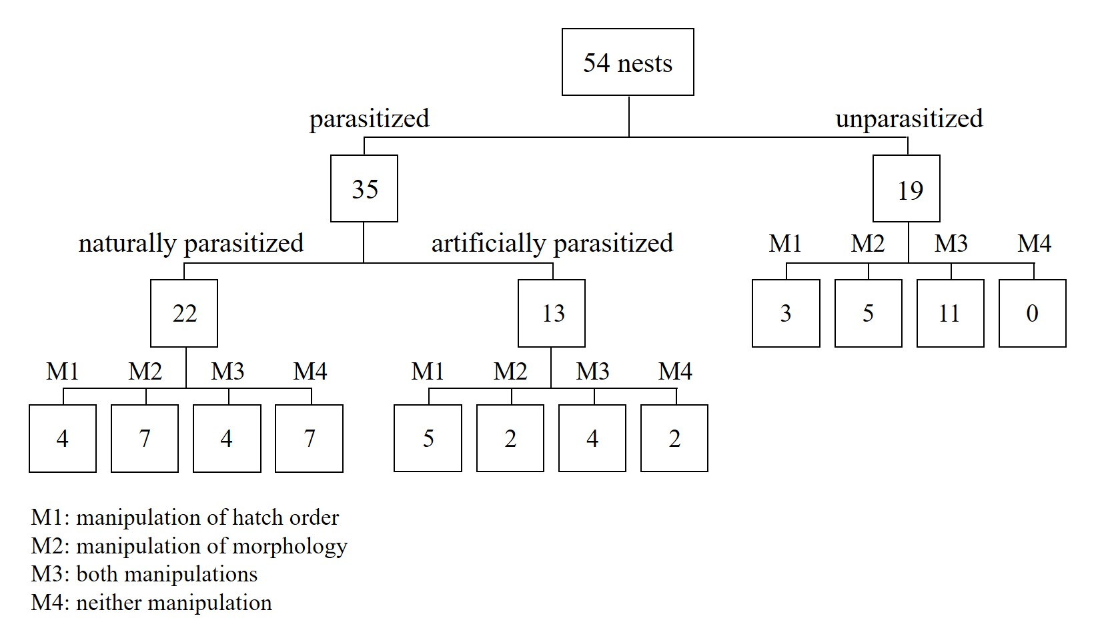
Figure S1. Flow diagram showing the design of the experiment. Numbers in boxes indicate the sample size of nests in the assigned treatments (M1-M4).

