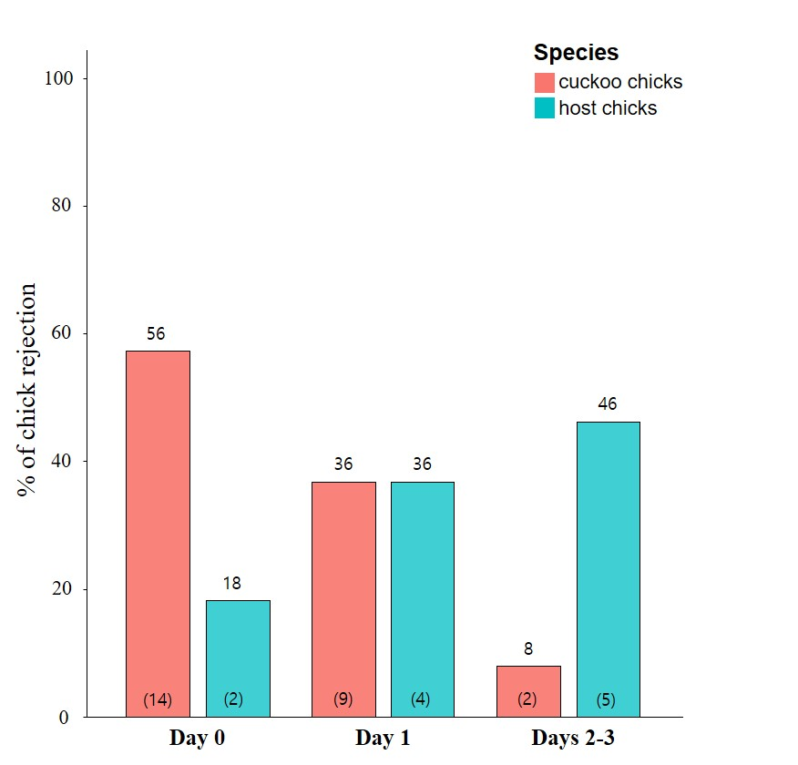
Figure S2. The percentage of cuckoo chicks and host chicks that were rejected according to the time to ejection (Day 0 = hatching day). Sample sizes are given in parentheses at the base of the bar, and numbers above bars depict the exact percentage.

