Electronic supplementary material: Female nutritional condition affects ovarian fluid quality in guppies
Gabriela Cardozo & Andrea Pilastro

Methods
Fish used in the experiment
Adult fish were haphazardly selected from different stock tanks. Before ejaculate collection (see main text), males were maintained for one week in individual tanks in which they had visual (but not physical) contact with a female, to restore their sperm reserves in case of previous recent matings. A previous study [1] has found that the OF collected from post-partum and gravid females has a different effect on sperm velocity, and therefore we had to use females in the same stage of their reproductive cycle. We excluded to use post-partum females, principally because it is logistically very difficult to obtain two females, one per diet treatment, that deliver their brood exactly 20 days after the beginning of the diet treatment and on the same day, in order to test the effect of their OF on the sperm of the same male (to control for among-males differences in sperm velocity, see below details on the experimental design). We therefore decided to use females that were all gravid, and close to parturition. To this end, we haphazardly collected from the stock tanks adult females that had recently produced a brood (they can be recognized by their “deflated” belly) and assigned randomly to one of the two diet treatment. The diet treatment (20 days) was shorter than the average gestation time (25 days) and the exclusion of short-gestation females that delivered a brood during the diet treatment ensured that all females were in the same reproductive stage (i.e. late-pregnancy).

Ovarian fluid solution for sperm velocity analyses
To collect the ovarian fluid (OF) samples we used the same protocol used in previous similar studies in the guppy [1-4]: each female was anaesthetized in a MS-222 water bath (0.15 g/l tricaine methanesulphonate solution), 3 µl of 0.9% NaCl was gently injected into the female’s gonoduct and retrieved using a Drummond micropipette. This operation was repeated three times (total volume injected 9 µl). Following this procedure, the OF within each female was diluted in the same initial volume (9 µl). Even if the volume of the OF retrieved from each female may slightly vary, its concentration will reflect the properties (i.e. volume, composition, concentration and viscosity) of OF within each female. We therefore used a fixed volume of the OF retrieved sample (3 µl) to measure sperm velocity (see main text for further details). Each female’s OF sample was used to measure sperm velocity from one individual male (Fig. 1S). In total we therefore used the OF samples of 34 females (17 AL and 17 R) to measure sperm velocity of 17 males.
At the end of the OF collection, female body size was measured as the distance between the tip of the snout to the caudal peduncle, where the fin rays meet the body (standard length, SL). SL was measured under the microscope to the nearest 1 mm using a ruler.

Sperm velocity assay
Sperm were collected from each male following an established procedure [5]: each male was anaesthetized in a MS-222 water bath (0.15 g/l tricaine methanesulphonate solution [4]) and placed on a slide under a stereomicroscope. A gentle abdominal pressure allowed the release of sperm in a drop of saline solution (NaCl 0.9%). In guppies, sperm are packaged in bundles, which can be easily collected with a pipette. The velocity of sperm leaving bundles was measured in the OF solution from one ad-libitum (AL) and one restricted (R) diet female. The procedure was replicated for 17 males (tested in 34 females) (Fig. 1S).
We used a Hamilton-Thorne CEROS sperm tracker (Hamilton-Thorne Research, Beverly, MA, USA) to estimate the sperm velocity using the following parameters: frame rate 60 Hz; no. of frames 30; threshold value for static cells 25 µm/s [1, 4]. For each analysis, we recorded the sperm leaving at least 3 different sperm bundles. Practically, approx. 10 sperm bundles were put on the slide with the OF solution. As soon as a bundle started to break up, the velocity of approx. 100 sperm leaving one bundle were measured. This operation was repeated in sequence on other two sperm bundles. Sperm velocity assays were based, on average, on 295 sperm cells (SD = 206.1; range 79-1177; data available at Dryad: https://doi.org/10.5061/dryad.n3q5t28) [6]. We obtained two sperm velocity estimates (µm s⁻¹), namely VAP, which is the average velocity of sperm cells over a smoothed cell path, and the curvilinear velocity (VCL), which were strongly positively correlated (R: r=0.93, P<0.001; AL: r=0.97, P<0.001), and, in this guppy population, are significantly repeatable within male [7] and predict competitive fertilization success [8]. The number of sperm analysed did not differ significantly between AL and R groups (Student t test, t₃₂ = 1.42, P=0.16) and was not correlated with the two measures of sperm velocity (AL: VAP, r=0.32, P=0.21, n=17; VCL, r=0.15, P=0.56, n=17; R: VAP, r=-0.06, P=0.83, n=17; VCL, r=-0.12, P=0.66, n=17; two diet groups pooled: VAP, r=0.25, P=0.15, n=34; VCL, r=0.17, P=0.33, n=34).

Statistical analyses
Since we had two measures of sperm velocity for each male (one measured in the OF sample retrieved from an Al female and one in the OF from a R female), we used a paired t test to compare VAP and VCL within male between AL and R female. Difference in VAP (AL-R) and VCL were both normally distributed (Shapiro-Wilk test, VAP: W=0.96, P=0.57, n=17; VCL: W=0.911, P=0.11, n=17), and showed homogenous variances (VAP: F=0.002; P=0.97; VCL: F=0.22, P=0.65, Levene test). Considering our relatively small sample size, the power to detect significant deviations from normality and homogeneity of variance assumptions may be reduced. We therefore further tested the robustness of our results using distribution-free non-parametric tests (sign test and Wilcoxon signed-rank test). The effect of the within-male order of analysis (two levels, first or second) and of female SL was tested using repeated-measure ANOVAs.

Supplementary results and discussion
The two groups of females did not differ in body size (SL): mean SL was 26.7 mm (SD=1.90, N=17) and 26.1 mm (SD=1.70, N=17), for AL and R females, respectively (paired t test, t₁₆=1.07, P=0.30; mean within-pair difference in SL = 0.58 mm, SD=2.27). The sperm swimming velocity was significantly lower in the sample of OF from diet-restricted females than from ad-libitum diet females also when non-parametric tests were used (Table 1S). Sperm swimming speed declined in the OF of R females in 13 out of 17 males (Fig. 1, main text), and in 14 out of 17 males (Fig. 2S), for VAP and VCL, respectively. In both cases more, a decrease in sperm velocity occurred more frequently than expected by chance (sign test, VAP: P=0.049; VCL: P=0.013).
Sperm velocity was not correlated with female body size in the two groups of females (all r<0.16, all P>0.54). Within-male difference between sperm velocity (μm^{-s}) in the ovarian fluid (OF) of females that were maintained at AL and R diet remained significant when the difference in body size between the two females was entered as a covariate (VAP: diet, F_{1,15}=5.08, P=0.04; difference in SL, F_{1,15}=2.55, P=0.13; VCL: diet, F_{1,15}=8.61, P=0.01; difference in SL, F_{1,15}=1.32, P=0.27; repeated measure ANOVA).

We can only speculate on the reason why in four cases (23.5%) sperm swimming speed (VAP) in the OF of R females increased, as compared to the velocity measured in the OF of AL females. One possibility is that the diet affected differentially some of the females, and hence the capability of their OF to enhance sperm velocity, or that the effect of nutritional condition on OF may differ across females. Alternatively, the intrinsic differences in the quality/quantity of the OF (and hence its effect on sperm velocity), or the error in sampling OF (resulting for example in a more or less concentrated OF solution) may be large enough to obscure, in some cases, the effect of the diet. Thirdly, it has to be noted that the within-male repeatability of sperm velocity (measured in activating solution), previously estimated in this guppy population, is 0.70 ± 0.08 SE for VAP and 0.58 ± 0.11 SE for VCL [7]. Therefore, because of the sperm velocity measurement error, a certain degree of within-male variability in sperm velocity can be expected. Finally, in guppies, sperm swimming velocity is significantly lower in the OF of a fully related female, as compared to the velocity in the OF on an unrelated female [4]. Part of the within-male variation we observed may also be explained by having included full-sib males and females in our sample. Although this possibility cannot be ruled out, it does not seem likely to account for the observed difference in sperm velocity associated with female diet. As a breeding routine, we used to collect new-born guppies from stock tanks and to raise them to maturity in separate tanks. Once sexually mature, recruits were subdivided among stock tanks. Considering that we have 30-35 stock tanks each of which contains 80-120 adults, and that the brood size is usually <10, the probability that two randomly chosen adults were full sibs is therefore very low. Furthermore, to explain our results with the inclusion on closely related individuals in our sample, it would also be necessary to assume that related females were all assigned to the restricted diet treatment.
Although sperm velocity tended to decrease with analysis order (between subject effect, VAP: F_{1,15}=3.89, P=0.07; VCL: F_{1,15}=5.74, P=0.03; repeated measure ANOVA), the difference in sperm velocity between AL and R OF was not affected by analysis order (Table 2S; Fig. 3S).

Supplementary references
1. Gasparini C, Andreatta G, Pilastro A. 2012 Ovarian fluid of receptive females enhances sperm velocity. Naturwiss. 99, 417-420. (doi:10.1007/s00114-012-0908-2).
2. Devigili A, Fitzpatrick JL, Gasparini C, Ramnarine I, Pilastro A, Evans JP. 2017 Possible glimpses into early speciation: the effect of ovarian fluid on sperm velocity accords with post-copulatory isolation between two guppy populations. J. Evol. Biol. 31, 66-74. (doi:10.1111/jeb.13194).
3. Gasparini C, Evans JP. 2013 Ovarian fluid mediates the temporal decline in sperm viability in a fish with sperm storage. PLoS One 8, e64431. (doi:10.1371/journal.pone.0064431).
4. Gasparini C, Pilastro A. 2011 Cryptic female preference for genetically unrelated males is mediated by ovarian fluid in the guppy. Proc. R. Soc. B 278, 2495-2501. (doi:10.1098/rspb.2010.2369).
5. Evans JP, Zane L, Francescato S, Pilastro A. 2003 Directional postcopulatory sexual selection revealed by artificial insemination. Nature 421, 360-363. (doi:10.1038/nature01367).
6. Cardozo G, Pilastro A. 2018 Data from: Female nutritional condition affects ovarian fluid quality in guppies. Dryad Digital Repository https://doi.org/10.5061/dryad.n3q5t28.
7. Gasparini C, Peretti AV, Pilastro A. 2009 Female presence influences sperm velocity in the guppy. Biol. Lett. 5, 792-794. (doi:10.1098/rsbl.2009.0413).
8. Boschetto C, Gasparini C, Pilastro A. 2011 Sperm number and velocity affect sperm competition success in the guppy (Poecilia reticulata). Behav. Ecol. Sociobiol. 65, 813-821. (doi:DOI 10.1007/s00265-010-1085-y).

Supplementary figures

Figure 1S

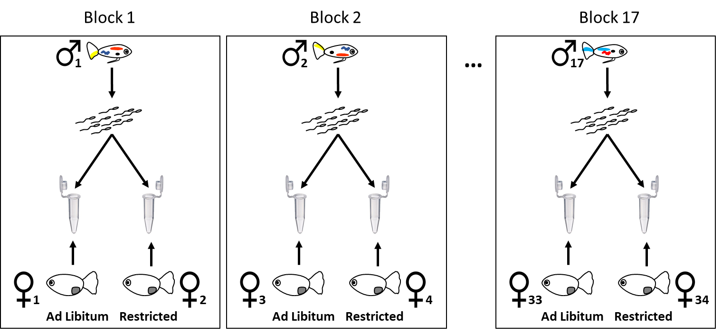
Figure 1S. Schematic diagram showing the experimental design. We used a different individual male and two individual females in each of the 17 experimental blocks. Each ejaculate (n=17) was split into two aliquots which were used to measure sperm velocity in the presence of the ovarian fluid (OF) of one ad libitum-diet female (n=17) and one restricted diet female (n=17).

Figure 2S

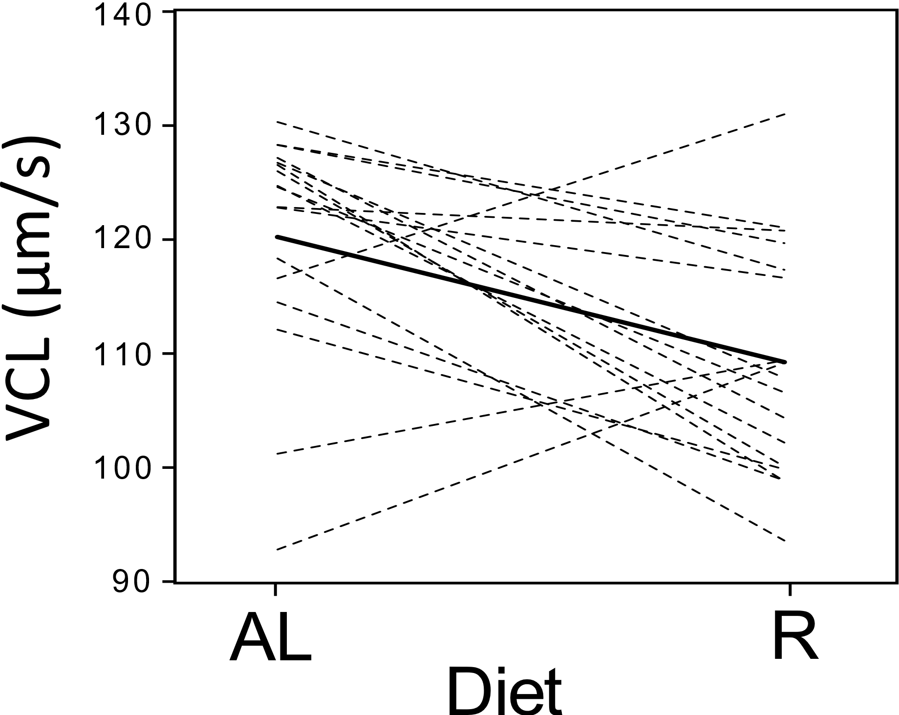
Figure 2S. In vitro sperm velocity (VCL) in the ovarian fluid (OF) of females that were maintained at restricted (R) or ad libitum (AL) diet. Dotted lines connect sperm velocity measures from the same individual male in the OF of two different individual females. Solid line represents the average velocity in the two conditions.

Figure 3S

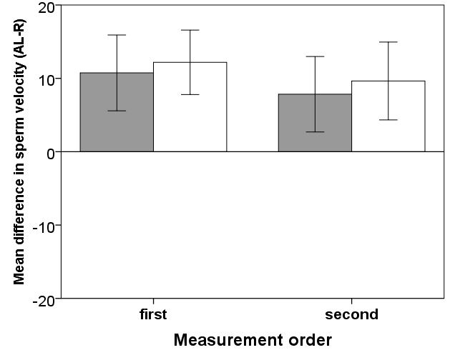

Figure 3S. Within-male difference between sperm velocity (μm^{-s}) in the ovarian fluid (OF) of females that were maintained at an ad libitum (AL) and a restricted (R) diet, in relation to measurement order. Positive values indicate that sperm swimming velocity was higher, on average, in the OF of AL females (VAP =grey bars; VCL = white bars; means ± SE) than in the OF of R females.

Supplementary tables

Table 1S. Non-parametric analysis (Wilcoxon signed-rank test) of the effect of the ovarian fluid on sperm velocity in relation to female diet. Each male’s (n=17) sperm swimming velocity was measured in the OF of a different individual female, one previously maintained at an ad libitum diet (AL, n=17) and one at a restricted diet (R, n=17)
Sperm velocity  measure | Diet | Median  (IQ range) | Median difference  (IQ range) | Wilcoxon W | P
VAP (μm^{-s}) | AL | 99.4 (84.2; 101.0) | 12.4 (-1.6; 19.5) | 123 | 0.027
 | R | 84.0 (73.3; 97.8)
VCL (μm^{-s}) | AL | 120.2 (115.6; 127.0) | 13.0 (4.1; 22.7) | 131 | 0.008
 | R | 107.9 (100.0; 118.5)

Table 2S. Within-male effect of the order of analysis on sperm velocity (mean ± SE) in the ovarian fluid of a R and an AL female (repeated measure ANOVA; factor = analysis order). Each male’s (n=17) sperm velocity was measured in the OF of a different ad libitum- (AL, n=17) and restricted-diet female (R, n=17)
Sperm velocity  Measure | Diet | First | N | Second | N | F_{treatment} | P | F_{order} | P
VAP (μm^{-s}) | AL | 99.3±3.2 | 9 | 88.8±4.6 | 8 | 6.44 | 0.023 | 0.16 | 0.70
 | R | 81.0±3.5 | 8 | 88.6±5.0 | 9
VCL (μm^{-s}) | AL | 124.5±1.5 | 9 | 115.4±4.5 | 8 | 10.21 | 0.006 | 0.14 | 0.72
 | R | 105.8±2.2 | 8 | 112.3±4.2 | 9

