Electronic Supplementary Material. Isolation by Environment in the Highly Mobile Olive Ridley Turtle (Lepidochelys olivacea) in the eastern Pacific.

Clara J. Rodríguez-Zárate, Jonathan Sandoval-Castillo, Erik van Sebille, Robert G. Keane, Axayácatl Rocha-Olivares, Jose Urteaga, and Luciano B. Beheregaray

Contents

Annex 1. Details on remote sensing environmental data source information.
Annex 2. Details on the BIOENV and pRDA analyses.
Figure S1. Annual variability of environmental variables in the Eastern Pacific for different seasons: migration to feeding grounds (Jan-Mar, FEED); migration to
breeding areas (April, MIG); mating (May-Jun, MATE); start of nesting season (Jul-Sep, NES1); ending of nesting season (Oct-Dec, NES2). (a) sea surface temperature; (b) chlorophyll_a; (c) sea surface height dynamic; (d) Thermocline depth.
Figure S2. Genetic clusters summarizing population structure. Factorial component analysis (FCA) for 22 (a) and 27 (b) sampling sites, dots of different colours
identify individuals from different genetic clusters.
Figure S3. Scatter plot of Isolation by Distance (IBD) correlation for olive ridley turtles in the eastern Pacific based on F_{ST} and D_{EST} genetic distances.
Figure S4. Spatial autocorrelation coefficient (r) for nesting colonies of olive ridleys in the eastern Pacific over a range of distance classes with 95% confidence
level (upper (U) and lower (L) confidence limits).
Figure S5. Mantel correlograms indicating correlation between genetic distance (DEST) and Euclidean environmental distances. (a) sea surface temperature (SST),
(b) chlorophyll concentration (Chl_a), (c) sea surface high anomaly (SSH) and (d) thermocline depth (Therm) at different seasons. White and black squares
represent non-significant and significant relationships between genetic and Euclidean/environmental distances for the different distance classes, respectively.
Figure S6. Connectivity matrix for olive ridley turtles in the eastern Pacific based on Lagrangian particle simulations. (a) particles released on 22 nesting sites
during the mating season and tracked back 150 days; (b) particles released on 22 nesting sites during nesting season and tracked back in time 120 days; and (c) particles released on 27 nesting sites during nesting season and tracked back in time 120 days.
Figure S7. Lagrangian particles distribution for olive ridley turtles in the eastern Pacific (a) particles released on 22 nesting sites during the mating season and
tracked back in time 150 days; (b) particles released on 22 nesting sites during nesting season and tracked back in time 185 days; and (c) particles released on 27 nesting sites during nesting season and tracked back in time 185 days. Distribution of particles shows two spatially distinct groups in the eastern Pacific (a northern population: green particles; and a southern population: red particles).
Figure S8. Triplot summarizing the first two axes of the statically significant partial redundancy analysis (RDA, P=0.002). Environmental factors are represented as
blue vectors where the direction of the arrowhead indicates high values and length of each vector represents the magnitude of their contribution to the model.
Sampling localities are represented by number and ordered from north to south.
Table S1. Detailed summary statistics of genetic diversity based on ten microsatellite markers for 22 nesting areas of olive ridley in the eastern Pacific.
Table S2. Summary statistics of genetic diversity based on ten microsatellite markers for 22 nesting areas of olive ridley turtles in the eastern Pacific.
Table S3. Pairwise comparisons of FST (below the diagonal) and DEST (above the diagonal) for 22 nesting areas of olive ridley turtles in the eastern Pacific. Bold
indicate significant values (P<0.05).
Table S4. First generation migrants of olive ridley turtle based on likelihood probabilities among nesting areas in the eastern Pacific.
Table S5. Summary of isolation by distance tests conducted on nesting colonies of olive ridley turtles at different geographic scales. Results of partial Mantel tests
corrected by regional population clustering are also shown. Significant tests are denoted in bold.
Table S6. Results of associations between environmental heterogeneity and genetic structure showing posterior probabilities of the most probable model for the
GESTE analysis and the best fit obtained with the BIOENV procedure for olive ridley turtles in the eastern Pacific in different seasons. Population structure for GESTE analysis is based on population specific’s F_{ST} only.
Table S7. Sum of posterior probabilities of models that include a given factor. These results are from five seasonal GESTE analyses that included six
factors. Shown in bold are the values from factors with a posterior probability > 0.1, which were selected for the final GESTE run.
Table S8. Results of Mantel tests and partial Mantel tests between genetic differentiation of olive ridley turtle nesting colonies in the eastern Pacific and pairwise
differences in sea surface temperature (SST), chlorophyll concentration (Chl_a), sea surface high anomaly (SSH) and thermocline depth (Therm) at different seasons. The controlled variable in the partial Mantel tests is indicated in parentheses. Significant tests are denoted in bold.
Table S9. Results of stepwise multiple regression analysis indicating associations between environmental heterogeneity and genetic structure for olive ridley
turtles in the eastern Pacific in different seasons. Results are shown for two different estimators of genetic differentiation D_{EST} and F_{ST} as response variables.

Annex 1. Details on remote sensing environmental data source information.

Environmental data was obtained from remote sensing and float data.

Sources for remote sensing data information included: AVHRR Pathfinder SST data Version 5.2 from US National Oceanographic Data Center and GHRSST (http://pathfinder.nodc.noaa.gov); Chl_a Ocean Color Data NASA/MODIS-Aqua Sensor (http://oceancolor.gsfc.nasa.gov/); AVISO SSH data (http://www.aviso.oceanobs.com/duacs/); and MBT, XBT, and CTD profiles from World Ocean Database (WOD) 2009 (http://www.nodc.noaa.gov/OC5/WOD09/pr_wod09.html) for thermocline data.

Annex 2. Details on the BIOENV and pRDA analyses.

We used the BIOENV procedure in R (Clarke & Ainsworth 1993), which calculates the Spearman’s rank correlation coefficient (r) between predictor and response variables (genetic distances), to select among all possible subsets of environmental variables the ‘best fit’ or combination of predictor variables with the highest value of r.

Additionally, a partial redundancy analysis (pRDA) was included as a complementary use to assess the effect of environmental variation on the patterns of genetic structure while controlling for the effects of isolation by distance. For the explanatory variables, we used the absolute values of four environmental factors (SST, Chla, SSH, and Therm) for each season. In addition, we considered the advection connectivity as the total number of migrants (emigrants and immigrants) per locality, calculated from Lagrangian particle simulation results. The pairwise geographic distances between sampling localities was used to perform multidimensional scaling (MDS) and calculate synthetic coordinates with the R function cmdscale. These synthetic coordinates were then used to control for spatial genetic structure. To avoid collinearity of explanatory variables in the RDA model, variance inflation factor (VIF) analysis was used to exclude highly correlated variables in a stepwise manner until remaining variables were below a VIF threshold of 10 (Dyer et al. 2010). RDA was performed using all variables retained, and the best model was selected using a stepwise model selection by Akaike information criterion implemented in the R package MASS (Venables and Ripley 2002). Significance of the final model was assessed by 1000 ANOVA permutations.
References for Annex 2:
- Clarke, KR & Ainsworth, M (1993) A method of linking multivariate community structure to environmental variables. Marine Ecology Progress Series, 92, 205-219.
- Dyer RJ, Nason JD, Garrick RC (2010) Landscape modelling of gene flow: improved power using conditional genetic distance derived from the topology of population networks. Molecular Ecology, 19, 3746–3759.
- Venables, WN & Ripley, BD (2002) Modern Applied Statistics with S. Fourth Edition. Springer, New York.

- 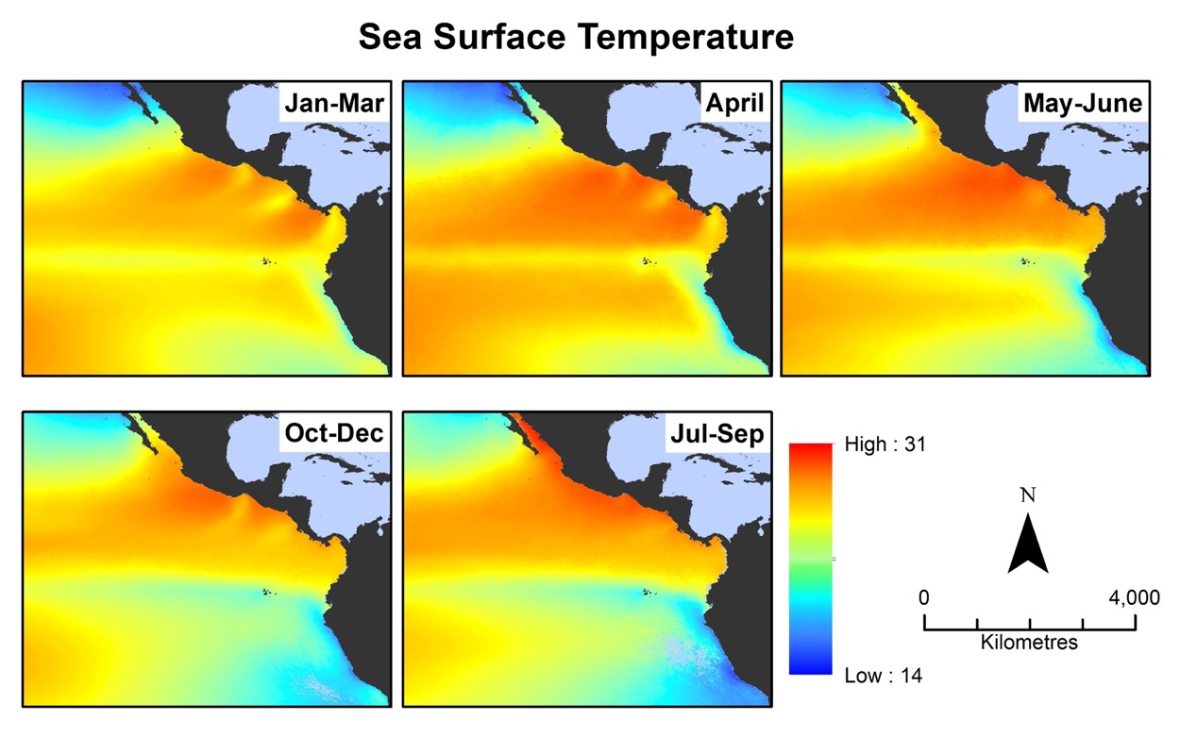

- 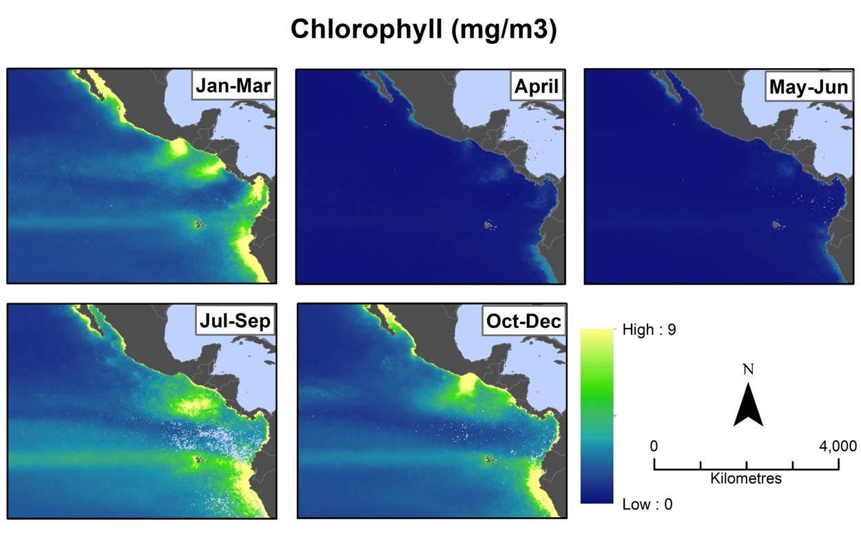

- 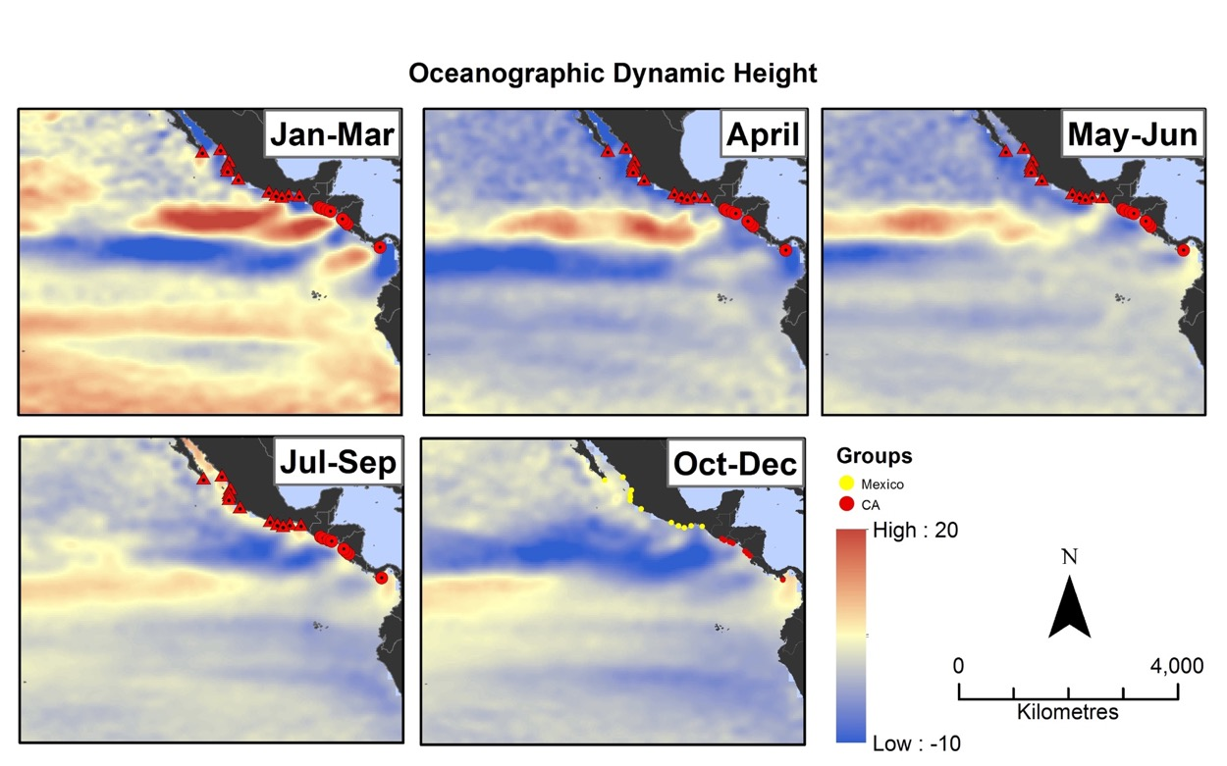

- 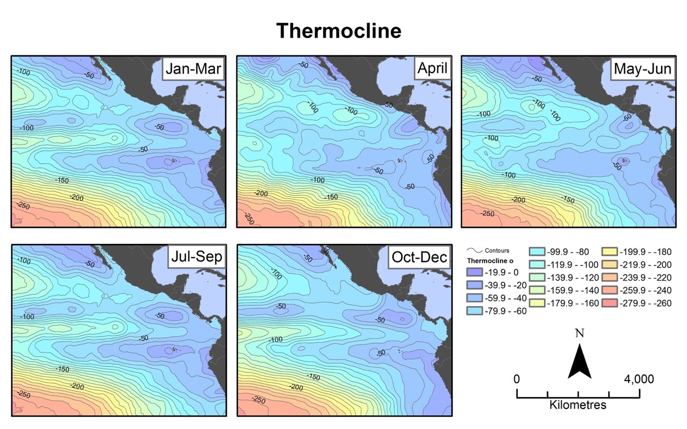

Figure S1. Annual variability of environmental variables in the Eastern Pacific for different seasons: migration to feeding grounds (Jan-Mar, FEED); migration to breeding areas (April, MIG); mating (May-Jun, MATE); start of nesting season (Jul-Sep, NES1); ending of nesting season (Oct-Dec, NES2). (a) sea surface temperature; (b) chlorophyll_a; (c) sea surface height dynamic; (d) Thermocline depth.

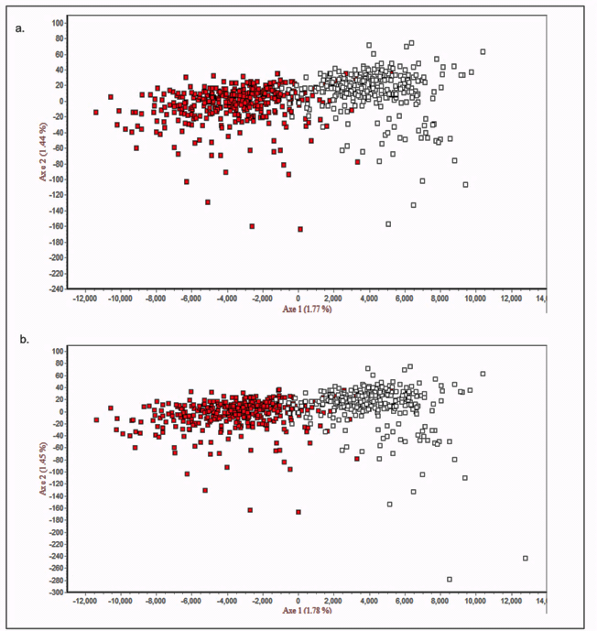
Figure S2. Genetic clusters summarizing population structure. Factorial component analysis (FCA) for 22 (a) and 27 (b) sampling sites, dots of different colours identify individuals from different genetic clusters.

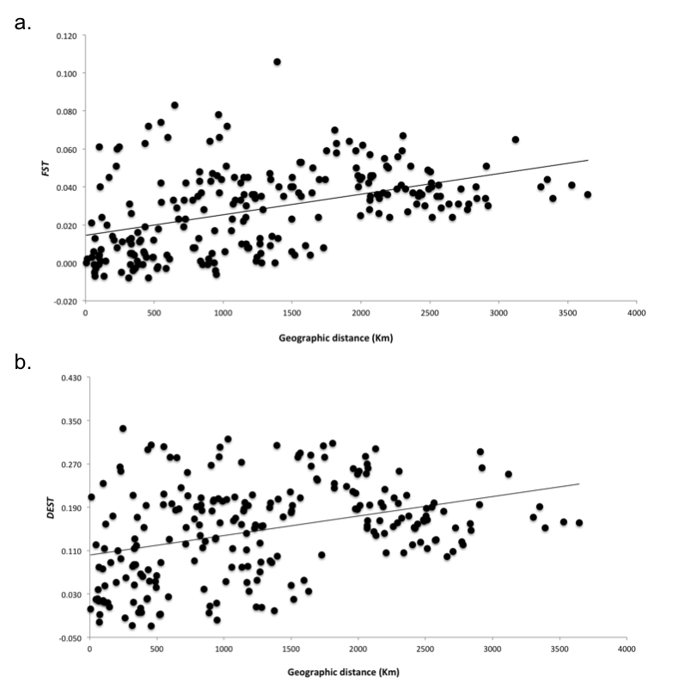
Figure S3. Scatter plot of Isolation by Distance (IBD) correlation for olive ridley turtles in the eastern Pacific based on F_{ST} and D_{EST} genetic distances.

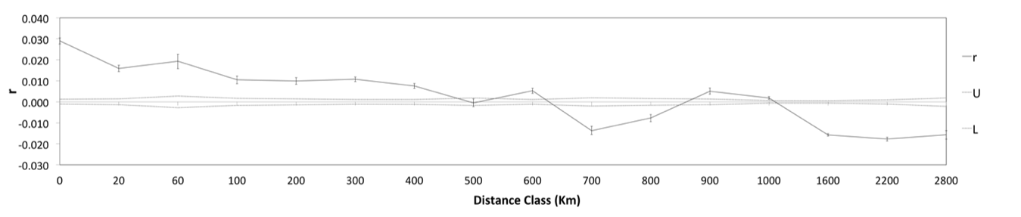

Figure S4. Spatial autocorrelation coefficient (r) for nesting colonies of olive ridleys in the eastern Pacific over a range of distance classes with 95% confidence level (upper (U) and lower (L) confidence limits).

 | (a) | (b) | (c) | (d)
FEED | 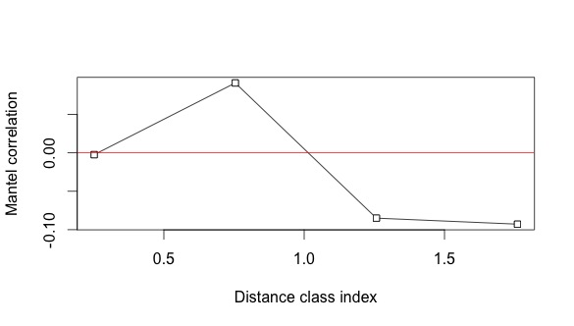 | 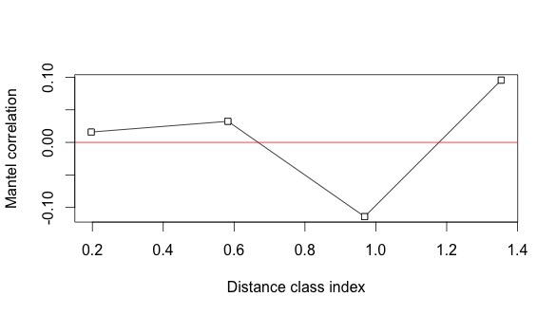 | 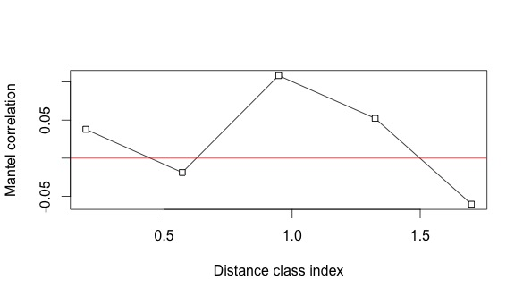 | 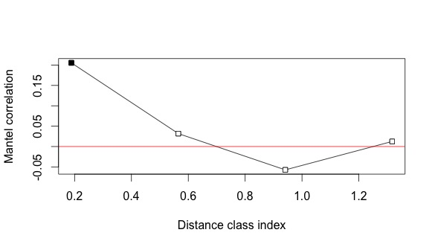
MIG | 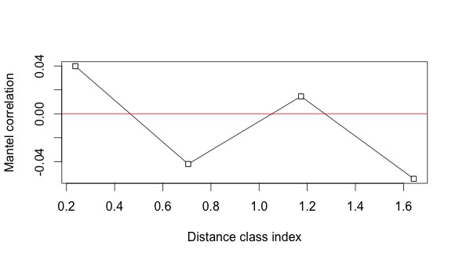 | 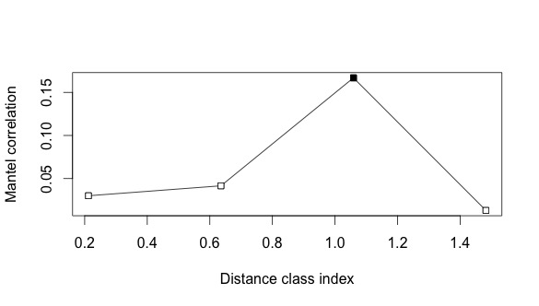 | 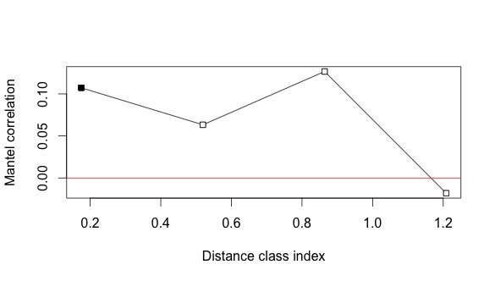 | 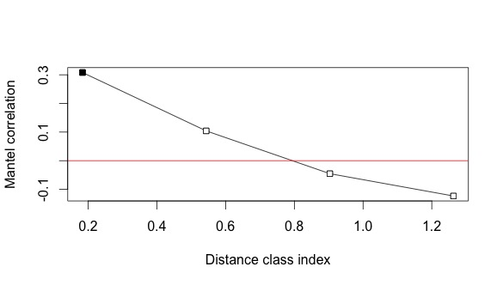
MATE | 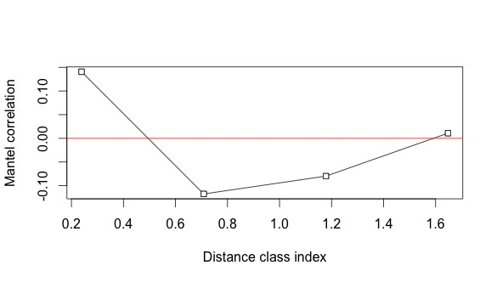 | 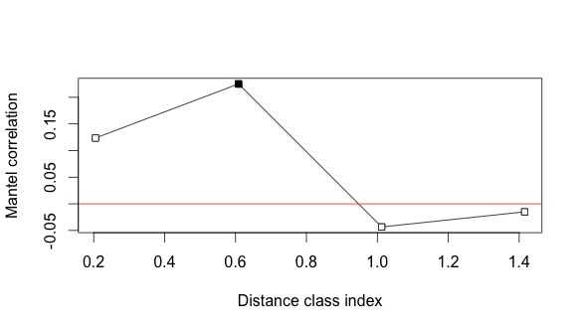 | 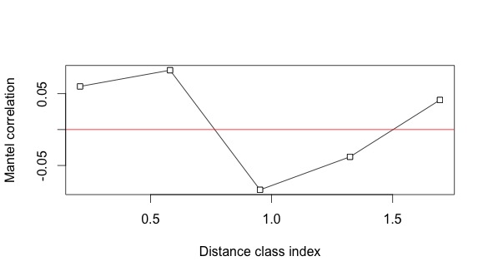 | 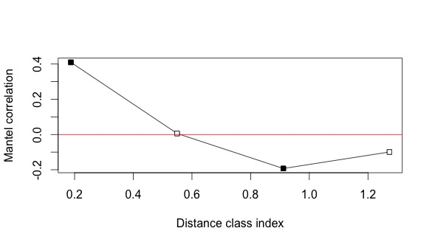

Figure S5. Mantel correlograms indicating correlation between genetic distance (DEST) and Euclidean environmental distances (a) sea surface temperature (SST), (b) chlorophyll concentration (Chl_a), (c) sea surface high anomaly (SSH) and (d) thermocline depth (Therm) at different seasons. White and black squares represent non-significant and significant relationships between genetic and Euclidean/environmental distances for the different distance classes, respectively

 | (a) | (b) | (c) | (d)
NES1 | 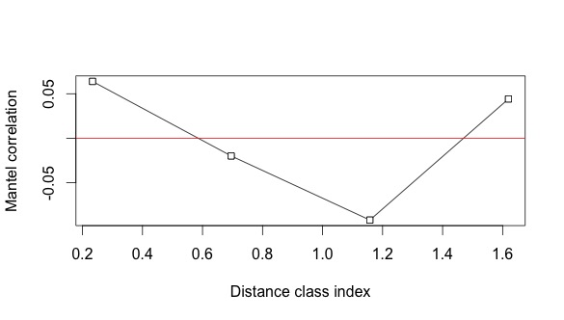 | 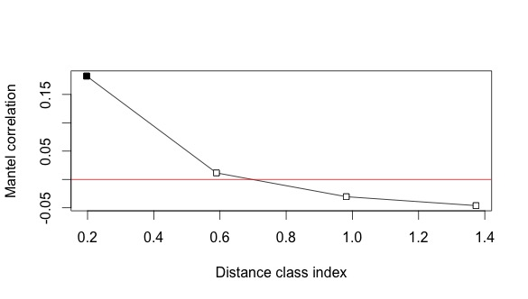 | 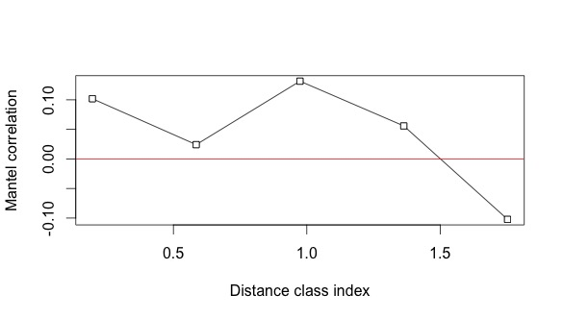 | 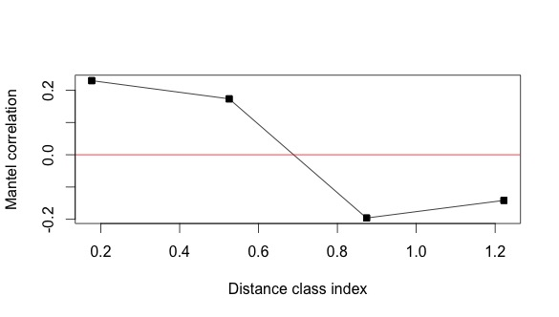
NES2 | 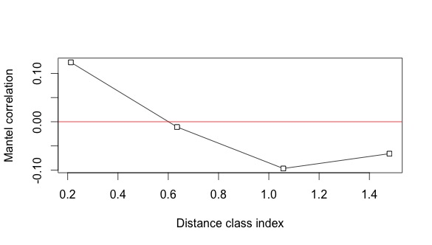 | 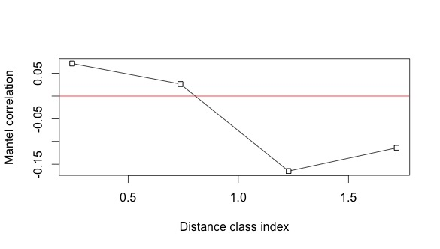 | 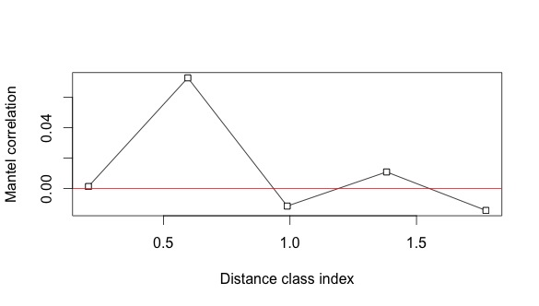 | 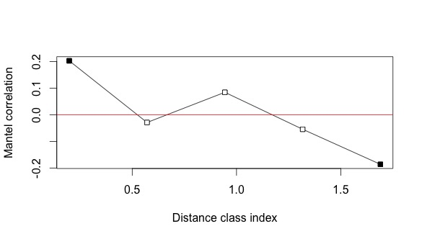

Figure S5. Cont. Mantel correlograms indicating correlation between genetic distance (DEST) and Euclidean environmental distances (a) sea surface temperature (SST), (b) chlorophyll concentration (Chl_a), (c) sea surface high anomaly (SSH) and (d) thermocline depth (Therm) at different seasons. White and black squares represent non-significant and significant relationships between genetic and Euclidean/environmental distances for the different distance classes, respectively.

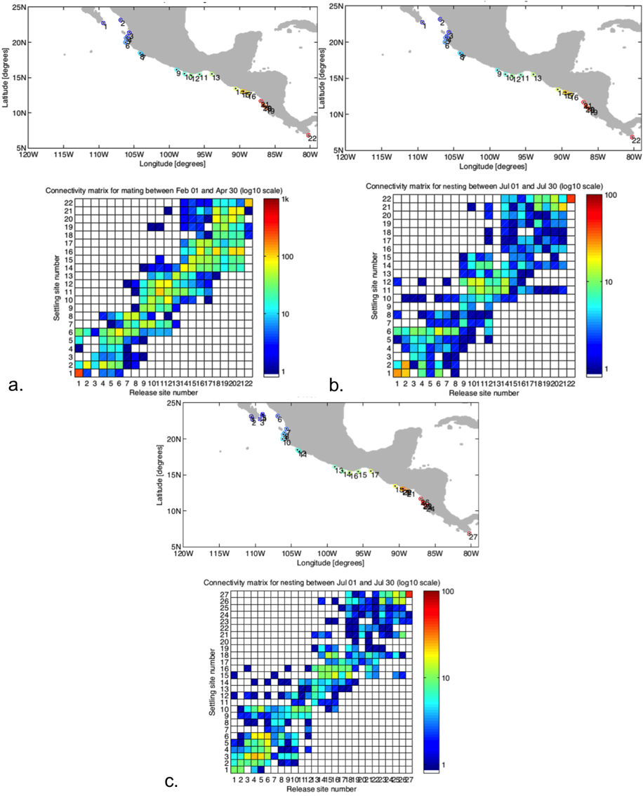
Figure S6. Connectivity matrix for olive ridley turtles in the eastern Pacific based on legrarian particles simulations. (a) particles released on 22 nesting sites during the mating season and tracked back in time 150 days; (b) particles released on 22 nesting sites during nesting season and tracked back in time 120 days; and (c) particles released on 27 nesting sites during nesting season and tracked back in time 120 days.

Figure S7. Lagrangian particles distribution for olive ridley turtles in the eastern Pacific (a) particles released on 22 nesting sites during the mating season and tracked back in time 150 days; (b) particles released on 22 nesting sites during nesting season and tracked back in time 185 days; and (c) particles released on 27 nesting sites during nesting season and tracked back in time 185 days. Distribution of particles shows two spatially distinct groups in the eastern Pacific (a northern population: green particles; and a southern population: red particles).

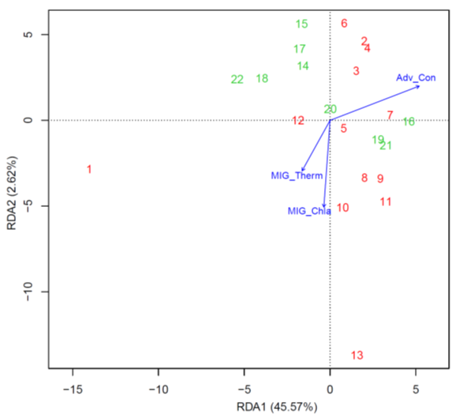

Figure S8. Triplot summarizing the first two axes of the statically significant partial redundancy analysis (RDA, P=0.002). Environmental factors are represented as blue vectors where the direction of the arrowhead indicates high values and length of each vector represents the magnitude of their contribution to the model. Sampling localities are represented by number and ordered from north to south.

Table S1. Detailed summary statistics of genetic diversity based on ten microsatellite markers for 22 nesting areas of olive ridley in the eastern Pacific.
Locus |  |  |  |  |  |  |  |  |  |  | Location
 | BCP N=80 | EVE N=18 | PLA N=21 | NVA N=20 | PVG N=25 | MIS  N=25 | PTI  N=15 | BAP N=21 | TCO N=18 | SJC N=30 |  | BCR N=24 | ESC  N=40 | PAR N=28 | GH  N=40 | SPD  N=38 | SJG  N=15 | SB  N=38 | NC  N=50 | NF  N=52 | NV  N=30 | NS  N=20 | PMA  N=60 | Mean  N_{A}
OR2
N_{A} | 12 | 6 | 8 | 7 | 6 | 2 | 6 | 5 | 6 | 9 |  | 7 | 7 | 5 | 13 | 10 | 6 | 9 | 9 | 6 | 7 | 7 | 9 | 7.2
Ho | 0.479 | 0.177 | 0.556 | 0.368 | 0.526 | 0.150 | 0.400 | 0.500 | 0.333 | 0.792 |  | 0.200 | 0.364 | 0.214 | 0.649 | 0.790 | 0.83 | 0.842 | 0.796 | 0.550 | 0.733 | 0.70 | 0.804
He | 0.748 | 0.762 | 0.831 | 0.765 | 0.779 | 0.224 | 0.888 | 0.747 | 0.775 | 0.691 |  | 0.787 | 0.765 | 0.484 | 0.739 | 0.787 | 0.79 | 0.835 | 0.792 | 0.776 | 0.705 | 0.78 | 0.729
AR | 4.581 | 4.431 | 5.335 | 4.442 | 4.401 | 1.783 | 6 | 4.11 | 4.68 | 4.228 |  | 4.614 | 4.464 | 3.299 | 4.756 | 4.953 | 4.76 | 5.372 | 5.02 | 4.438 | 4.15 | 4.90 | 4.406
F_{IS} | 0.362 | 0.774 | 0.339 | 0.525 | 0.331 | 0.337 | 0.579 | 0.339 | 0.581 | -0.14 |  | 0.751 | 0.529 | 0.567 | 0.124 | -0.002 | -0.04 | -0.008 | -0.00 | 0.297 | -0.04 | 0.11 | -0.102
OR4
N_{A} | 18 | 14 | 15 | 12 | 15 | 14 | 13 | 14 | 14 | 14 |  | 16 | 20 | 13 | 15 | 15 | 9 | 16 | 16 | 13 | 15 | 13 | 17 | 14.7
Ho | 0.809 | 0.800 | 0.950 | 0.824 | 1.000 | 0.727 | 0.857 | 0.933 | 0.889 | 0.786 |  | 0.833 | 0.946 | 0.833 | 0.921 | 0.849 | 0.66 | 0.973 | 0.898 | 0.800 | 0.900 | 0.95 | 0.893
He | 0.927 | 0.905 | 0.929 | 0.900 | 0.918 | 0.930 | 0.936 | 0.928 | 0.941 | 0.900 |  | 0.931 | 0.933 | 0.912 | 0.918 | 0.915 | 0.88 | 0.930 | 0.912 | 0.919 | 0.920 | 0.92 | 0.926
AR | 7.389 | 7.107 | 7.393 | 6.738 | 7.246 | 7.343 | 7.525 | 7.449 | 7.686 | 6.8 |  | 7.462 | 7.612 | 6.966 | 7.1 | 6.977 | 6.26 | 7.411 | 6.997 | 7.184 | 7.176 | 7.10 | 7.31
F_{IS} | 0.129 | 0.12 | -0.02 | 0.088 | -0.09 | 0.222 | 0.088 | -0.00 | 0.057 | 0.13 |  | 0.108 | -0.01 | 0.089 | -0.003 | 0.074 | 0.25 | -0.047 | 0.016 | 0.134 | 0.022 | -0.03 | 0.037
OR7
N_{A} | 13 | 6 | 11 | 7 | 8 | 3 | 6 | 5 | 9 | 9 |  | 8 | 8 | 7 | 9 | 10 | 7 | 10 | 13 | 7 | 9 | 9 | 12 | 7.7
Ho | 0.753 | 0.688 | 0.810 | 0.333 | 0.650 | 0.333 | 0.857 | 0.833 | 0.824 | 0.786 |  | 0.792 | 0.816 | 0.600 | 0.737 | 0.686 | 0.50 | 0.730 | 0.796 | 0.579 | 0.700 | 0.80 | 0.786
He | 0.821 | 0.592 | 0.855 | 0.722 | 0.680 | 0.318 | 0.764 | 0.735 | 0.771 | 0.772 |  | 0.753 | 0.745 | 0.811 | 0.744 | 0.770 | 0.67 | 0.763 | 0.774 | 0.692 | 0.773 | 0.81 | 0.73
AR | 5.325 | 3.801 | 5.958 | 4.098 | 4.008 | 2.667 | 4.243 | 4.134 | 4.813 | 4.96 |  | 4.679 | 4.656 | 4.952 | 4.636 | 4.884 | 4.29 | 4.884 | 4.883 | 4.385 | 4.61 | 5.25 | 5.349
F_{IS} | 0.08 | -0.16 | 0.056 | 0.546 | 0.046 | -0.05 | -0.12 | -0.14 | -0.06 | -0.01 |  | -0.05 | -0.09 | 0.267 | 0.011 | 0.112 | 0.27 | 0.045 | -0.02 | 0.168 | 0.007 | -0.03 | 0.032
OR11
N_{A} | 22 | 12 | 15 | 13 | 15 | 13 | 12 | 16 | 12 | 18 |  | 11 | 18 | 15 | 19 | 19 | 12 | 17 | 17 | 16 | 16 | 15 | 17 | 14.8
Ho | 0.908 | 0.722 | 0.800 | 0.800 | 0.920 | 0.957 | 1.000 | 0.857 | 0.778 | 0.900 |  | 0.833 | 0.795 | 0.821 | 0.892 | 0.947 | 1.00 | 0.974 | 0.857 | 0.810 | 0.933 | 0.90 | 0.893
He | 0.929 | 0.905 | 0.923 | 0.906 | 0.934 | 0.909 | 0.913 | 0.923 | 0.900 | 0.936 |  | 0.894 | 0.931 | 0.883 | 0.920 | 0.920 | 0.90 | 0.918 | 0.892 | 0.913 | 0.914 | 0.92 | 0.917
AR | 7.421 | 6.824 | 7.295 | 6.788 | 7.473 | 6.857 | 6.905 | 7.402 | 6.668 | 7.639 |  | 6.437 | 7.466 | 6.617 | 7.256 | 7.232 | 6.98 | 7.188 | 6.611 | 7.193 | 7.099 | 7.33 | 7.107
F_{IS} | 0.023 | 0.206 | 0.136 | 0.12 | 0.015 | -0.05 | -0.09 | 0.073 | 0.139 | 0.039 |  | 0.069 | 0.148 | 0.071 | 0.031 | -0.031 | -0.10 | -0.062 | 0.04 | 0.116 | -0.02 | 0.03 | 0.026
OR16
N_{A} | 12 | 8 | 10 | 8 | 9 | 7 | 13 | 11 | 10 | 10 |  | 8 | 10 | 8 | 10 | 10 | 7 | 9 | 13 | 8 | 9 | 9 | 11 | 9.5
Ho | 0.805 | 0.647 | 0.800 | 0.294 | 0.682 | 0.625 | 0.933 | 0.688 | 0.722 | 0.571 |  | 1.000 | 0.838 | 0.630 | 0.763 | 0.737 | 0.58 | 0.658 | 0.796 | 0.611 | 0.700 | 0.80 | 0.714
He | 0.802 | 0.702 | 0.814 | 0.781 | 0.755 | 0.720 | 0.883 | 0.849 | 0.843 | 0.671 |  | 0.844 | 0.773 | 0.655 | 0.760 | 0.765 | 0.70 | 0.729 | 0.772 | 0.808 | 0.706 | 0.77 | 0.806
AR | 5.126 | 4.699 | 5.514 | 4.726 | 4.617 | 4.373 | 6.53 | 6.047 | 5.683 | 4.461 |  | 5.615 | 4.97 | 3.636 | 4.871 | 4.818 | 4.31 | 4.554 | 4.82 | 5.35 | 4.632 | 5.25 | 5.195
F_{IS} | -0.00 | 0.081 | 0.081 | 0.018 | 0.63 | 0.099 | 0.134 | -0.05 | 0.195 | 0.147 |  | 0.151 | -0.19 | -0.08 | 0.039 | -0.005 | 0.03 | 0.176 | 0.098 | -0.03 | 0.249 | 0.00 | 0.115
OR20
N_{A} | 9 | 7 | 8 | 9 | 9 | 7 | 7 | 10 | 9 | 7 |  | 7 | 9 | 8 | 8 | 8 | 6 | 7 | 9 | 7 | 9 | 5 | 7 | 7.2
Ho | 0.718 | 0.778 | 0.900 | 0.900 | 0.440 | 0.680 | 0.636 | 0.800 | 0.706 | 0.667 |  | 0.643 | 0.649 | 0.679 | 0.790 | 0.790 | 0.75 | 0.790 | 0.755 | 0.600 | 0.633 | 0.50 | 0.673
He | 0.835 | 0.849 | 0.844 | 0.824 | 0.826 | 0.816 | 0.848 | 0.865 | 0.845 | 0.821 |  | 0.815 | 0.791 | 0.826 | 0.803 | 0.776 | 0.82 | 0.816 | 0.804 | 0.776 | 0.811 | 0.80 | 0.771
AR | 5.215 | 5.32 | 5.407 | 5.286 | 5.236 | 5.145 | 5.37 | 5.866 | 5.504 | 4.915 |  | 4.832 | 4.667 | 5.17 | 4.865 | 4.594 | 5.01 | 4.788 | 4.859 | 4.546 | 4.895 | 4.47 | 4.291
F_{IS} | 0.141 | 0.086 | -0.06 | -0.09 | 0.473 | 0.17 | 0.259 | 0.077 | 0.169 | 0.191 |  | 0.217 | 0.182 | 0.181 | 0.017 | -0.017 | 0.09 | 0.033 | 0.062 | 0.231 | 0.222 | 0.38 | 0.129
OR1
N_{A} | 18 | 10 | 11 | 11 | 12 | 14 | 12 | 11 | 12 | 14 |  | 9 | 12 | 13 | 11 | 10 | 8 | 9 | 11 | 10 | 11 | 11 | 13 | 9.7
Ho | 0.923 | 0.777 | 0.809 | 0.944 | 0.84 | 0.92 | 0.846 | 0.95 | 0.888 | 0.928 |  | 0.736 | 0.891 | 0.888 | 0.868 | 0.789 | 0.833 | 0.789 | 0.938 | 0.937 | 0.866 | 0.95 | 0.857
He | 0.907 | 0.890 | 0.878 | 0.911 | 0.900 | 0.900 | 0.898 | 0.906 | 0.924 | 0.906 |  | 0.882 | 0.911 | 0.883 | 0.872 | 0.886 | 0.855 | 0.882 | 0.884 | 0.903 | 0.902 | 0.873 | 0.884

Table S1 cont. Detailed summary statistics of genetic diversity based on ten microsatellite markers for 22 nesting areas of olive ridley turtles in the eastern Pacific.
Locus | Location
BCP N=80 | EVE N=18 | PLA N=21 | NVA N=20 | PVG N=25 | MIS  N=25 | PTI  N=15 | BAP N=21 | TCO N=18 | SJC N=30 | BCR N=24 | ESC  N=40 | PAR N=28 | GH  N=40 | SPD  N=38 | SJG  N=15 | SB  N=38 | NC  N=50 | NF  N=52 | NV  N=30 | NS  N=20 | PMA  N=60 | Mean  N_{A}
AR | 6.882 | 6.349 | 6.078 | 6.79 | 6.556 | 6.785 | 6.731 | 6.666 | 7.17 | 6.787 | 6.088 | 6.813 | 6.303 | 6.075 | 6.187 | 5.884 | 6.094 | 6.208 | 6.592 | 6.542 | 6.191 | 6.263
F_{IS} | -0.01 | 0.13 | 0.08 | -0.03 | 0.068 | -0.02 | 0.06 | -0.04 | 0.039 | -0.02 | 0.168 | 0.021 | -0.00 | 0.004 | 0.11 | 0.02 | 0.106 | -0.06 | -0.03 | 0.039 | -0.09 | 0.031
OR9
N_{A} | 8 | 4 | 5 | 4 | 5 | 4 | 4 | 5 | 4 | 5 | 5 | 7 | 5 | 6 | 5 | 3 | 5 | 4 | 3 | 4 | 7 | 5 | 5.0
Ho | 0.304 | 0.278 | 0.286 | 0.263 | 0.360 | 0.208 | 0.267 | 0.286 | 0.222 | 0.600 | 0.231 | 0.308 | 0.250 | 0.500 | 0.342 | 0.16 | 0.316 | 0.367 | 0.286 | 0.300 | 0.35 | 0.286
He | 0.332 | 0.257 | 0.305 | 0.245 | 0.322 | 0.445 | 0.303 | 0.265 | 0.259 | 0.567 | 0.600 | 0.518 | 0.263 | 0.480 | 0.306 | 0.30 | 0.285 | 0.369 | 0.261 | 0.273 | 0.36 | 0.302
AR | 2.44 | 2.191 | 2.51 | 2.138 | 2.453 | 2.744 | 2.386 | 2.282 | 2.246 | 3.426 | 3.678 | 3.367 | 2.241 | 3.22 | 2.386 | 2.23 | 2.286 | 2.573 | 2.136 | 2.222 | 2.88 | 2.339
F_{IS} | 0.085 | -0.08 | 0.066 | -0.07 | -0.12 | 0.537 | 0.125 | -0.08 | 0.145 | -0.05 | 0.625 | 0.409 | 0.05 | -0.04 | -0.11 | 0.45 | -0.10 | 0.005 | -0.09 | -0.10 | 0.03 | 0.056
OR14
N_{A} |  |  |  |  |  |  |  |  |  |  |  |  |  |  |  |  |  |  |  |  |  |  | 19.9
Ho | 0.896 | 0.889 | 0.952 | 0.889 | 0.960 | 0.917 | 0.933 | 0.905 | 0.875 | 0.933 | 0.875 | 0.921 | 0.857 | 0.947 | 0.974 | 0.72 | 0.895 | 0.918 | 0.947 | 0.900 | 0.89 | 0.891
He | 0.946 | 0.962 | 0.951 | 0.946 | 0.944 | 0.947 | 0.968 | 0.954 | 0.952 | 0.949 | 0.934 | 0.960 | 0.933 | 0.942 | 0.940 | 0.95 | 0.935 | 0.950 | 0.882 | 0.943 | 0.95 | 0.942
AR | 7.986 | 8.387 | 8.114 | 7.9 | 7.983 | 7.938 | 8.611 | 8.172 | 8.077 | 8.047 | 7.752 | 8.389 | 7.607 | 7.916 | 7.798 | 8.01 | 7.737 | 8.091 | 6.474 | 7.915 | 8.19 | 7.835
F_{IS} | 0.053 | 0.078 | -0.00 | 0.062 | -0.01 | 0.033 | 0.037 | 0.052 | 0.083 | 0.017 | 0.064 | 0.041 | 0.083 | -0.00 | -0.03 | 0.24 | 0.043 | 0.034 | -0.07 | 0.046 | 0.06 | 0.055
OR22
N_{A} | 13 | 9 | 8 | 9 | 9 | 7 | 9 | 9 | 9 | 11 | 7 | 10 | 9 | 8 | 9 | 6 | 9 | 12 | 8 | 8 | 8 | 13 | 9.2
Ho | 0.785 | 0.833 | 0.800 | 0.368 | 0.680 | 0.750 | 1.000 | 0.714 | 0.833 | 0.690 | 0.783 | 0.825 | 0.654 | 0.684 | 0.684 | 0.45 | 0.703 | 0.796 | 0.600 | 0.586 | 0.73 | 0.714
He | 0.792 | 0.716 | 0.787 | 0.787 | 0.760 | 0.761 | 0.841 | 0.825 | 0.775 | 0.723 | 0.716 | 0.779 | 0.793 | 0.672 | 0.731 | 0.61 | 0.733 | 0.742 | 0.738 | 0.632 | 0.70 | 0.789
AR | 5.104 | 4.58 | 5.018 | 4.796 | 4.599 | 4.515 | 5.547 | 5.309 | 4.898 | 4.849 | 4.15 | 5.045 | 5.035 | 4.065 | 4.47 | 3.78 | 4.635 | 4.531 | 4.757 | 4.073 | 4.69 | 5.117
F_{IS} | 0.009 | -0.17 | -0.01 | 0.538 | 0.107 | 0.014 | -0.19 | 0.137 | -0.07 | 0.047 | -0.09 | -0.05 | 0.179 | -0.01 | 0.065 | 0.27 | 0.041 | -0.07 | 0.191 | 0.073 | -0.04 | 0.096
Multilocus
N_{A} | 15.4 | 9.4 | 11 | 9.7 | 11.1 | 9 | 10 | 10.6 | 10.2 | 11.8 | 9.8 | 12.5 | 10.4 | 12.3 | 12 | 7.7 | 11.4 | 13.1 | 9.2 | 11 | 10.3 | 12.9
He | 0.798 | 0.732 | 0.791 | 0.757 | 0.764 | 0.680 | 0.789 | 0.777 | 0.774 | 0.78 | 0.793 | 0.800 | 0.727 | 0.775 | 0.769 | 0.72 | 0.772 | 0.781 | 0.746 | 0.738 | 0.76 | 0.781
AR | 5.747 | 5.369 | 5.862 | 5.370 | 5.457 | 5.015 | 5.985 | 5.744 | 5.743 | 5.611 | 5.531 | 5.745 | 5.183 | 5.476 | 5.430 | 5.15 | 5.495 | 5.459 | 5.306 | 5.331 | 5.63 | 5.521
F_{IS} | 0.037 | 0.095 | 0.015 | 0.168 | 0.030 | 0.049 | -0.07 | -0.04 | 0.056 | -0.00 | 0.016 | 0.029 | 0.017 | 0.007 | 0.004 | 0.12 | 0.013 | -0.00 | 0.027 | 0.032 | 0.02 | 0.044
Multilocus excluding locus
OR2
N_{A} | 15.8 | 9.8 | 11.3 | 10.0 | 11.7 | 9.8 | 10.4 | 11.2 | 10.7 | 12.1 | 10.1 | 13.1 | 11.0 | 12.2 | 12.2 | 7.9 | 11.7 | 13.6 | 9.6 | 11.4 | 10.7 | 13.3
He | 0.811 | 0.755 | 0.810 | 0.785 | 0.784 | 0.751 | 0.818 | 0.806 | 0.803 | 0.806 | 0.821 | 0.816 | 0.775 | 0.790 | 0.779 | 0.75 | 0.777 | 0.789 | 0.768 | 0.757 | 0.78 | 0.795
AR | 6.537 | 6.094 | 6.599 | 6.057 | 6.207 | 5.961 | 6.675 | 6.606 | 6.536 | 6.421 | 6.218 | 6.567 | 5.962 | 6.167 | 6.072 | 5.75 | 6.101 | 6.098 | 5.983 | 6.077 | 6.36 | 6.257
F_{IS} | 0.054 | 0.056 | 0.025 | 0.205 | 0.074 | 0.095 | 0.004 | 0.040 | 0.067 | 0.054 | 0.090 | 0.049 | 0.110 | 0.001 | 0.031 | 0.16 | 0.024 | -0.00 | 0.108 | 0.043 | 0.03 | 0.063
(N) sample size, (N_{A}) number of alleles, (Ho) observed heterozygosity, (He) expected heterozygosity, (AR) allelic richness, (F_{IS}) coefficient of inbreeding.

Table S2 Summary statistics of genetic diversity based on ten microsatellite markers for 22 nesting areas of olive ridley turtles in the eastern Pacific.
Country | Site Number | Nesting Colony | Site Code | Sample Size | N_{A} | Ho | He | AR | F_{IS}
Mexico | 1-5 | (1)Todos Santos-Pescadero (PES)  (2)San Cristobal (SAC)  (3)San José del Cabo (SJC)  (4)Cabo Pulmo (CP)  (5)Punta Colorada-Punta Arenas (PCA) | (BCP) | 80 | 15.3 | 0.738 | 0.803 | 6.436 | 0.087
 | 6 | El Verde | (EVE) | 18 | 9.4 | 0.658 | 0.732 | 5.957 | 0.130
 | 7 | Platanitos | (PLA) | 21 | 11.1 | 0.770 | 0.789 | 6.519 | 0.049
 | 8 | Nuevo Vallarta | (NVA) | 20 | 9.7 | 0.598 | 0.757 | 5.928 | 0.237
 | 9 | PuertoVallarta / La Gloria | (PVG) | 25 | 11.3 | 0.703 | 0.690 | 6.098 | 0.103
 | 10 | Mismaloya | (MIS) | 25 | 9.2 | 0.626 | 0.690 | 5.610 | 0.118
 | 11 | Ticuiz | (PTI) | 15 | 10 | 0.781 | 0.781 | 6.491 | 0.040
 | 12 | Boca de Apiza | (BAP) | 21 | 10.7 | 0.743 | 0.779 | 6.426 | 0.074
 | 13 | Tierra Colorada | (TCO) | 18 | 10.2 | 0.712 | 0.776 | 6.390 | 0.114
 | 14 | San Juan de Chacahua | (SJC) | 30 | 11.5 | 0.738 | 0.777 | 6.194 | 0.068
 | 15 | Barra de la Cruz | (BCR) | 24 | 9.8 | 0.697 | 0.795 | 6.116 | 0.151
 | 16 | Escobilla | (ESC) | 40 | 12.7 | 0.737 | 0.801 | 6.434 | 0.094
 | 17 | Puerto Arista | (PAR) | 28 | 10.7 | 0.650 | 0.743 | 5.856 | 0.148
Guatemala | 18 | Parque el Hawaii | (GH) | 40 | 12.3 | 0.775 | 0.775 | 5.476 | 0.013
El Salvador | 19 | Playa Dorada | (SPD) | 38 | 12.0 | 0.759 | 0.769 | 5.430 | 0.027
 | 20 | San Juan del Gozo | (SJG) | 15 | 7.7 | 0.652 | 0.720 | 5.155 | 0.139
 | 21-22 | (21)Las Bocanitas, (22)SanDiego | (SB) | 38 | 11.4 | 0.767 | 0.772 | 5.495 | 0.021
Nicaragua | 23 | Chacocente | (NC) | 50 | 13.1 | 0.792 | 0.781 | 5.459 | -0.003
 | 24 | La Flor | (NF) | 52 | 9.2 | 0.672 | 0.746 | 5.306 | 0.127
 | 25 | Playa Veracruz | (NV) | 30 | 11.0 | 0.725 | 0.738 | 5.331 | 0.035
 | 26 | Playa Salamina | (NS) | 20 | 10.3 | 0.758 | 0.768 | 5.630 | 0.039
Panama | 27 | La Marinera | (PMA) | 60 | 12.9 | 0.751 | 0.781 | 5.521 | 0.047
(N_{A}) number of alleles, (Ho) observed heterozygosity, (He) expected heterozygosity, (AR) allelic richness, (F_{IS}) coefficient of inbreed. Biopsy samples were collected from 27 nesting sites and beaches with less than 15 samples were assigned to major nesting areas (n = 22) using the criterion of the geographically closest neighbour.

Table S3. Pairwise comparisons of F_{ST} (below the diagonal) and D_{EST} (above the diagonal) for 22 nesting areas of olive ridley turtles in the eastern Pacific. Bold indicate significant values (P<0.05).
 | BCP | EVE | PLA | NVA | PVG | MIS | PTI | BAP | TCO | SJC | BCR | ESC | PAR | GH | SPD | SJG | SB | NC | NF | NV | NS | PMA
BCP | - | 0.08 | 0.04 | 0.06 | 0.08 | 0.19 | 0.19 | 0.09 | 0.10 | 0.02 | 0.10 | 0.03 | 0.26 | 0.17 | 0.15 | 0.16 | 0.12 | 0.14 | 0.19 | 0.16 | 0.12 | 0.16
EVE | 0.01 | - | 0.06 | 0.11 | 0.06 | 0.07 | 0.22 | 0.18 | 0.07 | 0.08 | 0.05 | 0.04 | 0.23 | 0.14 | 0.16 | 0.12 | 0.10 | 0.15 | 0.12 | 0.10 | 0.09 | 0.16
PLA | 0.004 | 0.01 | - | 0.07 | 0.04 | 0.17 | 0.19 | 0.15 | 0.05 | 0.07 | 0.09 | 0.05 | 0.29 | 0.15 | 0.16 | 0.15 | 0.10 | 0.13 | 0.18 | 0.12 | 0.11 | 0.15
NVA | 0.01 | 0.03 | 0.01 | - | 0.12 | 0.23 | 0.11 | 0.13 | 0.13 | 0.07 | 0.12 | 0.05 | 0.21 | 0.18 | 0.16 | 0.19 | 0.14 | 0.16 | 0.19 | 0.16 | 0.15 | 0.17
PVG | 0.01 | 0.01 | 0.001 | 0.02 | - | 0.11 | 0.17 | 0.08 | 0.01 | 0.11 | 0.08 | 0.08 | 0.18 | 0.18 | 0.19 | 0.19 | 0.13 | 0.18 | 0.19 | 0.17 | 0.15 | 0.19
MIS | -0.00 | -0.00 | -0.01 | 0.02 | 0.01 | - | 0.33 | 0.25 | 0.11 | 0.20 | 0.14 | 0.16 | 0.30 | 0.22 | 0.22 | 0.19 | 0.21 | 0.25 | 0.21 | 0.19 | 0.20 | 0.25
PTI | -0.01 | -0.00 | -0.01 | -0.02 | -0.01 | -0.01 | - | 0.20 | 0.19 | 0.25 | 0.13 | 0.18 | 0.08 | 0.28 | 0.28 | 0.30 | 0.24 | 0.25 | 0.29 | 0.28 | 0.25 | 0.26
BAP | -0.00 | 0.02 | -0.00 | 0.004 | 0.006 | 0.03 | -0.02 | - | 0.13 | 0.12 | 0.20 | 0.13 | 0.18 | 0.28 | 0.26 | 0.28 | 0.24 | 0.26 | 0.27 | 0.27 | 0.25 | 0.29
TCO | 0.01 | 0.009 | 0.006 | 0.01 | -0.01 | -0.00 | -0.005 | -0.01 | - | 0.15 | 0.08 | 0.09 | 0.21 | 0.20 | 0.20 | 0.19 | 0.15 | 0.19 | 0.20 | 0.18 | 0.17 | 0.17
SJC | 0.003 | 0.01 | 0.009 | 0.01 | 0.01 | 0.000 | 0.006 | 0.009 | 0.02 | - | 0.11 | 0.01 | 0.29 | 0.19 | 0.20 | 0.20 | 0.16 | 0.19 | 0.20 | 0.18 | 0.15 | 0.22
BCR | -0.02 | -0.01 | -0.01 | -0.00 | -0.02 | -0.05 | -0.02 | -0.02 | -0.03 | -0.01 | - | 0.07 | 0.21 | 0.18 | 0.21 | 0.20 | 0.16 | 0.19 | 0.21 | 0.18 | 0.17 | 0.21
ESC | 0.004 | 0.007 | 0.004 | 0.01 | 0.005 | -0.01 | -0.00 | 0.003 | 0.009 | 0.002 | -0.02 | - | 0.26 | 0.15 | 0.15 | 0.18 | 0.12 | 0.15 | 0.15 | 0.15 | 0.11 | 0.15
PAR | 0.01 | 0.03 | 0.01 | 0.01 | 0.009 | 0.05 | 0.004 | 0.01 | -0.00 | 0.03 | -0.03 | 0.01 | - | 0.30 | 0.30 | 0.28 | 0.28 | 0.30 | 0.31 | 0.28 | 0.26 | 0.30
GH | 0.03 | 0.03 | 0.03 | 0.04 | 0.03 | 0.007 | 0.003 | 0.03 | 0.03 | 0.03 | -0.00 | 0.02 | 0.02 | - | 0.01 | 0.05 | 0.006 | -0.00 | 0.02 | -0.00 | -0.02 | -0.00
SPD | 0.03 | 0.04 | 0.03 | 0.04 | 0.04 | 0.01 | 0.004 | 0.03 | 0.03 | 0.04 | 0.009 | 0.03 | 0.03 | 0.002 | - | 0.01 | 0.02 | 0.02 | 0.05 | 0.02 | -0.00 | 0.005
SJG | 0.04 | 0.03 | 0.04 | 0.06 | 0.04 | 0.02 | 0.01 | 0.04 | 0.04 | 0.04 | 0.02 | 0.04 | 0.04 | 0.01 | 0.004 | - | 0.02 | 0.04 | 0.06 | 0.01 | -0.01 | 0.03
SB | 0.02 | 0.02 | 0.02 | 0.03 | 0.02 | 0.009 | -0.01 | 0.02 | 0.02 | 0.03 | 0.001 | 0.02 | 0.01 | 0.001 | 0.003 | 0.007 | - | -0.00 | 0.05 | 0.004 | -0.02 | 0.006
NC | 0.03 | 0.03 | 0.02 | 0.03 | 0.03 | 0.01 | -0.00 | 0.02 | 0.03 | 0.03 | 0.001 | 0.02 | 0.01 | -0.00 | 0.003 | 0.01 | -0.00 | - | 0.03 | 0.002 | -0.00 | -0.00
NF | 0.02 | 0.03 | 0.02 | 0.04 | 0.03 | 0.01 | -0.00 | 0.03 | 0.02 | 0.03 | 0.01 | 0.02 | 0.03 | -0.01 | -0.00 | 0.009 | -0.00 | -0.01 | - | 0.01 | 0.01 | 0.03
NV | 0.04 | 0.02 | 0.03 | 0.04 | 0.03 | 0.01 | 0.007 | 0.03 | 0.03 | 0.04 | 0.01 | 0.03 | 0.03 | -0.00 | 0.006 | 0.006 | 0.002 | 0.000 | -0.01 | - | -0.02 | 0.008
NS | 0.02 | 0.02 | 0.02 | 0.03 | 0.02 | 0.004 | -0.00 | 0.02 | 0.02 | 0.03 | 0.003 | 0.02 | 0.01 | -0.00 | -0.00 | -0.00 | -0.00 | -0.00 | -0.01 | -0.00 | - | -0.01
PMA | 0.03 | 0.03 | 0.03 | 0.03 | 0.03 | 0.008 | -0.00 | 0.02 | 0.02 | 0.04 | 0.007 | 0.02 | 0.01 | 0.000 | -0.00 | 0.008 | 0.001 | -0.00 | -0.01 | 0.002 | -0.00 | -

Table S4. First generation migrants of olive ridley turtle based on likelihood probabilities among nesting areas in the eastern Pacific.
 |  |  |  | M29 | V60
Assigned Sample | Home | -log(L_home / L_max) | Probability | -log(L) | -log(L)
A32 | M29 | 1.395 | 0.0016 | 23.361 | 21.966
A59 | M29 | 0.635 | 0.0069 | 17.881 | 17.246
F3 | M29 | 0.063 | 0.0085 | 14.926 | 14.863
F5 | M29 | 3.536 | 0.0000 | 18.552 | 15.016
J3 | M29 | 0.356 | 0.0067 | 16.065 | 15.708
J17 | M29 | 0.812 | 0.0040 | 21.216 | 20.404
L4 | M29 | 0.336 | 0.0084 | 18.181 | 17.844
L11 | M29 | 0.640 | 0.0061 | 22.246 | 21.605
Home = northern population (M29); southern population (V60). Potential first generation migrants (red); most likely population (green).

Table S5. Summary of isolation by distance tests conducted on nesting colonies of olive ridley turtles at different geographic scales. Results of partial Mantel tests corrected by regional population clustering are also shown. Significant tests are denoted in bold.

 | P | r (slope) | R²
All eastern Pacific
F_{ST} | <0.0001 | 0.4399 | 0.1935
D_{EST} | 0.0003 | 0.3618 | 0.1309
Partial Mantel
F_{ST} | 0.7600 | -0.0030 | -
D_{EST} | 0.3533 | 0.0189 | -
Within Cluster 1
F_{ST} | 0.3510 | 0.0270 | 0.0092
D_{EST} | 0.4003 | 0.0255 | 0.0006
Within Cluster 2
F_{ST} | 0.4460 | 0.0078 | 0.0012
D_{EST} | 0.5580 | -0.0615 | 0.0040

Table S6. Results of associations between environmental heterogeneity and genetic structure showing posterior probabilities of the most probable model for the GESTE analysis and the best fit obtained with the BIOENV procedure for olive ridley turtles in the eastern Pacific in different seasons. Population structure for GESTE analysis is based on population specific’s F_{ST} only.

 |  | GESTE analysis |  |  |  |  |  |  | BIOENV procedure
 |  |  |  |  |  |  |  |  |  | D_{EST} |  |  |  |  | F_{ST}
Season | Model number | Variables included | Probability | Coefficient | Mean | Mode | 95% HPDI |  | Variable | Spearman rho | r (slope) | P |  | Variable | Spearman rho | r (slope) | P
MIG | 9 | Therm | 0.519 | α₀ | -3.9 | -3.89 | --4.8:-3.9 |  | Chl_a, SSH, Therm | 0.318 | 0.287 | 0.003 |  | Therm | 0.157 | 0.091 | 0.159
 |  |  |  | α ₄ | 0.314 | 0.33 | 0.09: 0.533
 |  |  |  | σ | 2.98E-01 | 2.48E-01 | 0.18: 0.52
MATE | 9 | Therm | 0.53 | α ₀ | -3.9 | -3.9 | -4.16: -3.64 |  | Chl_a, SSH, Therm | 0.318 | 0.237 | 0.029 |  | SSH, Therm | 0.154 | 0.085 | 0.209
 |  |  |  | α ₄ | 0.31 | 0.306 | 0.09: 0.55
 |  |  |  | σ | 0.226 | 0.181 | 0.10: 0.39
NES1 | 1 | Null | 0.59 | α ₀ | -3.89 | -3.9 | -4.14: -3.62 |  | Chl_a, SSH | 0.3 | 0.21 | 0.014 |  | Therm | 0.175 | 0.079 | 0.176
 |  |  |  | σ | 2.94E-01 | 2.30E-01 | 0.119: 0.512
NES2 | 1 | Null | 0.67 | α ₀ | -3.9 | -3.9 | -4.16; -3.64 |  | Chl_a, SSH | 0.132 | 0.012 | 0.451 |  | SST, SSH, Therm | 0.216 | 0.139 | 0.062
 |  |  |  | σ | 3.01E-01 | 2.48E-01 | 0.128:0.542
FEED | 1 | Null | 0.55 | α ₀ | -3.9 | -3.8 | -4.16; -3.63 |  | Therm | 0.198 | 0.116 | 0.133 |  | SST, Therm | 0.178 | 0.08 | 0.195
 |  |  |  | σ | 2.98E-01 | 2.43E-01 | 0.126:0.526
Sea surface temperature (SST), chlorophyll concentration (Chl_a), sea surface high anomaly (SSH) and thermocline depth (Therm). Migration to breeding areas (MIG); mating period (MATE); beginning of nesting season (NES1); ending of nesting season (NES2); and migration and residence on feeding areas (FEED). Regression coefficient (α); estimate of the variation that remains unexplained by the regression model (σ); highest probability density interval (HPDI). Significant correlations for BIOEV procedure are shown in bold.
Table S7. Sum of posterior probabilities of models that include a given factor. These results are from all seasonal GESTE analyses that included those six factors. Shown in bold are the values from tests with a posterior probability > 0.1, which were selected for the final GESTE run.

Factors | MIG | MATE | NES1 | NES2 | FEED
SST | 0.057 | 0.070 | 0.0448 | 0.0600 | 0.063
Chl_a | 0.048 | 0.053 | 0.0492 | 0.219 | 0.043
SSH | 0.050 | 0.041 | 0.0514 | 0.0390 | 0.061
Therm | 0.653 | 0.664 | 0.104 | 0.110 | 0.069
AdvCon | 0.057 | 0.045 | 0.0848 | 0.102 | 0.070
GeoDist | 0.062 | 0.052 | 0.0740 | 0.0666 | 0.067

Sea surface temperature (SST), chlorophyll concentration (Chl_a), sea surface high anomaly (SSH), thermocline depth (Therm), advection connectivity (AdvCon) and geographic distance (GeoDist). Migration to breeding areas (MIG); mating period (MATE); beginning of nesting season (NES1); ending of nesting season (NES2); and migration and residence on feeding areas (FEED).

Table S8. Results of Mantel tests and partial Mantel tests between genetic differentiation of olive ridley turtle nesting colonies in the eastern Pacific and pairwise differences in sea surface temperature (SST), chlorophyll concentration (Chl_a), sea surface high anomaly (SSH) and thermocline depth (Therm) at different seasons. The controlled variable in the partial Mantel tests is indicated in parentheses. Significant tests are denoted in bold.
Season | Response variable |  |  | Exploratory variable
 |  |  |  | SST | SST Geodist | SST Scluster |  | Chl_a | Chl_a Geodist | Chl_a Scluster |  | SSH | SSH Geodist | SSH Scluster |  | Therm | Therm Geodist | Therm Scluster
MIG | F_{ST} | P |  | 0.635 | 0.813 | 0.398 |  | 0.568 | 0.783 | 0.623 |  | 0.585 | 0.923 | 0.747 |  | 0.029 | 0.880 | 0.519
(April) |  | r |  | -0.03 | -0.11 | 0.055 |  | -0.01 | -0.08 | -0.02 |  | -0.01 | -0.15 | -0.07 |  | 0.158 | -0.12 | 0.001
 |  | P |  | 0.423 | 0.753 | 0.387 |  | 0.082 | 0.095 | 0.070 |  | 0.027 | 0.065 | 0.028 |  | 0.001 | 0.046 | 0.023
 |  | r |  | 0.011 | -0.11 | 0.000 |  | 0.149 | 0.189 | 0.254 |  | 0.198 | 0.174 | 0.259 |  | 0.326 | 0.197 | 0.269
MATE | F_{ST} | P |  | 0.233 | 0.853 | 0.578 |  | 0.563 | 0.924 | 0.825 |  | 0.105 | 0.635 | 0.329 |  | 0.156 | 0.944 | 0.616
(MJ) |  | r |  | 0.082 | -0.15 | -0.00 |  | -0.00 | -0.19 | -0.13 |  | 0.100 | -0.03 | 0.052 |  | 0.092 | -0.18 | -0.00
 | D_{EST} | P |  | 0.197 | 0.791 | 0.481 |  | 0.011 | 0.046 | 0.023 |  | 0.197 | 0.457 | 0.299 |  | 0.003 | 0.072 | 0.019
 |  | r |  | 0.094 | -0.12 | -0.03 |  | 0.276 | 0.243 | 0.323 |  | 0.068 | 0.001 | 0.055 |  | 0.312 | 0.177 | 0.282
NES1 | F_{ST} | P |  | 0.036 | 0.890 | 0.602 |  | 0.173 | 0.959 | 0.852 |  | 0.388 | 0.906 | 0.879 |  | 0.019 | 0.977 | 0.236
(JAS) |  | r |  | 0.146 | -0.14 | -0.17 |  | 0.079 | -0.20 | -0.12 |  | 0.022 | -0.13 | -0.13 |  | 0.175 | -0.19 | 0.081
 | D_{EST} | P |  | 0.245 | 0.972 | 0.840 |  | 0.061 | 0.278 | 0.167 |  | 0.009 | 0.050 | 0.056 |  | 0.017 | 0.446 | 0.076
 |  | r |  | 0.057 | -0.18 | -0.12 |  | 0.156 | 0.051 | 0.119 |  | 0.248 | 0.185 | 0.201 |  | 0.212 | 0.005 | 0.166
NES2 | F_{ST} | P |  | 0.026 | 0.946 | 0.252 |  | 0.972 | 0.873 | 0.901 |  | 0.128 | 0.608 | 0.753 |  | 0.021 | 0.766 | 0.198
(OND) |  | r |  | 0.178 | -0.19 | 0.094 |  | -0.21 | -0.16 | -0.22 |  | 0.092 | -0.02 | -0.07 |  | 0.171 | -0.07 | 0.090
 | D_{EST} | P |  | 0.263 | 0.989 | 0.614 |  | 0.292 | 0.613 | 0.687 |  | 0.176 | 0.635 | 0.810 |  | 0.016 | 0.194 | 0.044
 |  | r |  | 0.058 | -0.23 | -0.05 |  | 0.052 | -0.06 | -0.09 |  | 0.077 | -0.04 | -0.10 |  | 0.197 | 0.089 | 0.204
FEED | F_{ST} | P |  | 0.434 | 0.689 | 0.269 |  | 0.699 | 0.728 | 0.691 |  | 0.716 | 0.901 | 0.675 |  | 0.100 | 0.987 | 0.419
(JFM) |  | r |  | 0.022 | -0.04 | 0.103 |  | -0.04 | -0.06 | -0.04 |  | -0.04 | -0.13 | -0.04 |  | 0.113 | -0.24 | 0.030
 | D_{EST} | P |  | 0.349 | 0.662 | 0.350 |  | 0.324 | 0.398 | 0.365 |  | 0.093 | 0.219 | 0.097 |  | 0.029 | 0.456 | 0.123
 |  | r |  | 0.031 | -0.08 | 0.010 |  | 0.031 | 0.010 | 0.025 |  | 0.120 | 0.082 | 0.163 |  | 0.198 | 0.004 | 0.151
Migration to breeding areas, April (MIG, A); mating period, May-June (MATE, MJ); beginning of nesting season July to August (NES1, JAS); ending of nesting season, October to December (NES2, OND); and migration and residence on feeding areas, January to March (FEED, JFM).

Table S9. Results of stepwise multiple regression analysis indicating associations between environmental heterogeneity and genetic structure for olive ridley turtles in the eastern Pacific in different seasons. Results are shown for two different estimators of genetic differentiation D_{EST} and F_{ST} as response variables.
 |  | D_{EST} |  |  |  |  |  | F_{ST}
Season |  | Model | Variables included | β | R² | P |  | Model | Variables included | β | R² | P
MIG |  | 1 | Constant, Therm | 0.304 | 0.093 | <0.001 |  | 1 | Constant, Therm | 0.19 | 0.036 | 0.004
 |  | 2 | Constant, Therm  Chl_a | 0.264  0.155 | 0.115 | <0.001  0.017
MATE |  | 1 | Constant,  Chl_a | 0.278 | 0.073 | <0.001 |  | 1 | Constant,  SSH | 0.176 | 0.031 | 0.007
 |  |  |  |  |  |  |  | 2 | Constant,  SSH, Therm | 0.304  0.235 | 0.070 | <0.001  0.002
NES1 |  | 1 | Constant,  SSH | 0.349 | 0.122 | <0.001 |  | 1 | Constant, SST | 0.165 | 0.027 | 0.012
 |  |  |  |  |  |  |  | 2 | Constant, SST  SSH | 0.136  0.132 | 0.044 | 0.042  0.047
NES2 |  | 1 | Constant,  SSH | 0.361 | 0.126 | <0.001 |  | 1 | Constant,  SSH | 0.289 | 0.084 | <0.001
 |  |  |  |  |  |  |  | 2 | Constant,  SSH  SST | 0.268  0.141 | 0.103 | <0.001  0.027
FEED |  | 1 | Constant,  Therm | 0.215 | 0.046 | 0.001 |  | 1 | Constant,  Therm | 0.147 | 0.022 | 0.025
 |  |  |  |  |  |  |  | 2 | Constant,  Therm  SSH | 0.197  -0.16 | 0.047 | 0.004  0.015
Sea surface temperature (SST), chlorophyll concentration (Chl_a), sea surface high anomaly (SSH) and thermocline depth (Therm). Migration to breeding areas (MIG); mating period (MATE); beginning of nesting season (NES1); ending of nesting season (NES2); and migration and residence on feeding areas (FEED). Standardized regression coefficient (β) measured in standard deviation units that provide insights of the importance of a predictor in the model; multiple regression coefficient (R²); level of marginal significance of the model or P-value (P)

