Trans-generational immunisation in the acrobat ant Crematogaster scutellaris

Adele Bordoni¹*, Leonardo Dapporto¹, Irene tatini¹, Martina Celli¹, Manuel Bercigli¹, Serena Resurreción Barrufet¹, Brunella Perito¹, Stefano Turillazzi¹.

¹Biology Department, Florence University, 50019 Sesto Fiorentino, Italy.

Supplementary methods and results

M. anisopliae spore suspension and growth conditions

To verify the virulence of Metarhizium anisopliae commercial spores (Met52© Monsanto) against ants, we rinsed a series of ten foundresses of C. scutellaris in a suspension of the commercial product. After the death of the foundresses, we collected the fungal spores by washing the ant bodies showing growth of mycelium in Triton solution (0.01% in distilled water). The conidiospore suspension was plated on Maltose Extract Agar (MEA, OXOID) in Petri dishes and incubated at 30°C for some days. Conidia from individual colonies were recognized as belonging to M. anisopliae under microscope according to their morphology and then collected in Triton solution. Dilutions of spore suspension were plated on MEA and incubated at 30°C. The number of - Colony-Forming Units (CFU) were counted to determine the spore viable title (CFU/ml).

Determination of the Lethal dosage for foundresses and workers

To assess the lethal dosages of M. anisopliae conidia on foundresses, we prepared suspensions with different conidia concentrations (3×10³, 3×10⁴, 3×10⁵, 3×10⁶, 3×10⁷ CFU/ml), and a control Triton solution, and then rinsed ten foundresses for 3 seconds in each suspension.
Ants were reared in the darkness in a thermostatic room (20°C-25°C temperature, 80% humidity). To facilitate the germination of the spores, the foundresses were kept at 100% humidity during the first two days (cit). After 14 days, we evaluated the mortality of the foundresses revealing the following values:
Triton solution = 0%
3×10³ CFU/ml = 0%
3×10⁴ CFU/ml = 20%
3×10⁵ CFU/ml = 10%
3×10⁶ CFU/ml = 20%
3×10⁷ CFU/ml = 50%
Although the concentration of 3×10⁴ CFU/ml resulted in a mortality of 20%, the comparison of the other values suggested that 3×10⁵ CFU/ml can be considered a reliable LD10, and thus it was used as the low-dosage to expose foundresses.

On January 30th we treated 20 foundresses with Triton solution (0.01%) and allowed them to found colonies in spring conditions (darkness, 25°C-18°C temperature, 80% humidity). In each colony, at the emergence of the first worker, we added a plastic petri dish (5cm diameter) where we supplied ad libitum water, sugar and chopped dry dog food. We covered the queen chamber with aluminium foil to maintain darkness, while we exposed the foraging chamber to a 12-12h LD cycle. On May 23rd we collected 30 workers and we assessed the Metarhizium lethal dosage by rinsing ten workers in each of the following spore suspensions:
3×10³ CFU/ml = 20%
3×10⁴ CFU/ml = 80%
3×10⁵ CFU/ml = 90%
We used the 3×10⁴ CFU/ml as LD80 suspension for the challenges.
Treatment | n | Dead claustral | Live claustral | Producing suitable workers | mean workers ± s.d.
Triton | 35 | 6 | 3 | 20 | 3.2±1.7
Naïve | 35 | 6 | 2 | 15 | 2.5±1.1
Mt spores | 35 | 4 | 2 | 16 | 2.8±1.1
Dead Mt spores | 32* | 8 | 3 | 18 | 4.3±2.4

Table S1. Number of queens used in the study for each treatment (n), queens dead before day 150 without producing the first worker (Dear claustral), live queens at day 150 which did not produce the first worker (Live claustral), queens which produced workers suitable for the challenge (at least two worker produced with a difference in adult age of less than 10 days, see methods), mean and standard deviation of workers used for the challenges for each treatment. In the dead Mt spores groups, three queens died in the day of the treatment and they have been removed from the analysis.

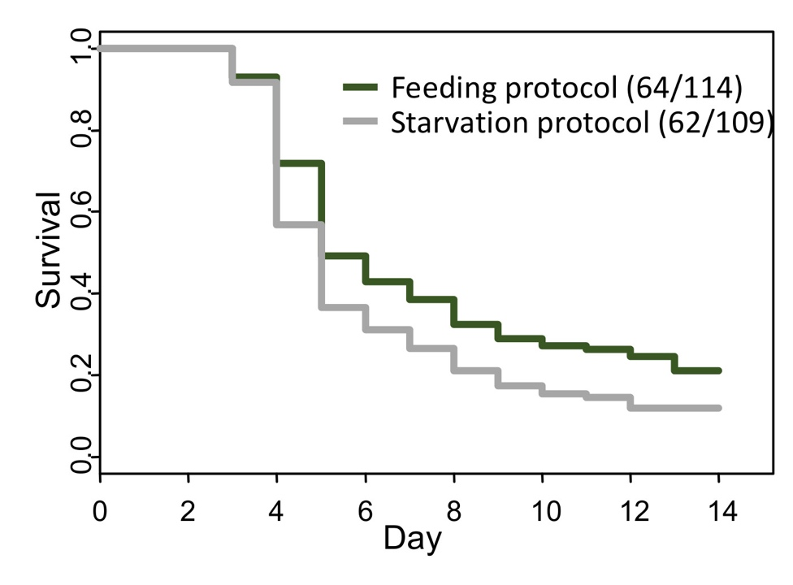

Figure S1 Survival plot for the workers subjected to the two protocols (feeding and starvation) during the 14 day challenge with a DL80 dose of M. anisopliae. In parentheses number of colony having produced suitable workers and total number of workers tested for each protocol.

