Supplementary Information: “Male spiders control offspring sex ratio through greater production of female-determining sperm.” – Proceedings of the Royal Society B.
Bram Vanthournout, Mette Marie Busck, Jesper Bechsgaard, Frederik Hendrickx, Andreas Schramm, Trine Bilde.
Supplementary Figure S1. Dot plot of propidium iodide stained sperm nuclei (PI, corresponding to DNA content) and forward scatter of the nucleus (FSC, corresponding to particle size) isolated from a leg (top) and pedipalp (bottom) of a male S. mimosarum. Dotted circles indicate populations of diploid nuclei (in both leg and pedipalp sample) and sperm nuclei (only in pedipalp sample). Figure was generated using Flowing Software (version 2.5.1; http://flowingsoftware.btk.fi/).
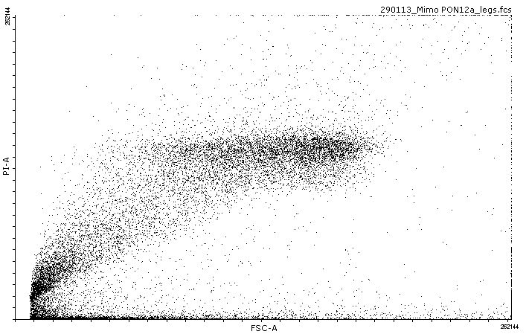
Diploid nuclei
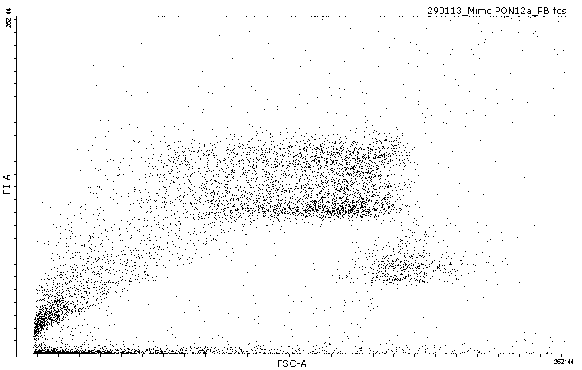
Sperm nuclei
Diploid nuclei

X-sperm analysis data.

FCS files containing the raw output data of the flow cytometry runs have been uploaded to FlowRepository (http://flowrepository.org/id/RvFr4wSgP6tERF9mxpOW30F941OaQDY73ZVArWWoQzG3eCocpmyKWPmytoSiUZT8). We visualized the PI intensities (representing DNA amount) as a function of the forward scatter (FSC) (representing cell size) using FCS Express 6 (DeNovosoftware). We manually selected populations representing sperm nuclei, and exported the data into Excel using a text file. Selection of the sperm nuclei population was performed blind, so the investigator was unaware whether the sample originated from a social or subsocial species. We observed a positive correlation between FSC and PI intensity, and corrected the PI intensity values according to the strength of the correlation in Excel. These Excel files have been uploaded unto the dryad repository (http://datadryad.org/review?doi=doi:10.5061/dryad.r3206.). Every worksheet represents one sperm sample that is named according to sample names in table S1. Within a worksheet the original and corrected scatterplots can be found. Proportion of X-sperm was estimated by fitting two normal distributions (representing 0- and X-sperm) to the PI intensity using the normalmixEM function in R [50]. The output of this analysis (with lamba = proportion of 0- and X-sperm, mu = mean of the distribution and sigma = standard deviation of the proportion) + the resulting PI density histogram is also given per sample.
Normality tests for X-sperm proportion estimates.
We used a one-sample t-test for to test for a significant difference of X-sperm proportion for each species. The assumption for the use of this test is that the data follows a normal distribution. We used the PROC UNIVARIATE in SAS 9.4 (SAS Institute Inc. 2016) with the data following a normal distribution as null hypothesis. The results indicate a p-value higher than 0.05 for all species, indicating that the distribution does not deviate significantly from a normal distribution.
S. africanus
Test | Statistic |  | p Value
Shapiro-Wilk | W | 0.891829 | Pr < W | 0.2843
Kolmogorov-Smirnov | D | 0.231939 | Pr > D | >0.1500
Cramer-von Mises | W-Sq | 0.065368 | Pr > W-Sq | >0.2500
Anderson-Darling | A-Sq | 0.388169 | Pr > A-Sq | >0.2500

S. dumicola
Test | Statistic |  | p Value
Shapiro-Wilk | W | 0.935575 | Pr < W | 0.5681
Kolmogorov-Smirnov | D | 0.22518 | Pr > D | >0.1500
Cramer-von Mises | W-Sq | 0.048674 | Pr > W-Sq | >0.2500
Anderson-Darling | A-Sq | 0.281188 | Pr > A-Sq | >0.2500
S. mimosarum
Test | Statistic |  | p Value
Shapiro-Wilk | W | 0.900955 | Pr < W | 0.2576
Kolmogorov-Smirnov | D | 0.167146 | Pr > D | >0.1500
Cramer-von Mises | W-Sq | 0.053791 | Pr > W-Sq | >0.2500
Anderson-Darling | A-Sq | 0.384796 | Pr > A-Sq | >0.2500

Supplementary Table S1. Overview of the samples used for X-sperm analysis.
Male¹ | species | storage method | sociality level | number of sperm nuclei | lower CI | mean | upper CI
dumi 1a | S. dumicola | - 80°C | social | 1900 | 0.53 | 0.71 | 0.91
dumi 1b | S. dumicola | - 80°C | social | 275 | 0.52 | 0.65 | 0.96
dumi 2 a + b | S. dumicola | - 80°C | social | 2734 | 0.54 | 0.61 | 0.67
dumi 3 a + b | S. dumicola | - 80°C | social | 1084 | 0.53 | 0.66 | 0.86
dumi 4a | S. dumicola | - 80°C | social | 1351 | 0.56 | 0.68 | 0.73
dumi 4b | S. dumicola | - 80°C | social | 2273 | 0.61 | 0.67 | 0.90
dumi 5 a+b | S. dumicola | - 80°C | social | 1810 | 0.69 | 0.74 | 0.78
dumi 6 a+b | S. dumicola | - 80°C | social | 1620 | 0.74 | 0.78 | 0.81
dumi 7 a+b | S. dumicola | - 80°C | social | 2936 | 0.60 | 0.63 | 0.65
dumi 8 | S. dumicola | - 80°C | social | 234 | 0.70 | 0.81 | 0.94
afri 1 | S. africanus | - 80°C | subsocial | 5049 | 0.49 | 0.51 | 0.52
afri 2 | S. africanus | - 80°C | subsocial | 1964 | 0.49 | 0.51 | 0.53
afri 3 | S. africanus | - 80°C | subsocial | 2991 | 0.52 | 0.55 | 0.57
afri 4a | S. africanus | - 80°C | subsocial | 925 | 0.5 | 0.52 | 0.56
afri 4b | S. africanus | - 80°C | subsocial | 996 | 0.58 | 0.6 | 0.65
afri 5a | S. africanus | - 80°C | subsocial | 1015 | 0.53 | 0.57 | 0.62
afri 5b | S. africanus | - 80°C | subsocial | 760 | 0.55 | 0.58 | 0.62
afri 6 a + b | S. africanus | - 80°C | subsocial | 6328 | 0.54 | 0.55 | 0.64
afri 7 a + b | S. africanus | - 80°C | subsocial | 5448 | 0.36 | 0.52 | 0.55
mimo 1 | S. mimosarum | - 80°C | social | 126 | 0.5 | 0.57 | 0.8
mimo 2 | S. mimosarum | - 80°C | social | 988 | 0.65 | 0.87 | 0.90
mimo 3 | S. mimosarum | - 80°C | social | 764 | 0.41 | 0.54 | 0.72
mimo 4 | S. mimosarum | - 80°C | social | 897 | 0.76 | 0.85 | 0.89
mimo 5* | S. mimosarum | alive | social | 590 | 0.58 | 0.66 | 0.74
mimo 6* | S. mimosarum | alive | social | 959 | 0.58 | 0.63 | 0.68
mimo 7* | S. mimosarum | alive | social | 1224 | 0.53 | 0.57 | 0.61
mimo 8 | S. mimosarum | - 80°C | social | 530 | 0.59 | 0.69 | 0.83
mimo 9* | S. mimosarum | alive | social | 1863 | 0.68 | 0.71 | 0.76
¹ sample number corresponds to the order as portrayed in Figure 2. Samples originating from two pedipalp measurements from the same male are indicated with ”a” and ”b”. Samples in which both pedipalps were pooled are indicated by ”a + b”.
Samples indicated with an asterisk (*) are processed on a BD Biosciences FACSaria flow cytometer, all other samples were processed using a Fortessa flow cytometer.

Microbiome screening.
Spiders were collected at several locations (see Table S2 for a detailed overview) and were either immediately stored in CTAB buffer or transported to the lab and stored at a later time. Though conditions were not sterile for this period, this is not an issue for this study as we screen for endosymbiotic bacteria that do not survive outside the host. As such, environmental contamination during transport and lab-rearing is very unlikely.
Supplementary Table S2. Overview of the samples used in the microbiome large dataset survey indicating percentage of the reads belonging to endosymbiont bacteria causing sex ratio distortion. Sample names correspond to the names in the NCBI database (https://www.ncbi.nlm.nih.gov/sra, accession numbers SRP130747, SRP130740 and SRP130742). Populations are indicated with MAH (Madagascar, Mahavanana), SAK (Madagascar, Isalo National Park), TANA (Madagascar, Antananarivo), PON (South Africa, Pongola Game Reserve), WEE (South Africa, Weenen Game Farm), KRU (South Africa, Kruger National Park), ADDO (South Africa, Addo), PAA (South Africa, Paarl).

 |  | Rickettsia | Spiroplasma | Wolbachia
X236_MAH_3 1 | mimosarum | 0 | 0 | 0
X237_MAH_3 2 | mimosarum | 0 | 0 | 0
X238_MAH_3 3 | mimosarum | 0 | 0 | 0
X244_MAH_5 1 | mimosarum | 0.00162768 | 0 | 0
X246_MAH_5 2 | mimosarum | 0.04568486 | 0 | 0
X255_MAH_8 1 | mimosarum | 0 | 0 | 0
X256_MAH_8 2 | mimosarum | 0 | 0 | 0
X257_MAH_8 3 | mimosarum | 0.00673038 | 0 | 0
X259_MAH_9 1 | mimosarum | 0 | 0 | 0
X261_MAH_9 2 | mimosarum | 0.01863412 | 0 | 0
MB380_PON_12 1 | mimosarum | 0 | 0.31897927 | 0
MB381_PON_12 2 | mimosarum | 0 | 0 | 0
MB382_PON_12 3 | mimosarum | 0 | 0 | 0
X431_PON_34 1 | mimosarum | 0 | 0 | 0.01819174
X432_PON_34 2 | mimosarum | 0 | 0 | 0
MB383_PON_35 1 | mimosarum | 0 | 0 | 0
MB384_PON_35 2 | mimosarum | 0 | 0 | 0
MB376_PON_5 1 | mimosarum | 0.00599772 | 0 | 0
MB377_PON_5 2 | mimosarum | 0 | 0 | 0
M523_PON_52 1 | mimosarum | 0 | 0 | 0
MB385_PON_52 2 | mimosarum | 0 | 0 | 0
MB386_PON_52 3 | mimosarum | 0 | 0 | 0
MB387_PON_52 4 | mimosarum | 0 | 0 | 0
M522_PON_52 5 | mimosarum | 0 | 0 | 0
X281_SAK_17 1 | mimosarum | 0.07198656 | 0 | 0
X282_SAK_17 2 | mimosarum | 0 | 0 | 0
MB365_SAK_17 3 | mimosarum | 0 | 0 | 0
X284_SAK_20 1 | mimosarum | 0 | 0 | 0
X286_SAK_20 2 | mimosarum | 0 | 0 | 0.02258356
X285_SAK_20 3 | mimosarum | 0 | 0 | 0
X290_SAK_21 1 | mimosarum | 0 | 0 | 0
X291_SAK_21 2 | mimosarum | 0 | 0 | 0
X289_SAK_21 3 | mimosarum | 0 | 0 | 0
X294_SAK_22 1 | mimosarum | 0.02338415 | 0 | 0
X295_SAK_22 2 | mimosarum | 0.03388299 | 0 | 0
MB366_SAK_22 3 | mimosarum | 0 | 0 | 0
X296_SAK_23 1 | mimosarum | 0.09320285 | 0.10873666 | 0
X297_SAK_23 2 | mimosarum | 0.10391153 | 0.11875603 | 0
X298_SAK_23 3 | mimosarum | 0 | 0.01828822 | 0
MB367_TANA_51 1 | mimosarum | 0.02147766 | 0 | 0
MB368_TANA_51 2 | mimosarum | 0.01228372 | 0 | 0
MB369_TANA_52 1 | mimosarum | 0.02829335 | 0 | 0
MB370_TANA_52 2 | mimosarum | 0.11325232 | 0 | 0
X327_TANA_52 3 | mimosarum | 0 | 0 | 0
MB371_TANA_57 1 | mimosarum | 0.07934685 | 0 | 0
MB372_TANA_57 2 | mimosarum | 71.5394143 | 0 | 0
X350_TANA_58 1 | mimosarum | 16.936067 | 0 | 0
X351_TANA_58 2 | mimosarum | 0.70336678 | 0 | 0
MB373_TANA_58 3 | mimosarum | 0.77384308 | 0 | 0
MB374_TANA_59 1 | mimosarum | 0.20792357 | 0 | 0
MB375_TANA_59 2 | mimosarum | 0.10561461 | 0 | 0
X495_WEE_2 1 | mimosarum | 0.01820002 | 0 | 0
X496_WEE_2 2 | mimosarum | 0 | 0 | 0
X497_WEE_2 3 | mimosarum | 0 | 0 | 0
X411_WEE_26 1 | mimosarum | 0 | 0 | 0
X413_WEE_26 2 | mimosarum | 0 | 0 | 0
MB378_WEE_36 1 | mimosarum | 0 | 0.00153278 | 0
MB379_WEE_36 2 | mimosarum | 0 | 0 | 0
X419_WEE_36 3 | mimosarum | 0 | 0 | 0
M572_WEE_40 1 | mimosarum | 0.04273504 | 0 | 0
M573_WEE_40 2 | mimosarum | 0 | 0 | 0
X399_ADDO_1 1 | dumicola | 0 | 0 | 0
X401_ADDO_1 2 | dumicola | 0 | 0 | 0
X402_ADDO_1 3 | dumicola | 0 | 0 | 0
M558_ADDO_15 1 | dumicola | 4.64963982 | 0 | 0
M547_ADDO_15a 1 | dumicola | 0 | 0 | 0
M548_ADDO_15a 2 | dumicola | 0 | 0 | 0
M549_ADDO_15a 3 | dumicola | 0.13463042 | 0 | 0
MB313_ADDO_16 1 | dumicola | 0 | 0.00680349 | 0
MB314_ADDO_16 2 | dumicola | 0 | 0.0045775 | 0
M541_ADDO_6a 1 | dumicola | 0 | 0 | 0
M542_ADDO_6a 2 | dumicola | 0 | 0 | 0
M640_ADDO_6C 1 | dumicola | 0 | 0 | 0
MB302_ADDO_8 1 | dumicola | 0 | 0 | 0
MB303_ADDO_8 2 | dumicola | 0 | 0 | 0
MB315_ADDO_9 1 | dumicola | 0 | 0 | 0
MB316_ADDO_9 2 | dumicola | 0 | 0 | 0
MB317_KRU_12 1 | dumicola | 0 | 0.90527298 | 0
MB318_KRU_12 2 | dumicola | 0 | 52.9469092 | 0
MB319_KRU_12 3 | dumicola | 0 | 5.4897068 | 0
M601_KRU_18 1 | dumicola | 0 | 0 | 0
M602_KRU_18 2 | dumicola | 0 | 0 | 0
M593_KRU_21 1 | dumicola | 0 | 0 | 0
M589_KRU_27 1 | dumicola | 87.3577155 | 0 | 0
M590_KRU_27 2 | dumicola | 38.9255419 | 0 | 0
M537_KRU_3 1 | dumicola | 0 | 0 | 0
M538_KRU_3 2 | dumicola | 0 | 0.01098358 | 0
M620_KRU_5 1 | dumicola | 0 | 0 | 0
M621_KRU_5 2 | dumicola | 0.00522111 | 0 | 0
M622_KRU_5 3 | dumicola | 0 | 0 | 0
M877_PAA_1 1 | dumicola | 0 | 0 | 0
M878_PAA_1 2 | dumicola | 0 | 0 | 0
MB322_PAA_12 1 | dumicola | 0 | 0 | 0
M897_PAA_2 1 | dumicola | 0.00797257 | 0 | 0
M898_PAA_2 2 | dumicola | 0 | 0 | 0
M899_PAA_2 3 | dumicola | 0 | 0 | 0
M855_PAA_3 1 | dumicola | 0 | 0 | 0
M856_PAA_3 2 | dumicola | 0 | 0 | 0
M862_PAA_5 1 | dumicola | 0.07835967 | 0 | 0
M894_PAA_7 1 | dumicola | 0 | 0 | 0
M895_PAA_7 2 | dumicola | 0 | 0 | 0
M8942_PAA_7 3 | dumicola | 0 | 0 | 0
MB307_PON_36 1 | dumicola | 0 | 0 | 0
M754_PON_37 1 | dumicola | 0 | 0 | 0
M662_PON_55 1 | dumicola | 0 | 0 | 0
M663_PON_55 2 | dumicola | 0 | 0 | 2.16004087
M664_PON_55 3 | dumicola | 0 | 0 | 0
X548_PON_56 1 | dumicola | 0 | 0 | 0
X435_PON_61 1 | dumicola | 0 | 0 | 0
X436_PON_61 2 | dumicola | 0.05635073 | 0 | 0
X478_WEE_20 1 | dumicola | 0 | 0 | 0
X479_WEE_20 2 | dumicola | 0 | 0 | 0
X480_WEE_20 3 | dumicola | 0 | 0 | 0
X483_WEE_23 1 | dumicola | 0.03328895 | 0 | 0
MB311_WEE_23 2 | dumicola | 0.59653551 | 0 | 0
MB312_WEE_23 3 | dumicola | 0.57961132 | 0.03409478 | 0
X415_WEE_29 1 | dumicola | 0 | 0 | 0
X416_WEE_29 2 | dumicola | 0 | 0 | 0
X417_WEE_29 3 | dumicola | 0 | 0 | 0
X423_WEE_39 1 | dumicola | 0 | 0 | 0
X424_WEE_39 2 | dumicola | 0 | 0 | 0
X425_WEE_39 3 | dumicola | 0 | 0 | 0
M561_WEE_41 1 | dumicola | 0 | 0 | 0
M562_WEE_41 2 | dumicola | 0 | 0 | 0
M563_WEE_41 3 | dumicola | 0.46006757 | 0 | 0

