Electronic Supplementary Material - 2: Friendship across species borders: factors that facilitate and constrain heterospecific sociality

Hari Sridhar and Vishwesha Guttal
Centre for Ecological Sciences, Indian Institute of Science, Bengaluru, 560012, India.
Email: harisridhar1982@gmail.com and guttal@iisc.ac.in

Supplementary Appendix 1: Description of different scenarios in which heterospecifics might be chosen over conspecifics as social partner.

According to earlier social information use models [1, 2, 3], partner choice is determined by only two factors: decrease of social benefit (only in terms of information relevance) and competition cost, in relation to phenotypic distance. Depending on the shapes of these two curves, the optimal partner for social information use could be a conspecific or a heterospecific. In other words, only one scenario, corresponding to the optimum in the above trade-off, leads to a heterospecific being chosen as a partner. Our conceptual model, however, allows for the possibility of multiple scenarios leading to heterospecifics being chosen as social partners, with the simple social benefit-competition trade-off being only one of them. In other words, net social benefit could be maximised in different parts of the multi-dimensional trait space depending on how social benefit and costs vary along four axes (Supplementary Figure 1). Moreover, factors unrelated to the trait space, such as availability, dispersion and familiarity of individuals, could also influence partner choice. Below, we provide a few examples to illustrate the diversity of scenarios that could result in heterospecifics being preferred over conspecifics, which are not accounted for by earlier models (Supplementary Figure 1).

SA 1.1 Heterospecific partner might be preferred when partner relevance and competition cost are unrelated
In a scenario where partner relevance and competition costs are determined by different traits, the best partner will be one that is similar in the trait(s) important for relevance but dissimilar in the trait(s) important for competition (Supplementary Figure 1a). Such a partner is more likely to be found among heterospecifics than conspecifics because different traits are, usually, strongly correlated among conspecifics. In other words, we are unlikely to find two conspecifics that are highly similar in one trait and highly dissimilar in another. Potential examples of such scenarios are the numerous documented cases of social information use between birds and mammals for protection (e.g. Jay-Squirrel [4]; go-away bird - dik-dik [5]), where social partners, though ecologically very different, still share the same predators.

SA 1.2 Heterospecific partner might be preferred when competition is predominantly intraspecific
In scenarios where competition is linked to breeding, i.e. either for mates directly or for resources in relation to mate attraction [6, 7], competition costs will be applicable only for conspecific social partners. In such scenarios, heterospecifics, even if they provide lower social benefit, might still get chosen because their net social benefit is high because of zero (or negligible) competition costs (Supplementary Figure 1b). Unlike the first scenario presented, which is possible only when traits important for social benefit and competition costs are different, this scenario is possible even in cases where the same trait(s) underlies social benefit and competition costs, for example, social information on nest site selection in birds [8].

SA 1.3 Even when heterospecifics and conspecifics are equally-relevant partners, heterospecific partner might be preferred when only it can provide a social benefit, or it provides a better-quality benefit than a conspecific can provide
In some scenarios, heterospecifics and conspecifics might both be equally relevant partners but only the former might be able to provide a certain social benefit (Supplementary Figure 1c). For example, individuals of migrant bird species are known to use cues from resident heterospecifics to choose habitats in their wintering areas [8]. Even if conspecifics and heterospecifics share the same level of overlap in habitat requirements with the focal bird (i.e. equal relevance), only the latter has the experience of the area to be able to provide reliable information on habitat quality. In other scenarios, even if both conspecifics and heterospecifics can provide social benefits, the quality of benefit provided by latter might be greater, e.g. when a heterospecific individual is more vigilant than a conspecific individual.

SA 1.4 Heterospecific partner might be preferred when it is more phenotypically similar than a conspecific
Social information models implicitly assume that conspecific individuals are always at shorter phenotypic distances, and therefore are more relevant partners, than heterospecifics. However, this need not always be the case. Studies with fish have shown that heterospecifics that are more similar in body-size get chosen as grouping partners over conspecifics that are less similar [9, 10]. Therefore, heterospecifics might sometimes be more similar than conspecifics in the trait important for partner relevance and therefore get chosen as partner (Supplementary Figure 1d).

SA 1.5 Heterospecific might be preferred even when it is intrinsically less beneficial as a partner than a conspecific
Choice of social partner will be constrained by what individuals are available within the area in which sociality is required. In a scenario where conspecifics are rare, heterospecifics might get chosen as social partner even if they are not as beneficial as conspecifics intrinsically. Studies have shown that fish species that form single-species social groups in their native range, switch to grouping with heterospecifics in their introduced ranges in which conspecifics are rare [11, 12]. An analogous scenario is seen in relation to pollinator attraction in plant species of low intraspecific densities [13]. Such species suffer from low outcrossing success because there aren’t enough individuals to attract and maintain pollinators. However, where individuals of such plants are present near congeners with whom it shares pollinators, outcrossing success is improved because individuals of both plant species together attract pollinators. In general, one might expect that low intraspecific densities will promote heterospecific sociality. In contexts where individuals repeatedly interact with the same individuals, familiarity of individuals will influence partner choice. Grouping with familiar individuals has been suggested to have many advantages including reduced aggression, greater cohesion of groups, faster social learning etc. [14] Studies on fish have shown that even species that have innate preferences for conspecifics as social partners, will, nevertheless choose to group with familiar heterospecifics over unfamiliar conspecifics [14]. Preferences for familiar heterospecifics has also been reported in bats [15] and birds [16]. Finally, potential partners need not always be solitary individuals. Available partner options could also include social groups, either of other species or of conspecifics. Net benefit provided by a group will be a function of the group’s composition (i.e. traits of the individuals forming the group) and size. One can, therefore, imagine a scenario where conspecifics might be more valuable partners than heterospecifics at an individual level, yet, the latter gets chosen as social partner when it is available as a social group. For example, formation of mixed-species bird flocks is often based on the attraction of individuals of one species to social groups of another species [17]. Just as potential partners need not be solitary, the agent making the partner choice could also be a social group. Our literature survey revealed numerous instances of heterospecific sociality that were based on a social group of one species joining a social group of another species. In such cases, composition and size of the group making the choice will also influence who is chosen. Joining mobile animal groups can, additionally, offer benefits that are absent at an individual level. For example, groups can facilitate transfer of social information, through simple local interactions such as copying movement of neighbours, even when very few individuals of a group have pertinent information [18]. Groups can navigate accurately despite imperfect information of individuals [19], even when no individual is aware of others’ informational status [18], and in complex and uncertain environments [20]. Heterogeneities in moving groups, for example arising from informational status of individuals, can also facilitate consensus decision in groups [21]. Such emergent properties of groups could be an additional factor in social partner choice, resulting in preference for a group of heterospecifics over conspecifics.
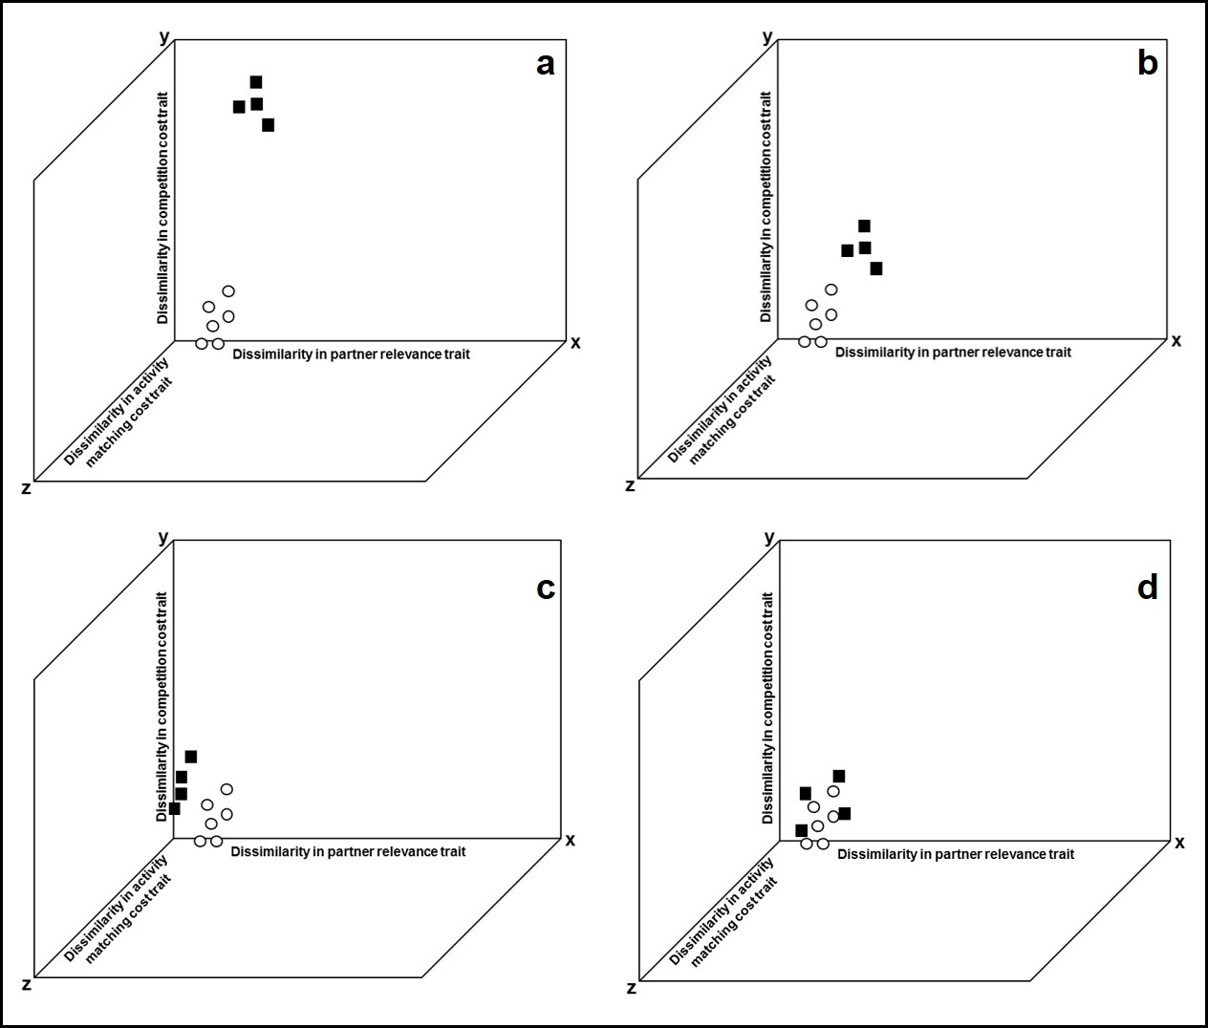
Supplementary Figure 1. Different scenarios that could result in a heterospecific being chosen over a conspecific as social partner depicted on a multi-dimensional trait dissimilarity space. Axes of multi-dimensional trait space are formed by traits important for relevance of partner (x axis), cost of competition (y axis) and cost of activity matching (z axis; see Box 1 in main paper for definition of terms). Trait important for quality of partner is not discussed, except in (d). Although cost of activity matching axis is shown, examples presented do not vary in where partners lie along this axis. Each potential partner’s position on the multi-dimensional trait dissimilarity space is determined by dissimilarities in traits with focal individual. Circles indicate conspecific individuals and squares represent heterospecifics. Filled symbols indicate social partners chosen based on net social benefit provided. a. Heterospecifics chosen as social partner are similar in trait important for relevance but dissimilar in trait important for competition costs. b. Competition is only intraspecific, therefore heterospecifics are chosen even when they are as similar as conspecifics in cost of competition trait. c. Heterospecifics chosen are more similar that conspecifics in trait important for partner relevance. d. Heterospecifics and conspecifics similar in traits underlying partner relevance and cost of competition; however, heterospecifics chosen because they provide a social benefit that conspecifics cannot provide. In other words, quality of benefit provided by heterospecific is greater than conspecific.

References
- Seppänen J-T, Forsman JT, Mönkkönen M, Thomson RL. 2007 Social information use is a process across time, space, and ecology, reaching heterospecifics. Ecology. 88, 1622–1633. (doi:10.1890/06-1757.1)

- Parejo D, Avilés JM. 2016 Social information use by competitors: resolving the enigma of species coexistence in animals? Ecosphere. 7, e01295. (doi:10.1002/ecs2.1295)

- Gil MA, Emberts Z, Jones H, St. Mary CM. 2017 Social information on fear and Food drives animal grouping and fitness. The American Naturalist. 189, 227–241. (doi:10.1086/690055)

- Randler C. 2006 Red Squirrels (Sciurus vulgaris) respond to alarm calls of Eurasian jays (Garrulus glandarius). Ethology. 112, 411–416. (doi:10.1111/j.1439-0310.2006.01191.x)

- Lea AJ, Barrera JP, Tom LM, Blumstein DT. 2008 Heterospecific eavesdropping in a nonsocial species. Behavioral Ecology. 19, 1041–1046. (doi:10.1093/beheco/arn064)

- Gibson RM, Aspbury AS, McDaniel LL. 2002 Active formation of mixed-species grouse leks: a role for predation in lek evolution? Proceedings of the Royal Society B: Biological Sciences. 269, 2503–2507. (doi:10.1098/rspb.2002.2187)

- Given MF. 1990 Spatial distribution and vocal interaction in Rana clamitans and R. virgatipes. Journal of Herpetology. 24, 377. (doi:10.2307/1565053)

- Forsman JT, Thomson RL, Seppanen J-T. 2007 Mechanisms and fitness effects of interspecific information use between migrant and resident birds. Behavioral Ecology. 18, 888–894. (doi:10.1093/beheco/arm048)

- Krause J, Godin J-GJ. 2010 Shoal choice in the banded Killifish (Fundulus diaphanus, Teleostei, Cyprinodontidae): effects of predation risk, fish size, species composition and size of shoals. Ethology. 98, 128–136. (doi:10.1111/j.1439-0310.1994.tb01063.x)

- Krause J, Godin J-GJ, Brown D. 1996 Phenotypic variability within and between fish shoals. Ecology. 77, 1586–1591. (doi:10.2307/2265553)

- Camacho-Cervantes M, Garcia CM, Ojanguren AF, Magurran AE. 2014 Exotic invaders gain foraging benefits by shoaling with native fish. Royal Society Open Science. 1, 140101–140101. (doi:10.1098/rsos.140101)

- Camacho-Cervantes M, Magurran AE, Deacon AE, Ramnarine IW, Ojanguren AF. 2014 Association tendency and preference for heterospecifics in an invasive species. Behaviour. 151, 769–780. (doi:10.1163/1568539x-00003169)

- Moeller DA. 2004 Facilitative interactions among plants via shared pollinators. Ecology. 85, 3289–3301. (doi:10.1890/03-0810)

- Ward AJW, Axford S, Krause J. 2003 Cross-species familiarity in shoaling fishes. Proceedings of the Royal Society B: Biological Sciences. 270, 1157–1161. (doi:10.1098/rspb.2003.2337)

- Ancillotto L, Allegrini C, Serangeli MT, Jones G, Russo D. 2014 Sociality across species: spatial proximity of newborn bats promotes heterospecific social bonding. Behavioral Ecology. 26, 293–299. (doi:10.1093/beheco/aru193)

- Wascher CAF, Szipl G, Boeckle M, Wilkinson A. 2012 You sound familiar: carrion crows can differentiate between the calls of known and unknown heterospecifics. Animal Cognition. 15, 1015–1019. (doi:10.1007/s10071-012-0508-8)

- Sridhar H, Shanker K. 2014 Importance of intraspecifically gregarious species in a tropical bird community. Oecologia. 176, 763–770. (doi:10.1007/s00442-014-3045-0)

- Couzin ID, Krause J, Franks NR, Levin SA. 2005 Effective leadership and decision-making in animal groups on the move. Nature. 433, 513–516. (doi:10.1038/nature03236)

- Simons A. 2004 Many wrongs: the advantage of group navigation. Trends in Ecology & Evolution. 19, 453–455. (doi:10.1016/j.tree.2004.07.001)

- Berdahl A, Torney CJ, Ioannou CC, Faria JJ, Couzin ID. 2013 Emergent sensing of complex environments by mobile animal groups. Science. 339, 574–576. (doi:10.1126/science.1225883)

- Couzin ID, Ioannou CC, Demirel G, Gross T, Torney CJ, Hartnett A, Conradt L, Levin SA, Leonard NE. 2011 Uninformed individuals promote democratic consensus in animal groups. Science. 334, 1578–1580. (doi:10.1126/science.1210280)

