Supplemental Information. Read, Q. D., B. Baiser, J. M. Grady, P. L. Zarnetske, S. Record, and J. Belmaker. Tropical bird species have less variable body sizes. Biology Letters. **Appendix 1**. Detailed information on compilation of covariates and potential dataset artifacts.

*Classification of tropical and nontropical species*: We downloaded range polygons for all bird species [1]. We calculated the area of the polygons in km2, using the sum of resident and breeding range as the range size of a species (not counting winter range and areas passed through while migrating). We calculated the centroid of all the resident and breeding range polygons for each species by finding the area-weighted mean of the centroids of all the polygons. If the absolute value of the latitude of this centroid was greater than 23.5°, we classified the species as nontropical; otherwise, we classified the species as tropical.

*Distances between members of each species pair*: We calculated phylogenetic, latitudinal, and geographic distances between the two members of each sister pair. We used the total branch length between the two members of each sister pair as an index of phylogenetic distance. We used the difference between the absolute values of latitude of the range centroids of the tropical and nontropical species as a covariate, as well as the distance in km2 between the median location of specimen collection of the tropical and nontropical species to indicate geographic distance between the members of each pair.

*Climate variability:* We downloaded the global 1979-2013 BioClim variables for the entire terrestrial globe at 0.5' resolution [2]. For comparison, 41% of VertNet specimen records were collected between 1979-2013 and 80% were collected between 1950-2016; we assume that the climate normals between 1979-2013 are a good estimate of the long-term climate experienced by the bird species in our dataset. We averaged the following variables across years and across all points where specimens were collected: seasonal variability of temperature (variable BIO4, or standard deviation of mean monthly temperatures × 100), seasonal variability of precipitation (variable BIO15, or coefficient of variation of mean monthly precipitation values), interannual variability of temperature (coefficient of variation of mean annual temperatures), and interannual variability of precipitation (coefficient of variation of mean annual precipitation values).

*Functional traits*: We extracted traits from a database of bird foraging and diet traits [3]. We tested whether the mean difference varied by the literature value of each pair’s mean body mass, or by a categorical diet classification. We classified a species pair as predatory if at least one of its members had a carnivorous or omnivorous diet.

*Species range size and migrant status:* We calculated the range size for each species by summing the areas of the resident and breeding range polygons described above [1].Additionally, we classified species with only a year-round range as nonmigratory, species with both resident and breeding range as partial migrants, and species with no permanent range as obligate migrants. We classified a species pair as containing a migrant if at least one of its members was a partial or obligate migrant.

*Richness of co-occurring species:* For each geographic coordinate where a specimen was collected, we counted the number of range polygons that overlapped that point to estimate the richness of co-occurring species. In addition, we counted the number of congeners of the target species whose ranges overlapped the point.

*Potential dataset artifacts*: We used the coordinates of each point where specimens were collected to calculate the convex hull area of the locations of specimen collections as an index of the spatial spread of collections. First, we projected the latitude-longitude coordinates into the Albers equal area grid coordinate reference system. We calculated the area of the smallest convex polygon containing the points. In addition, we calculated the spatial CV of temperature across the range where specimens were collected and the spatial CV of precipitation across the range. Finally, we counted the number of distinct populations from which we had measurements for each species, as well as the elevational range from which the measurements were collected.

**Works Cited in Appendix 1**

1. BirdLife Data Zone. See http://datazone.birdlife.org/home (accessed on 23 January 2017).
2. Chelsa Climate. See http://chelsa-climate.org/ (accessed on 23 January 2017).
3. Wilman H, Belmaker J, Simpson J, de la Rosa C, Rivadeneira MM, Jetz W. 2014 EltonTraits 1.0: Species-level foraging attributes of the world’s birds and mammals. *Ecology* **95**, 2027–2027. (doi:10.1890/13-1917.1)

Supplemental Information. Read, Q. D., B. Baiser, J. M. Grady, P. L. Zarnetske, S. Record, and J. Belmaker. Tropical bird species have less variable body sizes. Biology Letters. **Appendix 2**. Unpaired phylogenetically corrected *t­-*test comparing body size variability of tropical and non-tropical bird species.

In this study, we corrected for phylogenetic non-independence when comparing body size variability of bird species inside and outside the tropics by conducting a paired *t­-*­test using only sister species pairs that consisted of one tropical and one nontropical species. An alternative method of correcting for phylogenetic non-independence is to do an unpaired *t­­-­*test with a phylogenetic model for the error term. In order to determine whether our result was robust to the method chosen, we conducted this analysis as well. In the unpaired case, it is possible to use all tropical and nontropical bird species in the comparison rather than only the tropical-nontropical sister pairs.

We subjected the entire VertNet specimen body size dataset to the same quality controls that we did for the sister species, including removing juvenile and otherwise anomalous specimens, measurements that differed by a factor of ≥10 from the mean for that species, species that had fewer than 10 valid measurements, and species that were not found in the global bird phylogeny. After these quality controls, we were left with 1827 tropical bird species and 1028 nontropical species, and we calculated the coefficient of variation of log10 body mass for each species. We performed an unpaired one-sided *t*-test not corrected for phylogeny, with the null hypothesis that CV of nontropical species is not greater than CV of tropical species. In addition we used the *phylolm()* function in the R package *phylolm* [1] to perform an unpaired one-sided *t­-*test corrected for phylogeny on the same values, assuming a Brownian motion model of trait evolution.

The comparison ignoring phylogeny indicated that nontropical birds have greater CV of body mass (*t* = 8.332; *p* < 2.2 × 10-16). The phylogenetically corrected comparison also indicated that nontropical birds have greater CV of body mass (*t* = 6.284; *p* = 1.9 × 10-10). The effect size is lower in the phylogenetically corrected comparison because the degrees of freedom are reduced when properly accounting for phylogenetic non-independence of tropical and nontropical birds’ body size variability. We concluded that our inference is robust to the method of phylogenetic correction used; our main result, covariate analysis, and discussion in the main text are based on the sister pair method of analysis.

**Works Cited in Appendix 2**

1. Ho LST, Ane C. 2014 A linear-time algorithm for Gaussian and non-Gaussian trait evolution models. *Systematic Biology* **63**, 397-408.

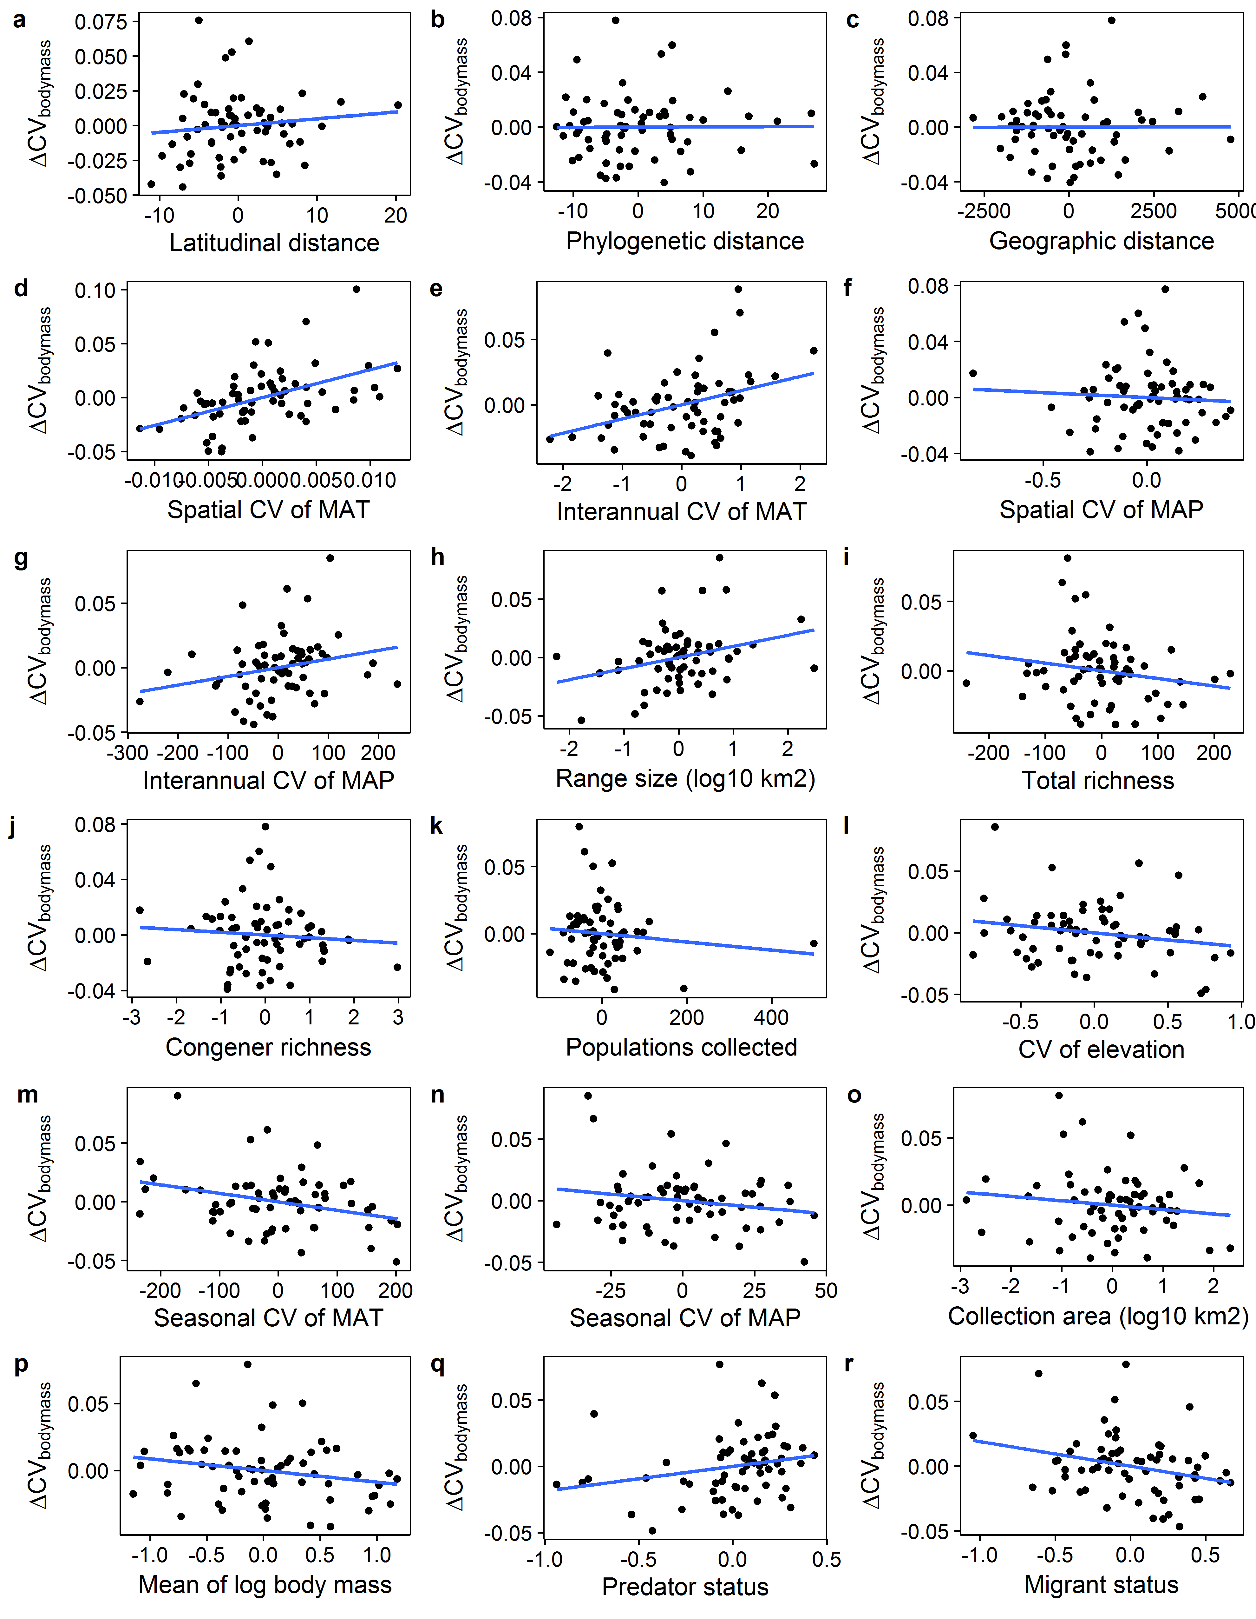Supplemental Figure 1. Scatterplots showing relationships between the within-pair difference of body mass CV between tropical and temperate birds (on the y-axis in all cases) and the within-pair difference of different variables hypothesized to underlie the latitudinal gradient in niche breadth. Variables are conditioned on all other predictors, with a regression line shown for visualization purposes. On both axes, a positive difference indicates a greater value for the nontropical species.

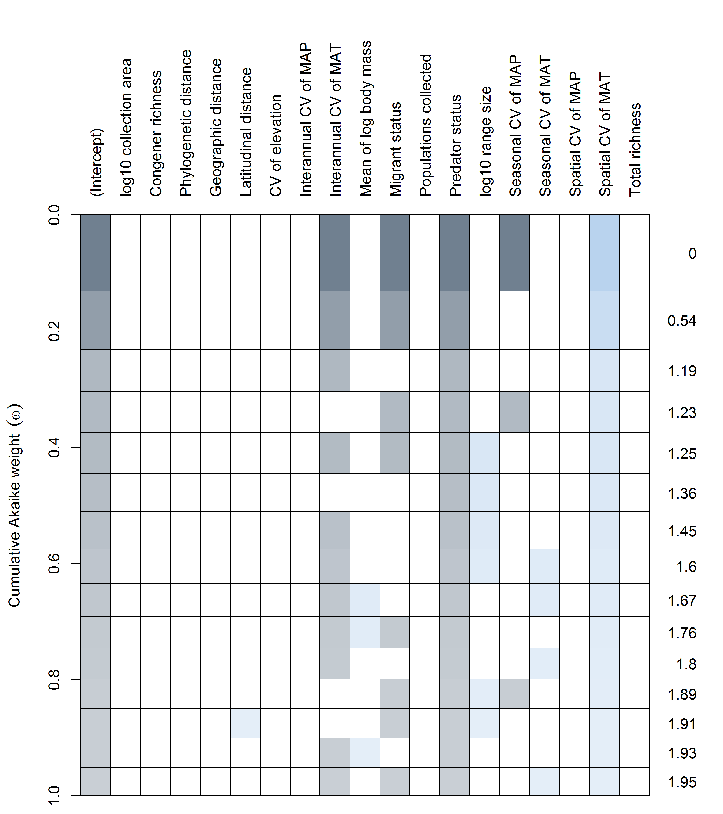Supplemental Figure 2. Model selection table graphically visualizing the model weights of the predictors retained in the family of best models, defined as those with ΔAICc ≤ 2. Each row represents a model. The rows are arranged by increasing ΔAICc of the models such that the best model is on the top row. The ΔAICc of each model relative to the single best model is shown at right. A shaded box indicates that the predictor in the corresponding column was included in the model. Darker shading corresponds to a higher model weight.

Supplemental Table 1. Standardized multiple regression coefficients from the best model selected with AICc using forward selection, including standard errors of the coefficients, *t­-*statistics, *p­-*values, and variance inflation factors (VIF) for each coefficient.

