Supplementary material

Divide and conquer: intermediate levels of population fragmentation maximize cultural accumulation

Maxime Derex^{1,2,3}, Charles Perreault^{1,4}, Robert Boyd^{1,4}

¹ Institute of Human Origins, Arizona State University, Tempe, AZ 85287, USA.
² Human Biological and Cultural Evolution Group, Department of Biosciences, University of Exeter, Penryn TR10 9FE, United Kingdom.
³ Laboratory for Experimental Anthropology – ETHICS (EA 7446), Lille Catholic University, 59016 Lille, France
⁴ School of Human Evolution and Social Change, Arizona State University, Tempe, AZ 85287, USA.

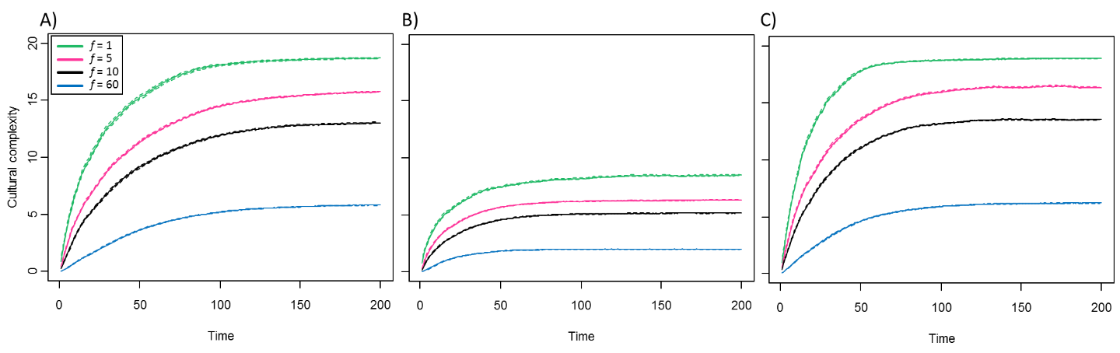
Supplementary Figure 1: Panel A shows the effect of fragmentation (f) when innovation does not depend on cultural diversity (ρ = 1) for p = 0.005 and ε = 0.2. Panel B shows the performance of populations at a higher rate of learning error (ε = 0.4). In this case, populations produce less complex cultural traits than in panel A. Panel C shows the performance of populations at a higher rate of innovation (p = 0.01). In that case, populations reach the same level of cultural complexity than in panel A, but more rapidly. Lines show the value (+/- s.e.m.) found after 200 time steps averaged over 30 simulations. Other parameters: n = 600, m = 0.01.

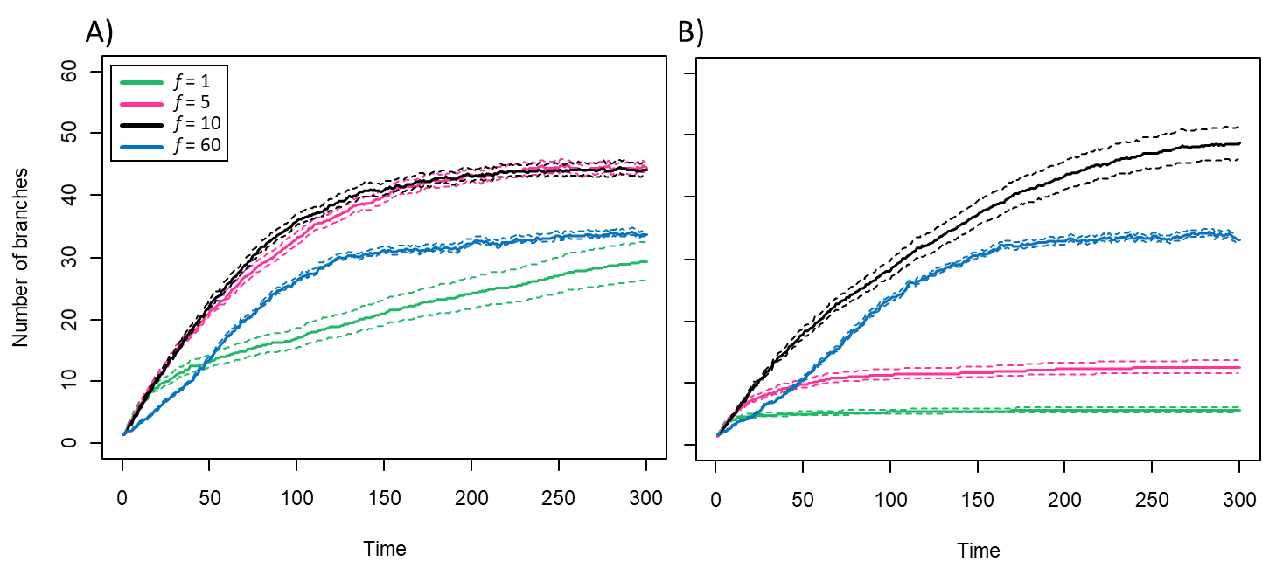
Supplementary Figure 2: Panel A shows the effect of fragmentation (f) on the number of branches explored by populations when ρ = 1.3. Panel B shows the effect of fragmentation (f) on the number of branches explored by populations when ρ = 1.6. Lines show the value (+/- s.e.m.) found after 300 time steps averaged over 30 simulations. Other parameters: n = 600, p = 0.005, m = 0.01, ε = 0.2

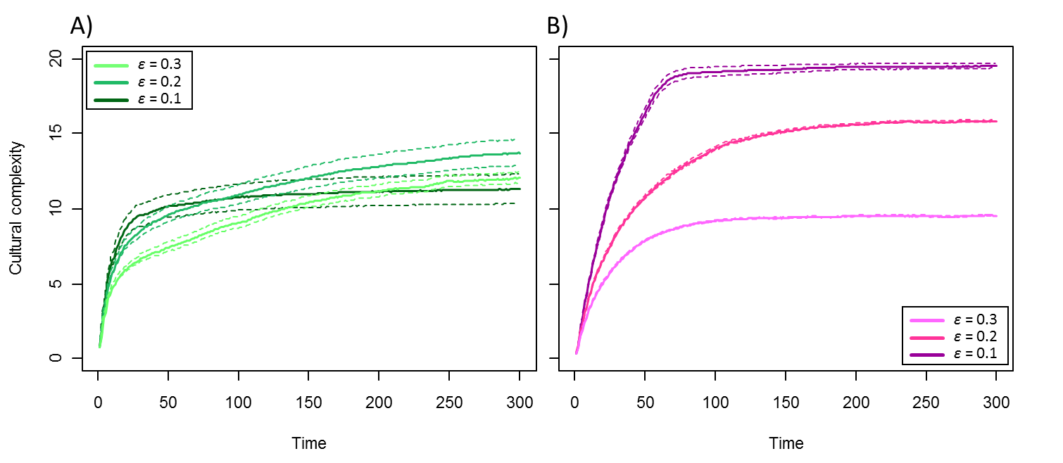
Supplementary Figure 3: Panel A indicates that higher rates of learning error (ε) can slightly benefit cultural complexity in non-fragmented populations (f = 1) when innovation weakly depends on cultural diversity (ρ = 1.3). This is because individuals can branch off to another trajectory after having failed to properly acquire a cultural trait, which promotes cultural diversity. Panel B shows the performance of weakly fragmented populations (f = 5) for the same rates of learning error. Only when learning error is high (ε = 0.3) are non-fragmented populations doing better than fragmented ones, because, in this case, the cultural complexity steady state of weakly fragmented populations becomes determined by populations’ ability to maintain innovations. When error rates are lower, fragmented populations are more likely to produce complex cultural items than non-fragmented populations (Supplementary Fig. 2) and can stabilize them. Lines show the value (+/- s.e.m.) found after 300 time steps averaged over 30 simulations. Other parameters: n = 600, p = 0.005, m = 0.01.

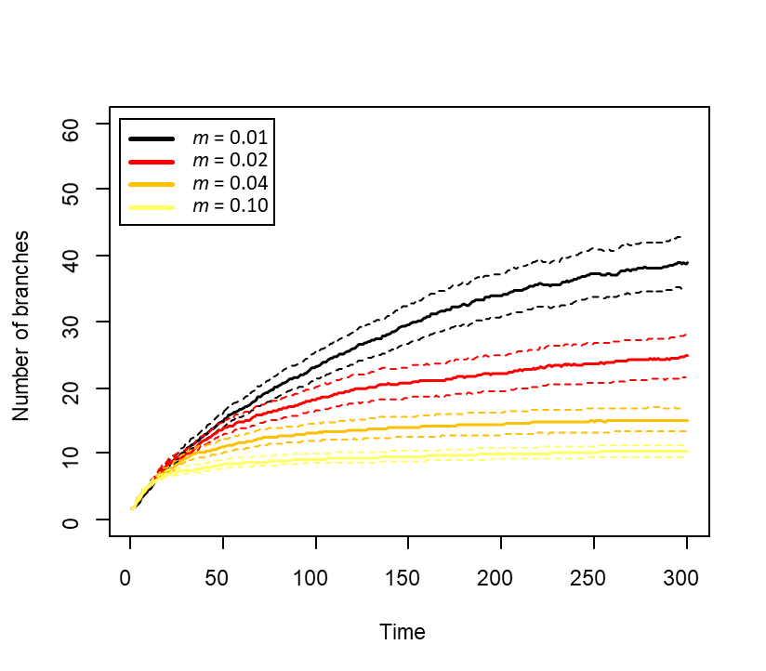
Supplementary Figure 4: Effect of migration (m) on the number of branches explored by moderately fragmented populations (f = 10) when innovation strongly depends on cultural diversity (ρ = 1.6). As migration rate increases, the number of branches explored by sub-populations decreases. Other parameters: n = 600, s = 10, p = 0.005, ε = 0.2.

